
Excel Bitesize 3- Analysing your data
Contents
Conditional Formatting 3
Colour scales 3
Applying more rules 4
Add Reference number to each row of data 5
Fill Series 5
Make your data into a table 6
Name the table 6
Pivot Tables 7
Creating a pivot table 7
Field values 9
Sorting & Filtering a pivot table 10
Add a Slicer to a pivot table 11
Formatting a pivot table 11
Refreshing data in a Pivot table 12
Recommended Pivot Tables 12
Changing value field settings 12
Custom value name 13
Summarise values by 13
Show values As 15
Changing the sort order 16
Custom sort order 17
Grouping dates 18
Sub totals and Grand totals 19

Conditional Formatting
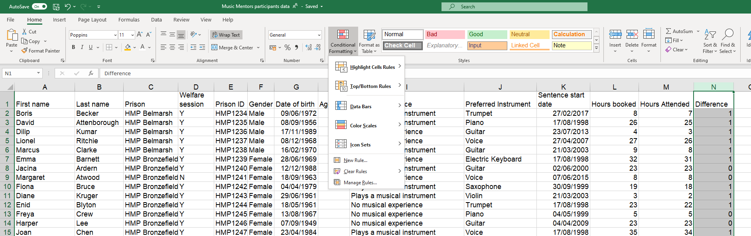
1. Click on the Home tab
2. Highlight the data you want to format and click on Conditional Formatting

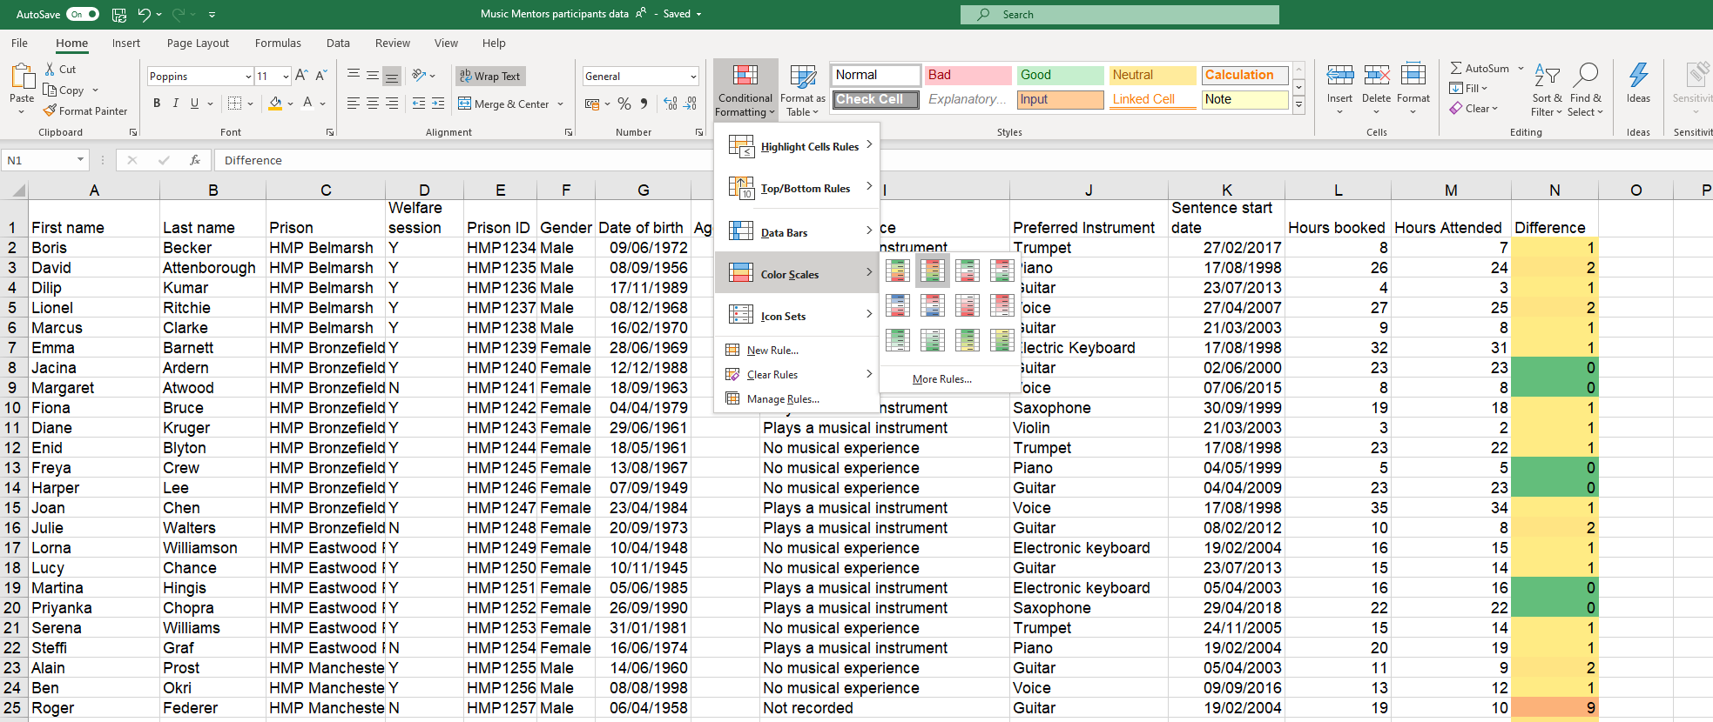
Colour scales
2. Or click on More rules to create your own scale
1. Select a standard colour scale

Applying more rules
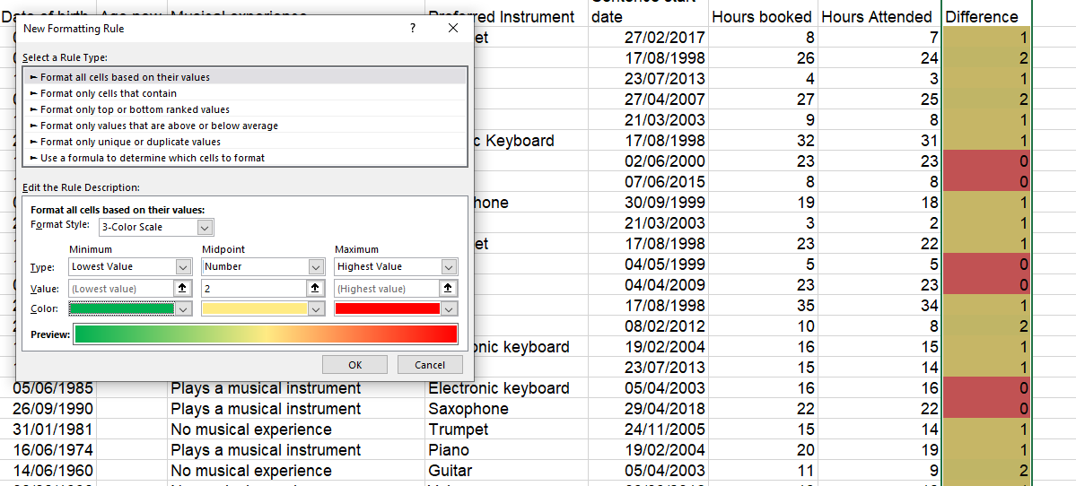
Change colours
Set your own mid- point. In this example, 1 or less will be displayed in green, 2 in yellow gradually moving towards red as the numbers increase

Add Reference number to each row of data

If the dataset you have received doesn’t have a unique ID key associated with it, it’s a good idea to add a unique reference number column to the worksheet. The reason for this is that it gives you a fail safe way to count records once you start slicing and dicing data. Without this, blank cells can play havoc with calculations.
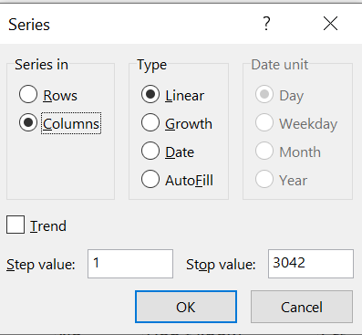
With a small data set you can simply start by numbering the first row and then drag it down the column to the bottom row but with large data sets this becomes unwieldy. Luckily Excel has a built-in feature to enable this called Fill Series.
3. Click on the Fill command button
1. Click on the Home tab
2. Create a new column for the reference number and enter the first number in the series
4. Select Series
6. Step value as 1
5. Check Columns so that the series fills down the column
7. Enter the number of rows of data as the Stop value

Fill Series
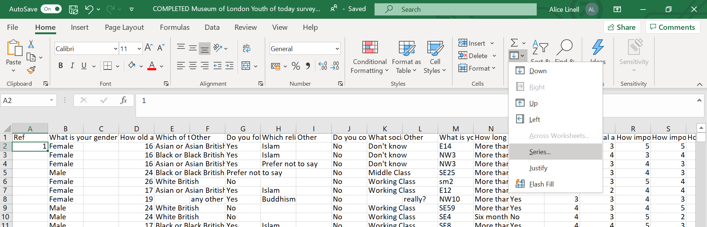

Make your data into a table
2. Click on the Table command button
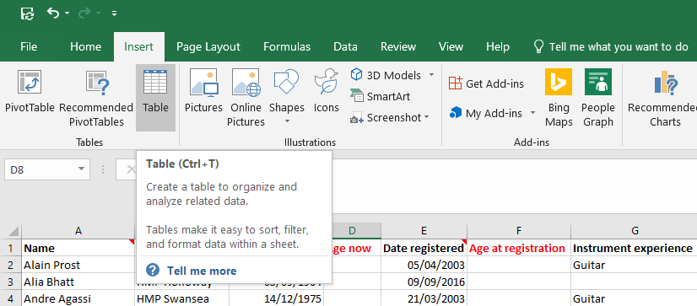
1. Click on the Insert tab
- Alternative shortcut: Ctrl + T
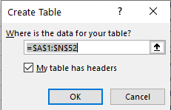
3. A window will open. Confirm the cells to be included in the table and that the data has headers

Name the table
It is good practice to name the table as it makes life much easier later when working with formulas. Naming the formula is basically giving your data set a name which will enable you to recognise which data set you need to be working with.
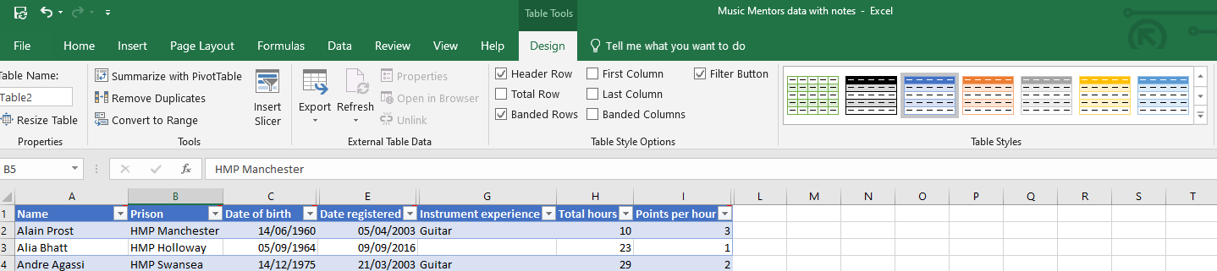
2. Rename the table. For example, “BookingData”
1. Click on the table & select the Design tab

Pivot Tables

Creating a pivot table
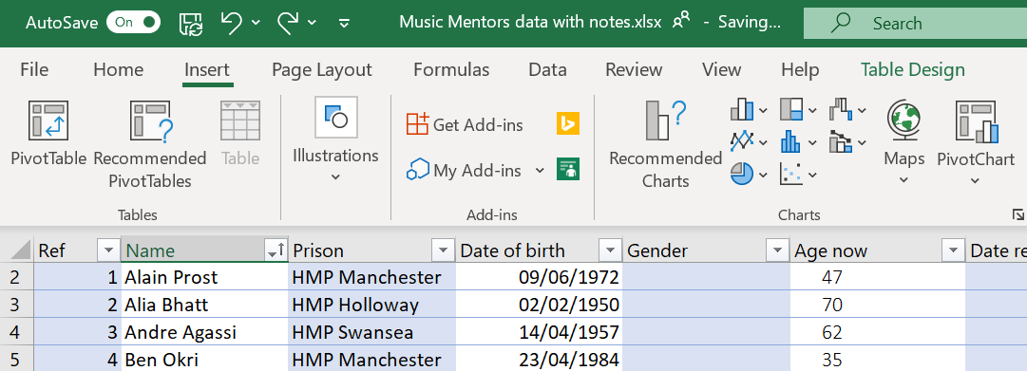
1. Click on the Insert tab
2. Click on Pivot Table

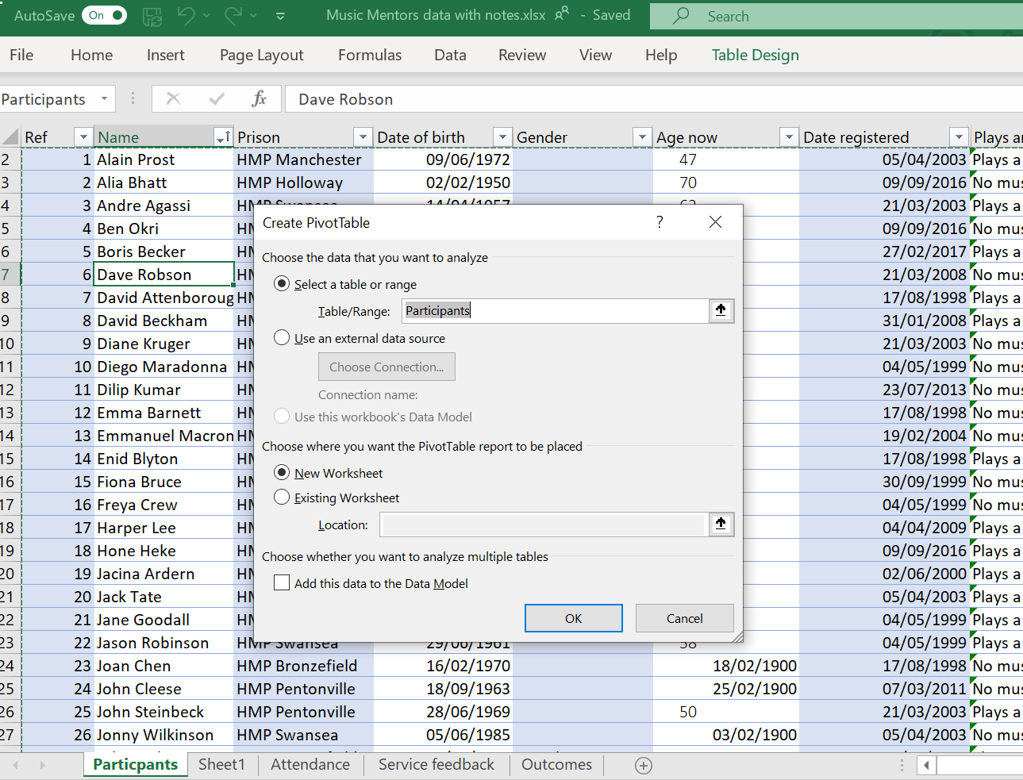
2. Select the table you want to base the pivot table on. Here you can see the table name “participants”. Using a table ensures you have a dynamic data source for your pivot table

3. Select New Worksheet

This will automatically update the table as below, now displaying dates across as columns

5. The columns from your table appear in the fields

4. An empty pivot table is created

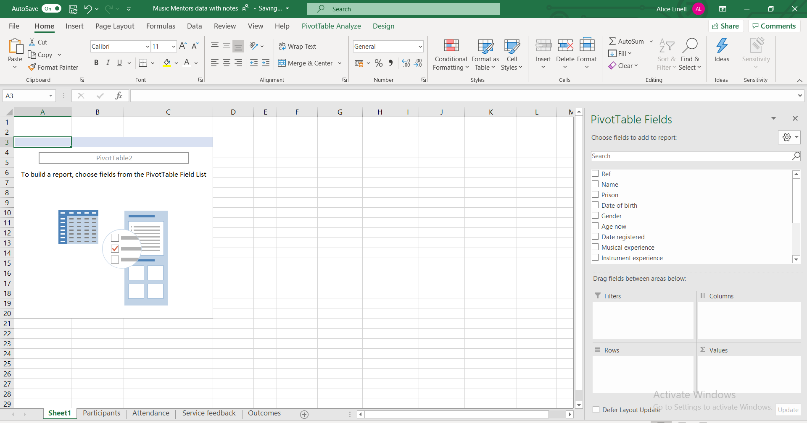
6. To create a simple pivot table that shows the number of prisoners attending sessions from each prison drag and drop the Prison field into the Rows box and the Name field into Values

7. The pivot table now displays how many prisoners attended the music sessions from each prison

8. As the name field is text the pivot table assumes you want to Count the number of records in the Name

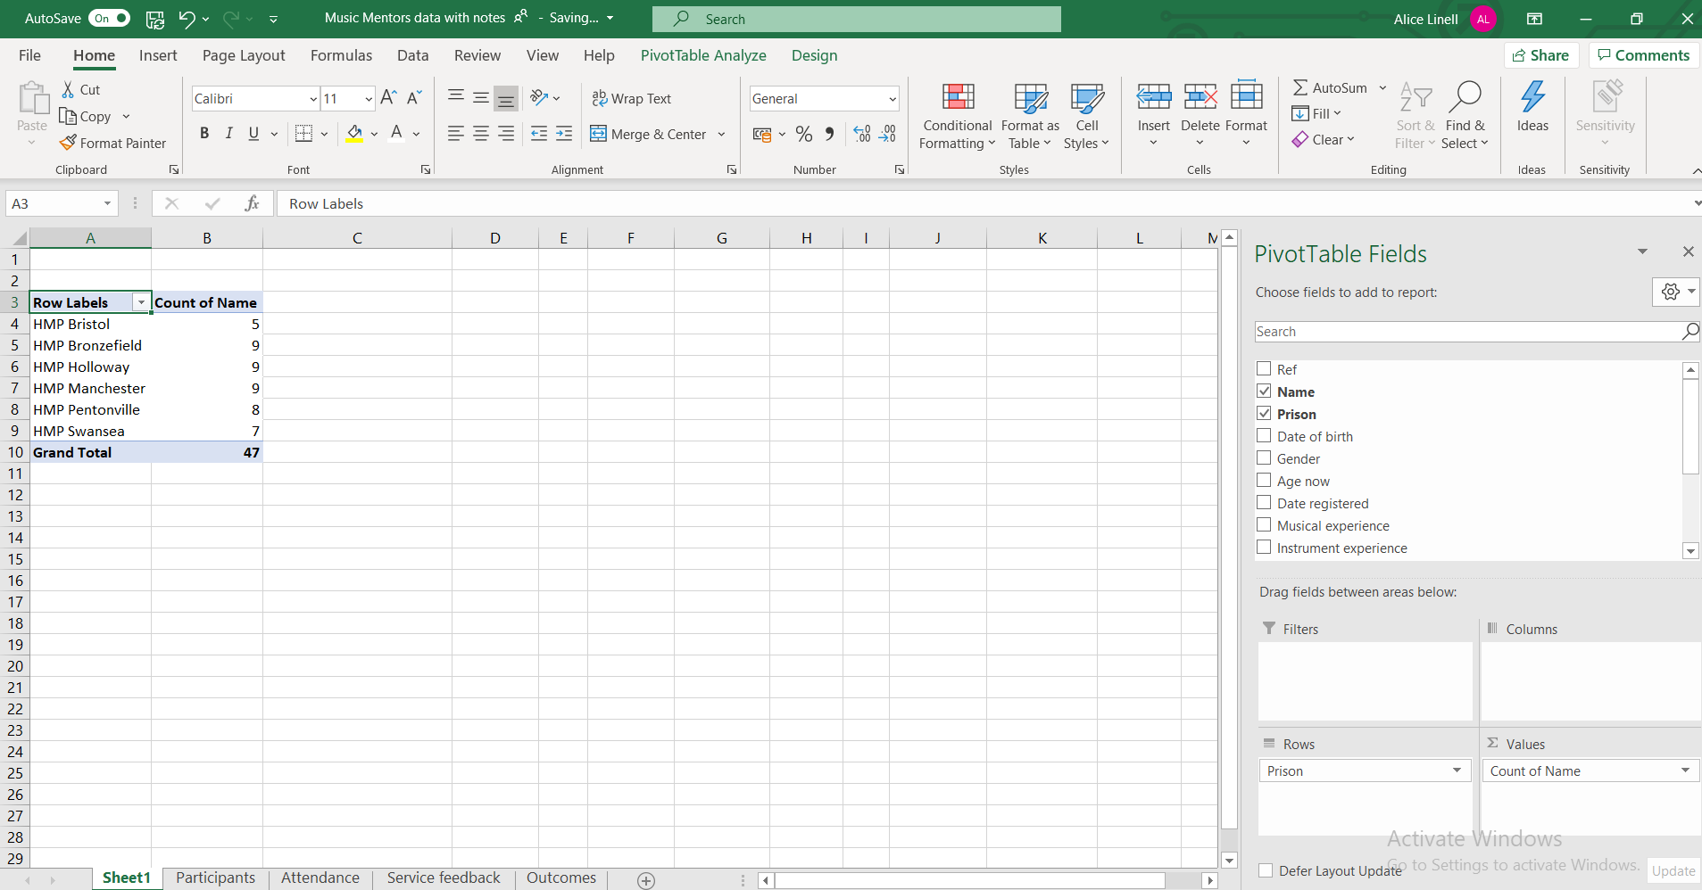

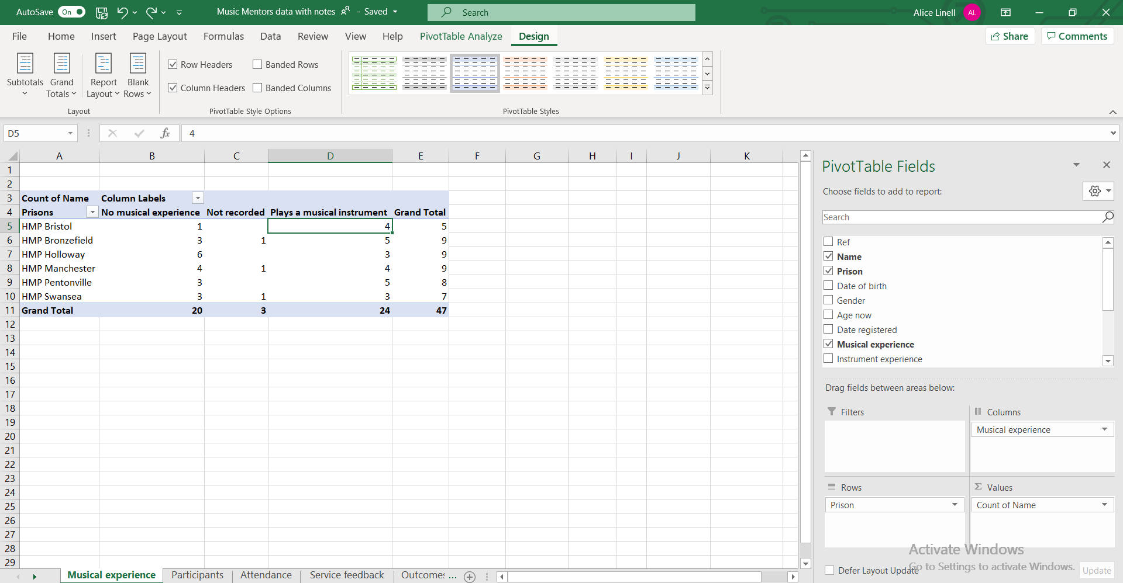
9. Add complexity to your Pivot table. To show how many of the attendees from each prison already had musical experience, add the field Musical experience to the Columns field

Field values
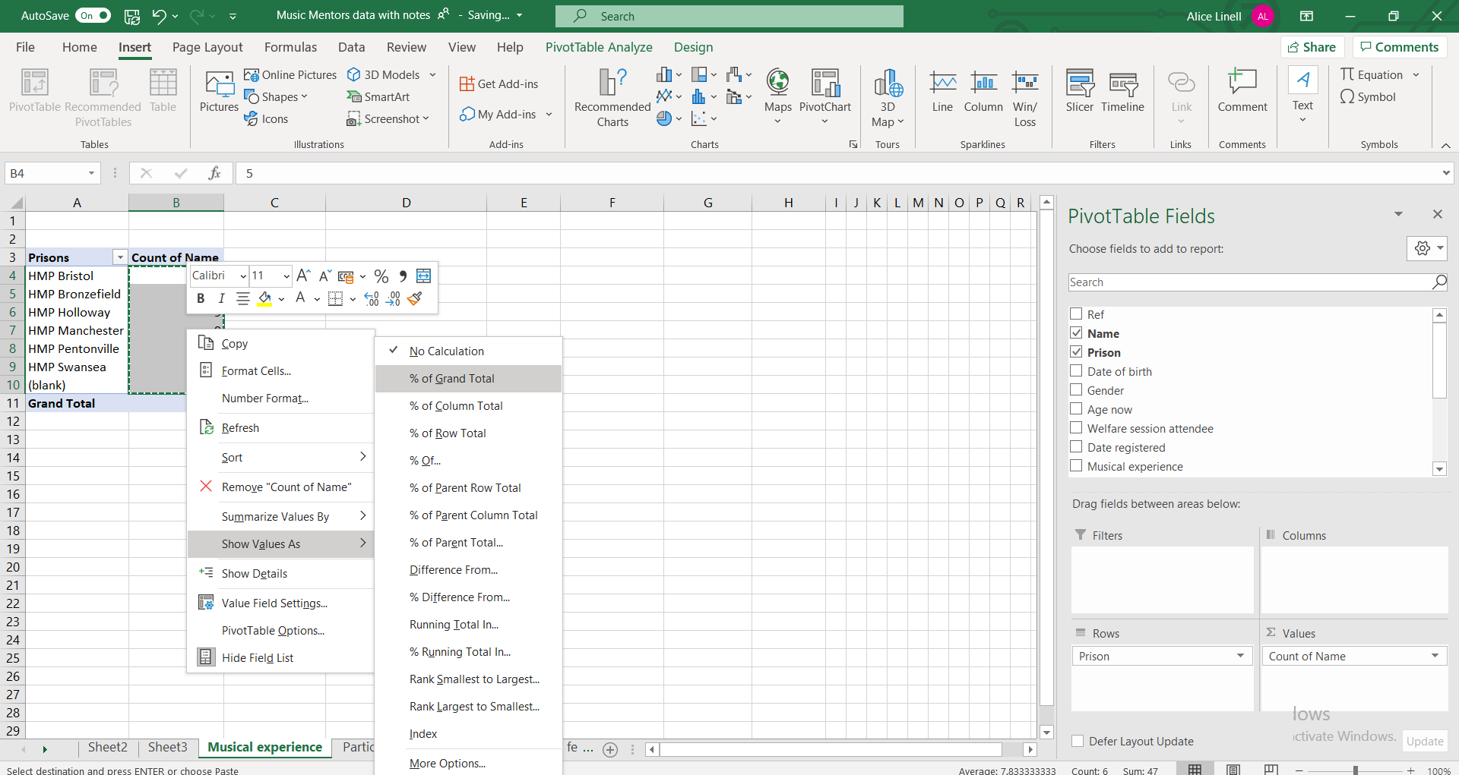
2. Select Show Values As and then % of Grand Total

1.Highlight the fields you want to display as a percentage.

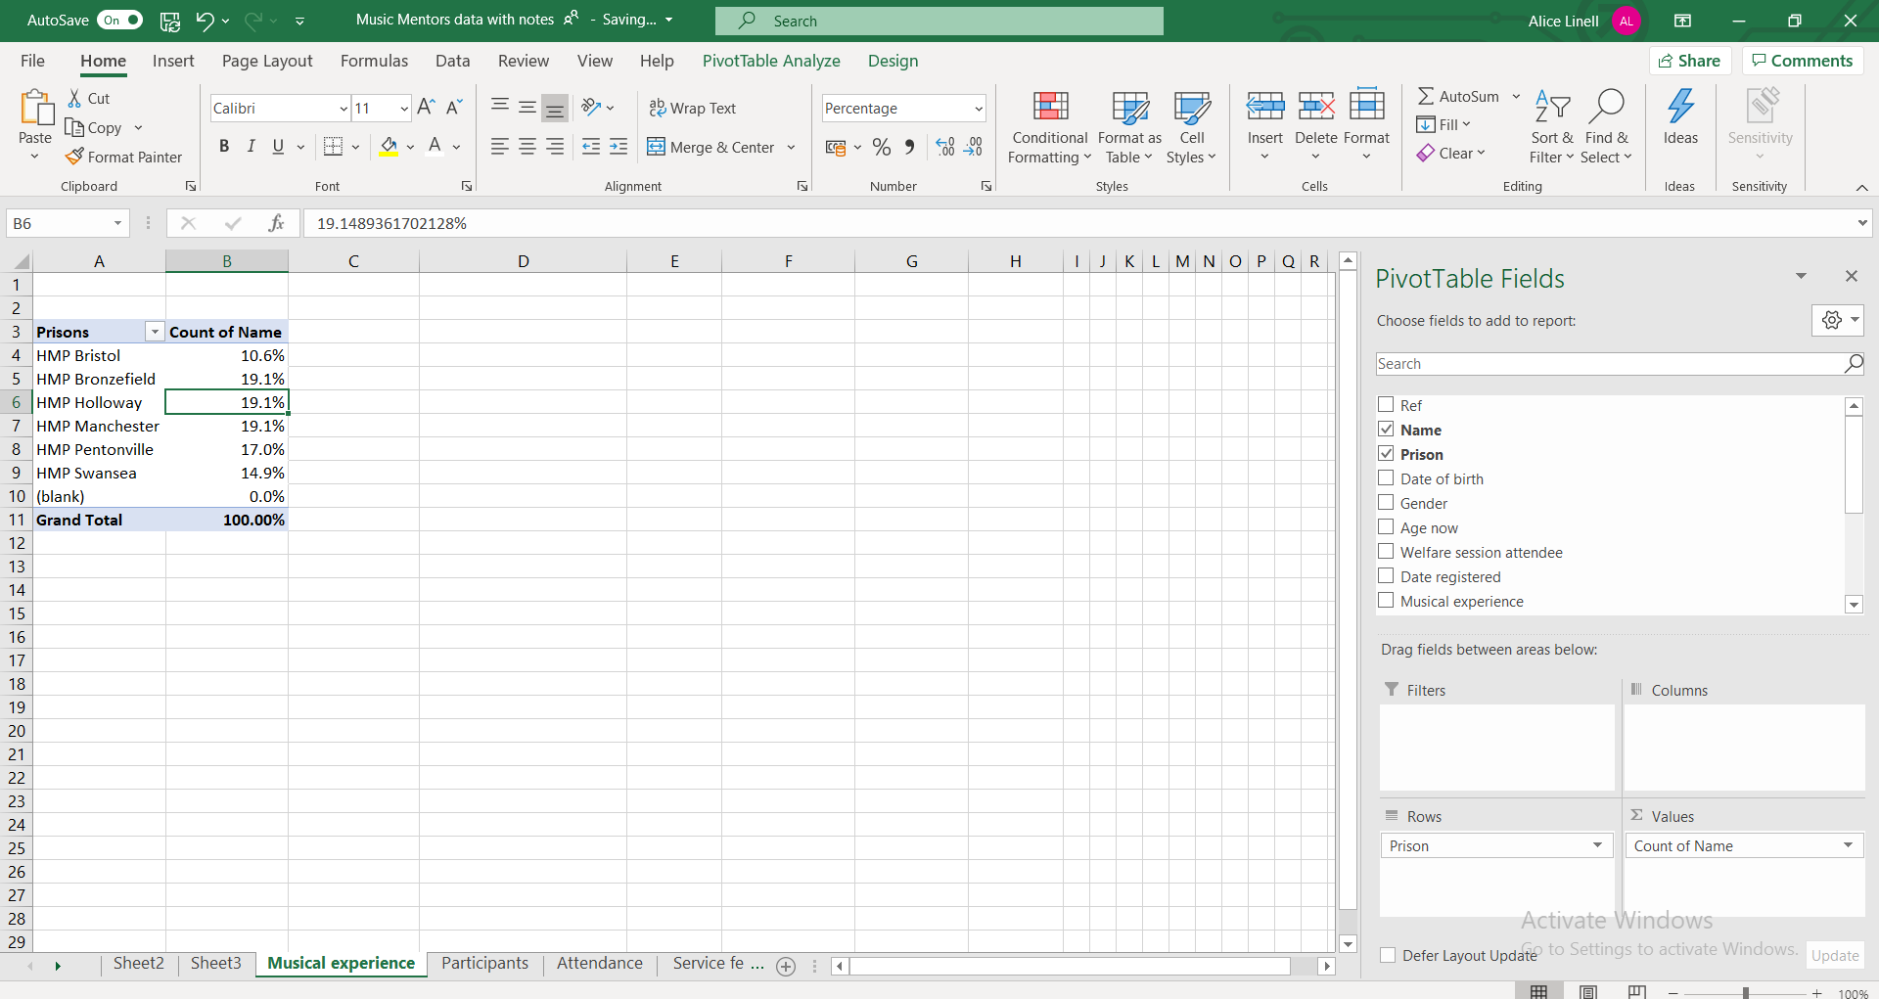
4. Use the Decrease decimal place command button to round numbers.

3. Percentages replace the original numbers

Sorting & Filtering a pivot table
Simple sorting and filtering work exactly the same as elsewhere in Excel.
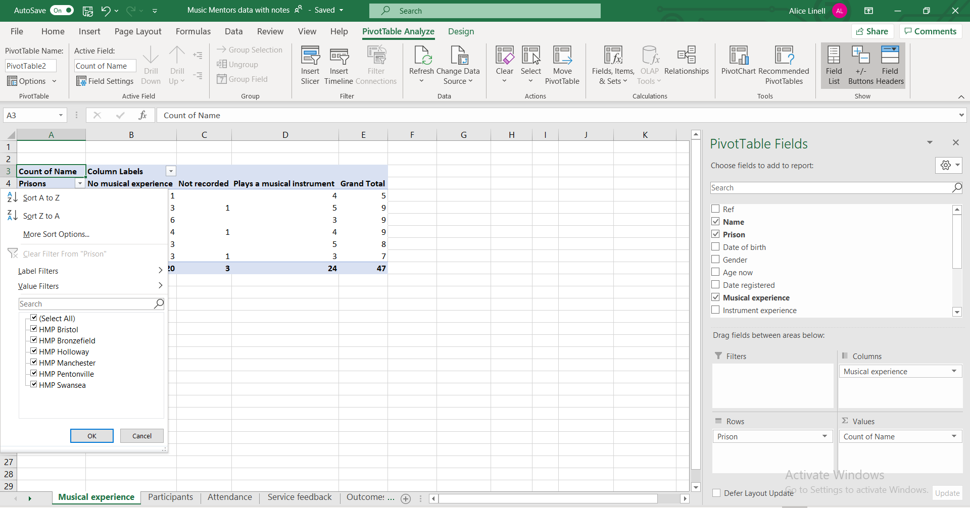
Click next to the row or column heading for sorting and filtering options

Add a Slicer to a pivot table
1. Click on Insert Slicer

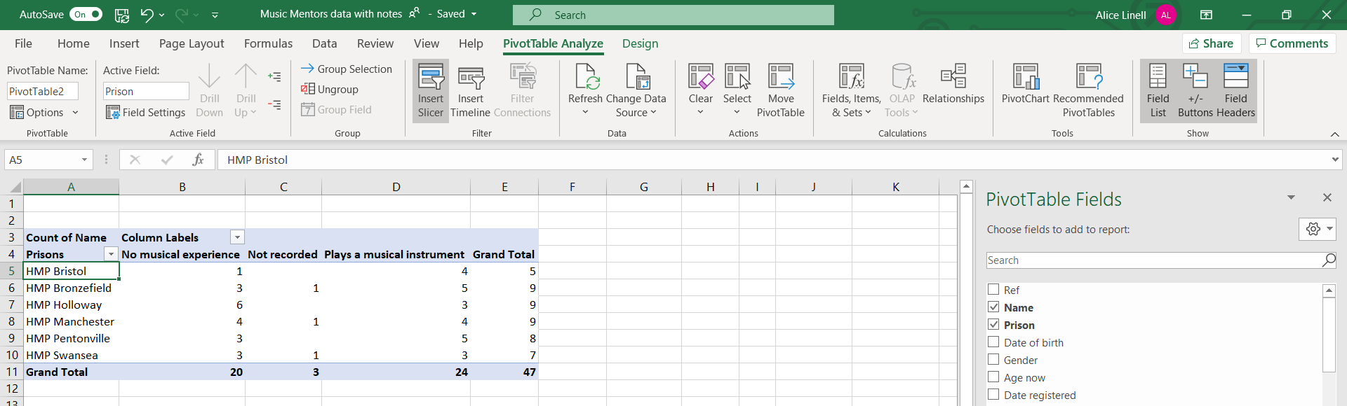

Formatting a pivot table
Like Tables, Pivot Tables can be formatted.
1. Click on the pivot table and then on the Design tab

2. Add and remove specific headers or banding for rows & columns

3. Change the format (colours, banding, outline etc)

Refreshing data in a Pivot table
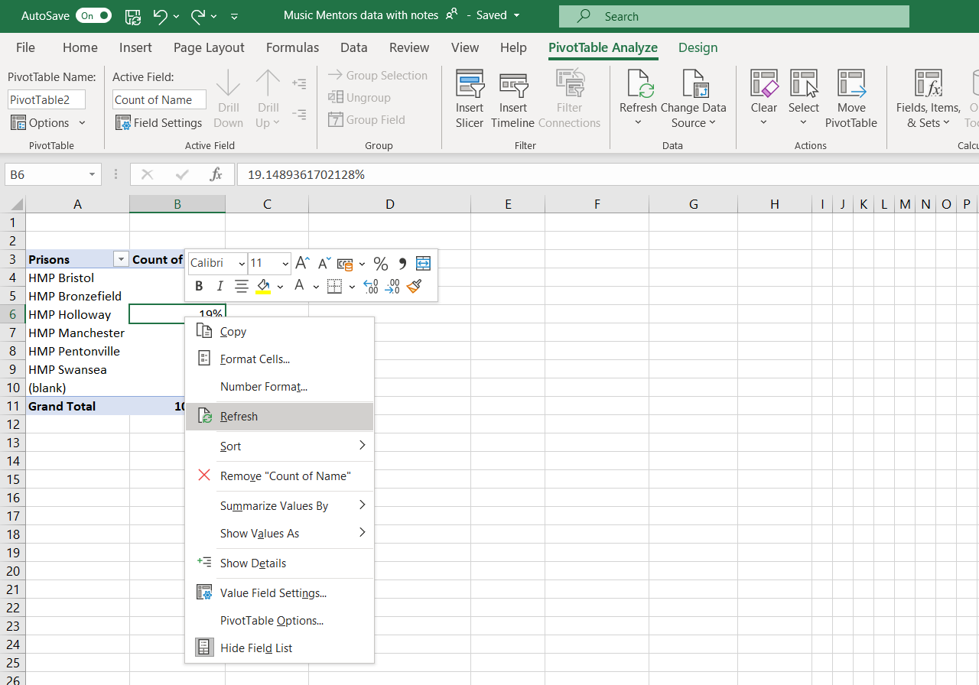
If you make changes to the data set being used to the pivot table, you might need to refresh the chart so that the changes are immediately reflected in the chart.

Recommended Pivot Tables
A short cut to creating pivot tables can be to use the recommended Pivot table function.

Changing value field settings
In pivot tables you can select different types of setting for the values portion of your Pivot table. You can:
- Give the value set a custom (display) name
- Specify how you want to summarise values
- Specify how you want to display values
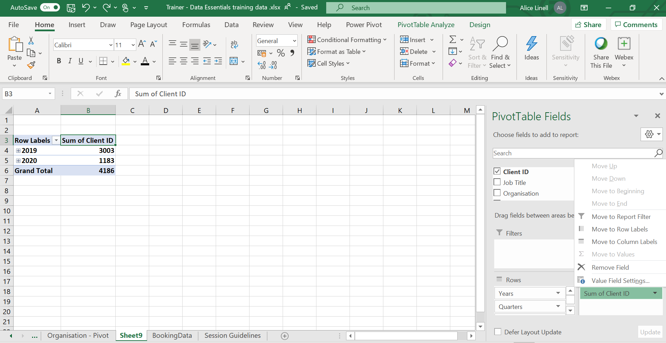
1. Right mouse click on the Value eg Sum of Client ID and select the option Value Field Settings

Custom value name
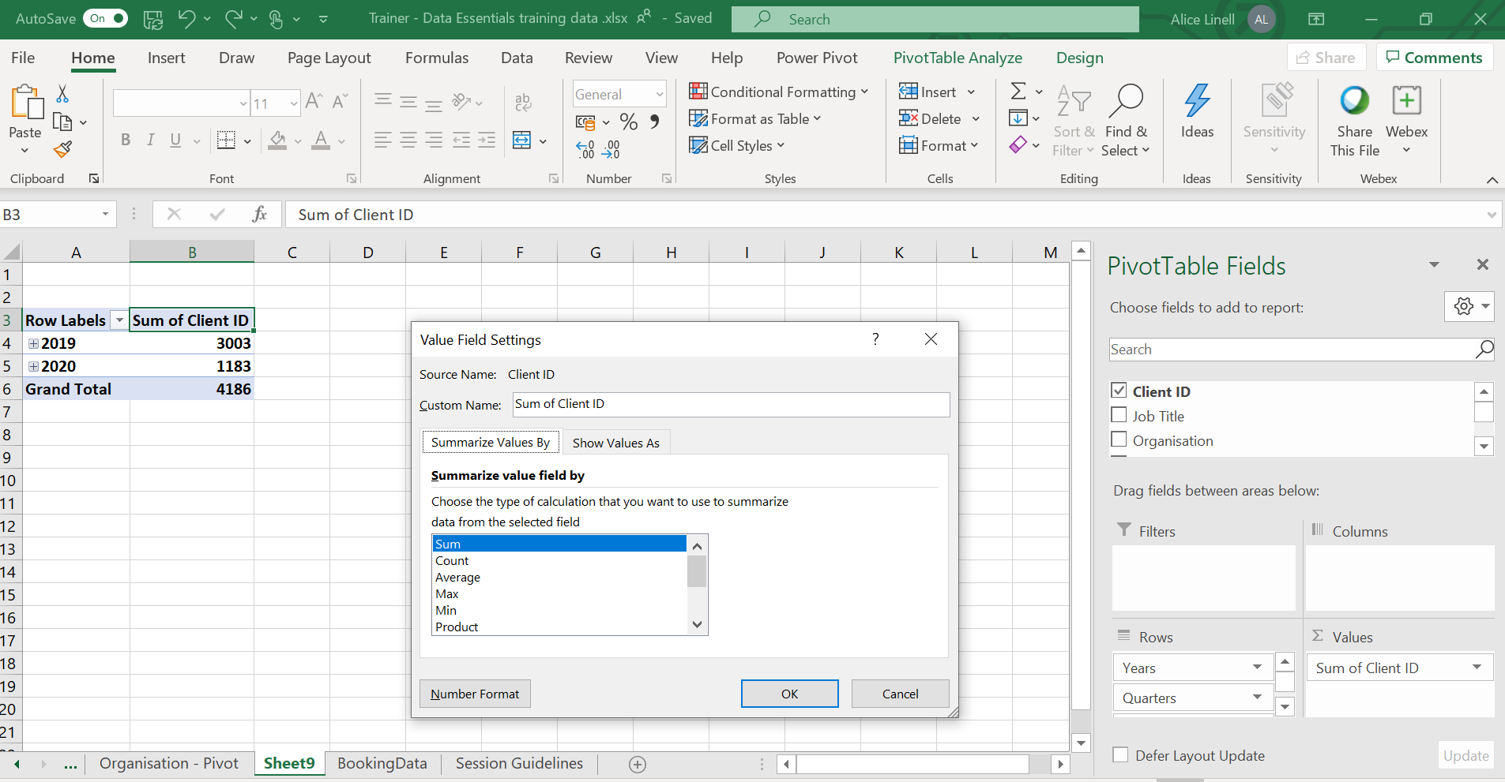
Type in the name you would like to use for the value field.

Summarise values by

2. Select how you want your field summarised
1. Select the tab Summarise Values By
Most common calculations used to summarise data:
Function | Summarizes
Sum | The sum of the values adds all the values in the selected data range. This is the default function for numeric values.
Count | The number of values. The Count summary function works the same as the COUNTA worksheet function. Count is the default function for values other than numbers.
Average | The average of the values. The average is the mean average of the numbers. To calculate: Excel adds up all the numbers, then divides by how many numbers there are. In other words it is the sum divided by the count.
Max | The largest value.
Min | The smallest value.
Product | The product of the values. The product is the result of multiplying the numbers eg the product of 2 and 3 is 6.

Show values As

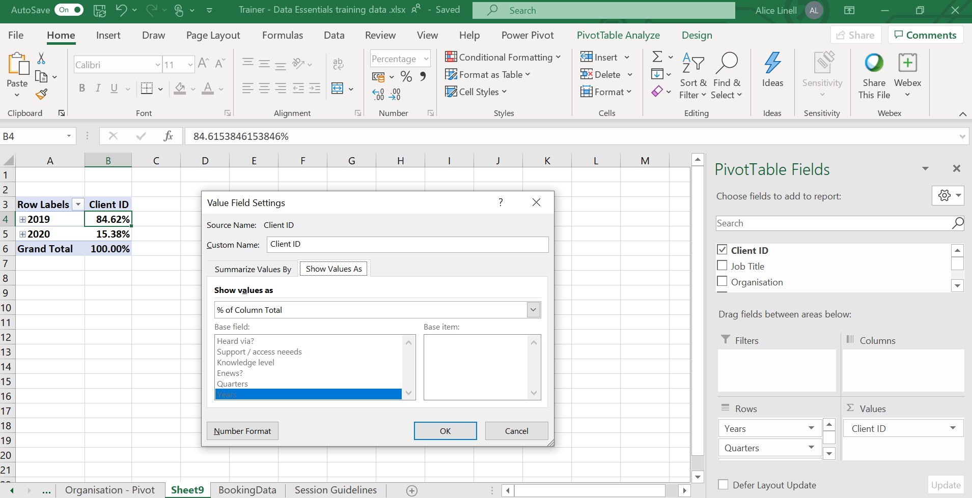
2. Select how you want to display the data
1. Select the tab Show Values As
Most common ways of displaying data:
Use this calculation | To
No calculation | Turn off custom calculation.
% of Column Total | Display all the values in each column or series as a percentage of the total for the column or series.
% of Row Total | Display the value in each row or category as a percentage of the total for the row or category.
Rank smallest to largest | Display the rank of selected values in a specific field, listing the smallest item in the field as 1, and each larger value with a higher rank value. Create a new column for Rank if you want to show the specific amounts too.
Rank largest to smallest | Display the rank of selected values in a specific field, listing the largest item in the field as 1, and each smaller value with a higher rank value. Create a new column for Rank if you want to show the specific amounts too.

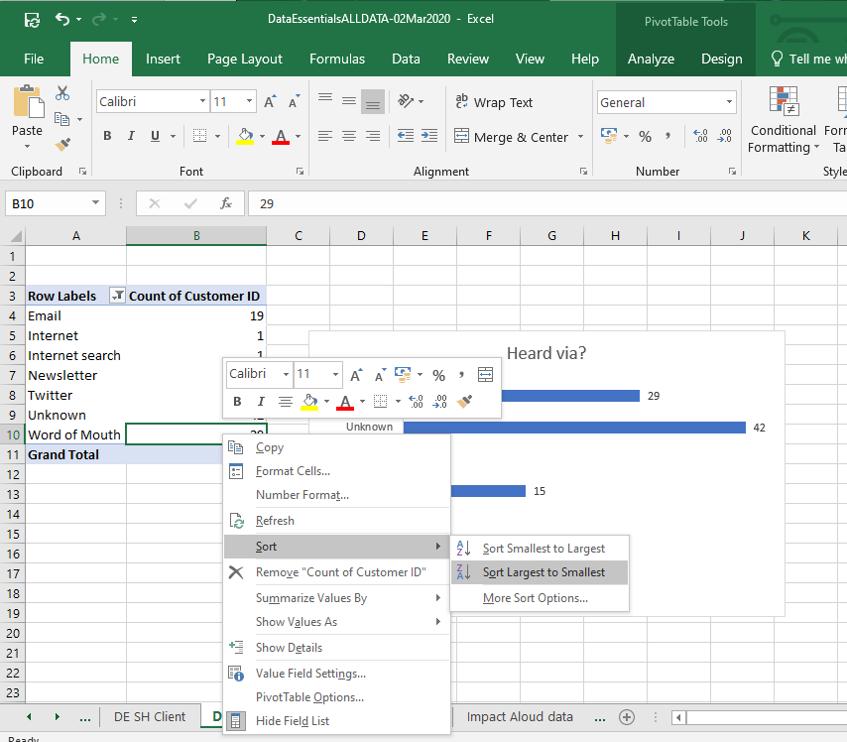
Changing the sort order
More sort options allows you to input a specific sort order
2. Select sort and the sort order you require
1.Right mouse click on a value in the data set you want to sort

Custom sort order
Go to File > Options > Advanced

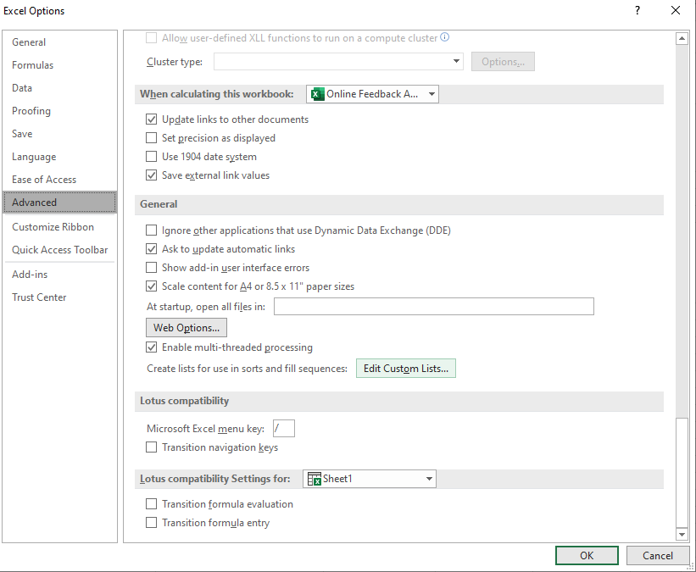
- Select the option Edit Custom Lists

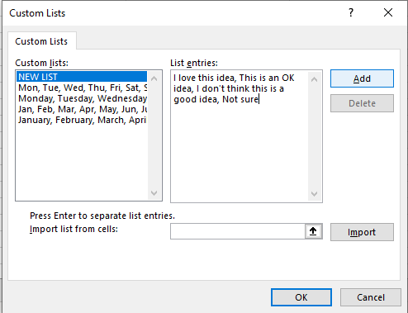
- Click on OK
- Click on Add
- Add your custom sort order separated by commas.
You can also choose to import the values from a range of cells.

Grouping dates

In Excel 2016 forward Excel automatically groups dates by months & quarters. If you are working with an Excel version prior to that or you want to change the automatic grouping you can manually group dates.

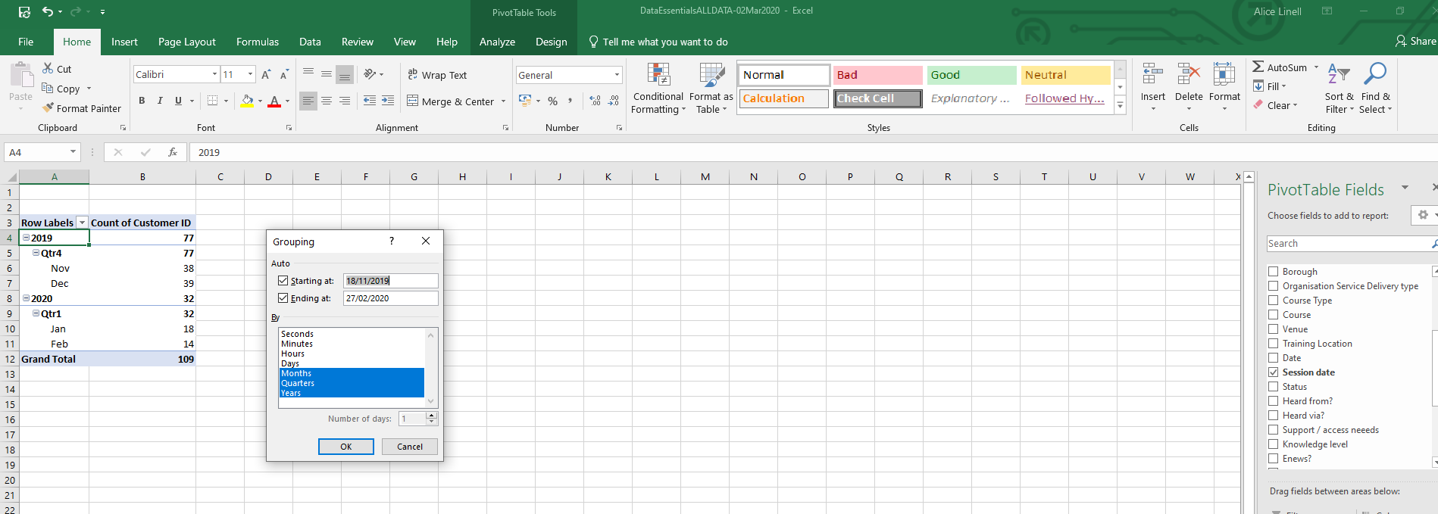
- Select the Grouping you require
- Right mouse click on a date value

Sub totals and Grand totals
- Click Subtotals or Grand Totals to show or not show totals
- Click on the Pivot table


