
Excel Bitesize 3- Analysing your data
Contents
Make your data into a table 4
Name the table 4
Pivot Tables 5
Creating a pivot table 5
Field values 7
Sorting & Filtering a pivot table 8
Add a Slicer to a pivot table 9
Formatting a pivot table 9
Refreshing data in a Pivot table 10
Recommended Pivot Tables 10
Changing value field settings 10
Custom value name 11
Summarise values by 11
Show values As 12
Changing the sort order 14
Custom sort order 15
Grouping dates 16
Sub totals and Grand totals 17
Creating a Pivot table from multiple data sources 17
Formulas & Functions 19
Calculations 19
Sum 19
Average 19
Max 19
Min 19
Formulas & Operators 20
Copying formulas 21
Absolute Cell references 21
Age calculation formula 22
IF formula 22
Count If 22
Anatomy of a Function 23
VLookup 23

Conditional Formatting
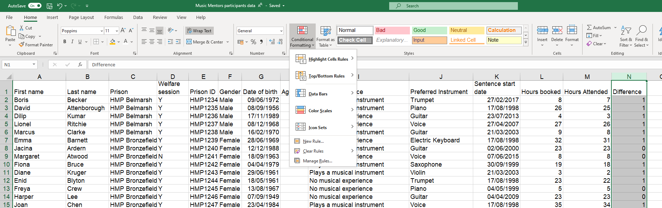
1. Click on the Home tab
2. Highlight the data you want to format and click on Conditional Formatting

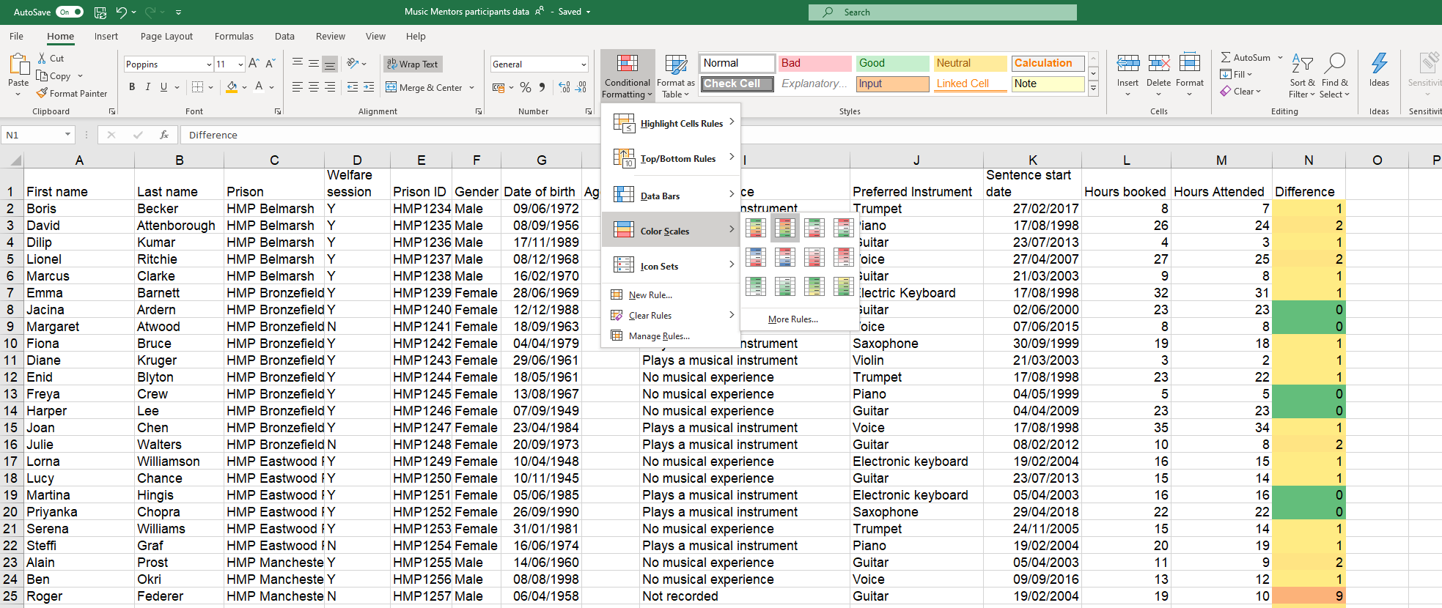
Colour scales
2. Or click on More rules to create your own scale
1. Select a standard colour scale

Applying more rules
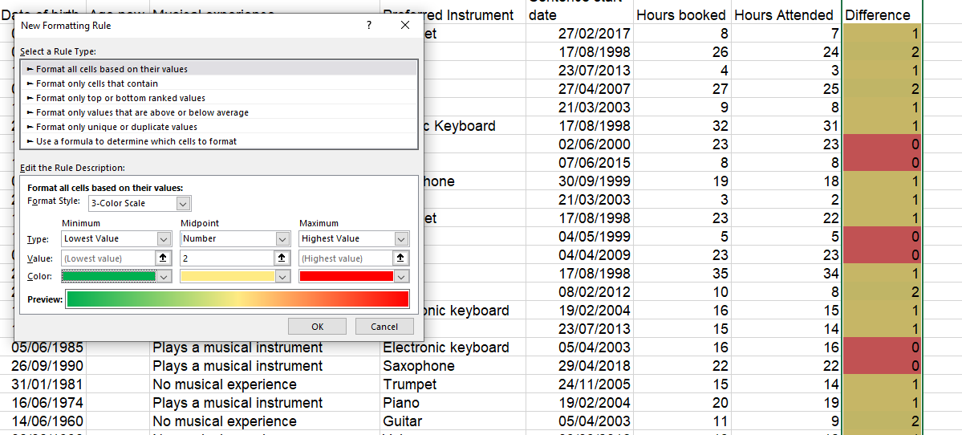
Change colours
Set your own mid- point. In this example, 1 or less will be displayed in green, 2 in yellow gradually moving towards red as the numbers increase

Make your data into a table
2. Click on the Table command button
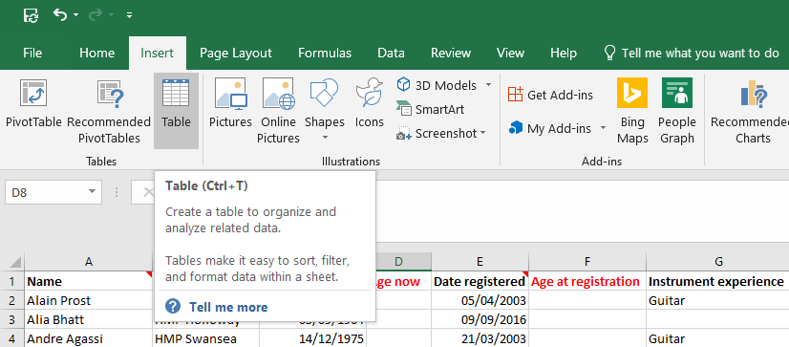
1. Click on the Insert tab
- Alternative shortcut: Ctrl + T
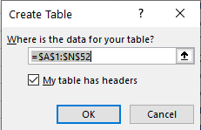
3. A window will open. Confirm the cells to be included in the table and that the data has headers

Name the table
It is good practice to name the table as it makes life much easier later when working with formulas. Naming the formula is basically giving your data set a name which will enable you to recognise which data set you need to be working with.
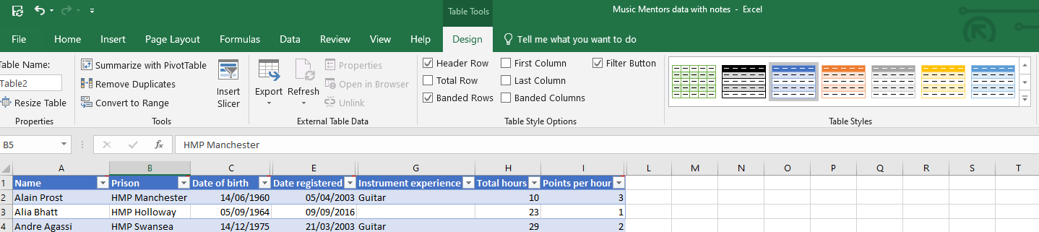
2. Rename the table. For example, “BookingData”
1. Click on the table & select the Design tab

Pivot Tables

Creating a pivot table
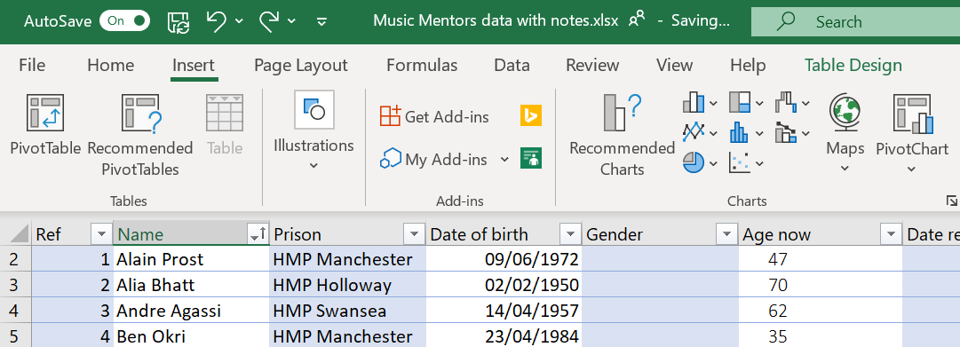
1. Click on the Insert tab
2. Click on Pivot Table

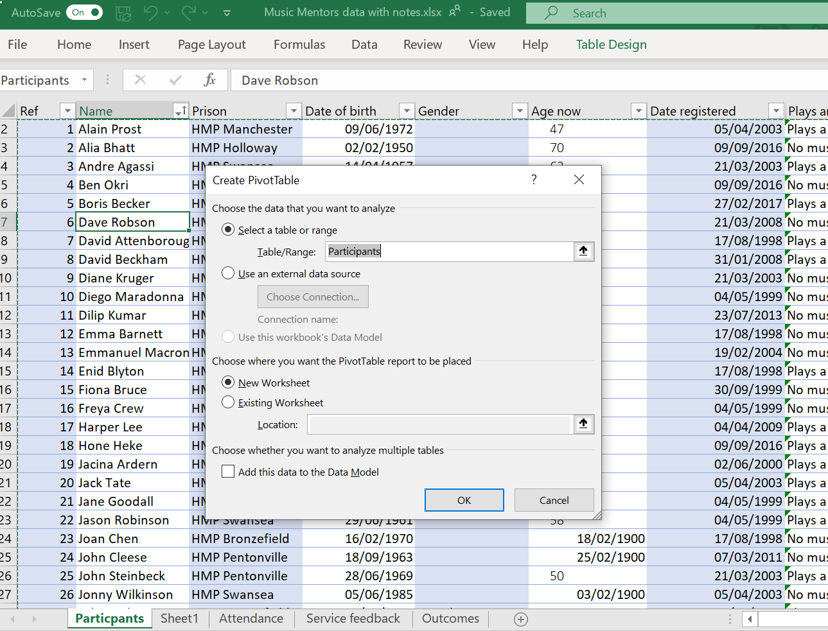
2. Select the table you want to base the pivot table on. Here you can see the table name “participants”. Using a table ensures you have a dynamic data source for your pivot table

3. Select New Worksheet

This will automatically update the table as below, now displaying dates across as columns

5. The columns from your table appear in the fields

4. An empty pivot table is created

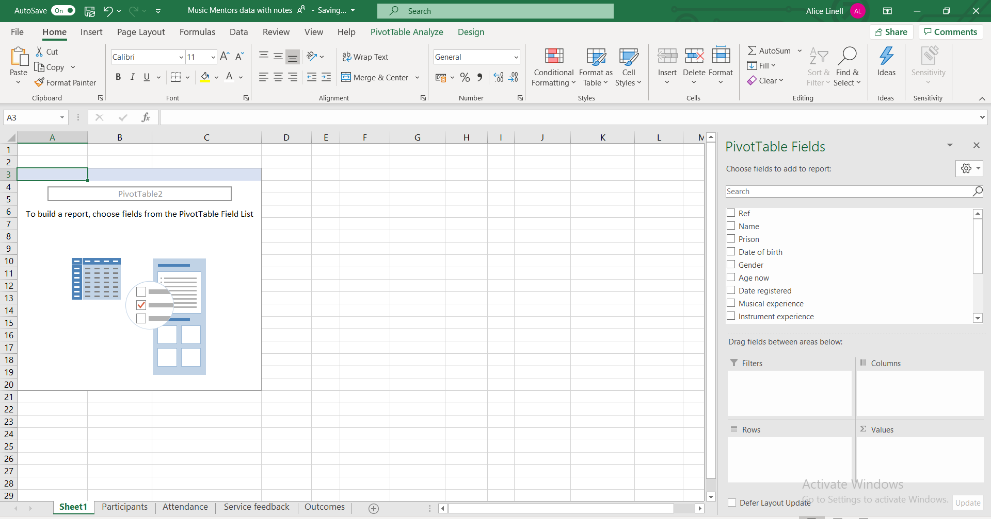
6. To create a simple pivot table that shows the number of prisoners attending sessions from each prison drag and drop the Prison field into the Rows box and the Name field into Values

7. The pivot table now displays how many prisoners attended the music sessions from each prison

8. As the name field is text the pivot table assumes you want to Count the number of records in the Name

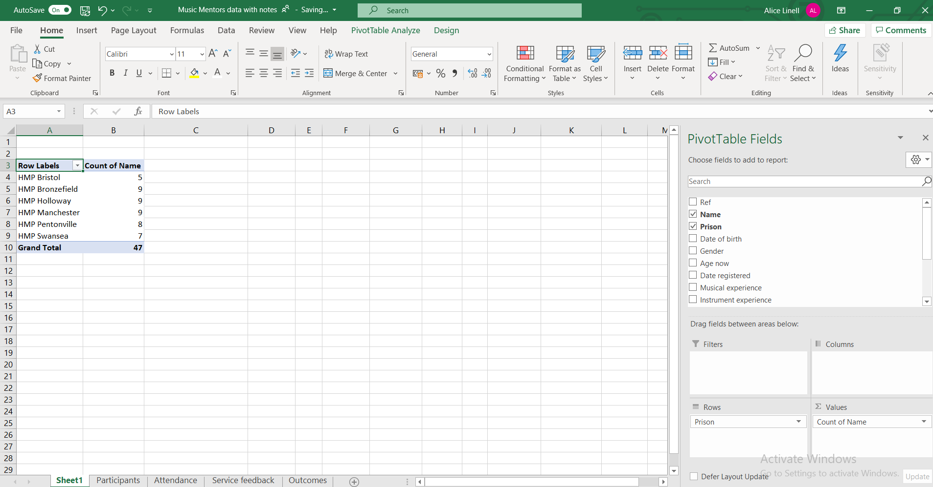

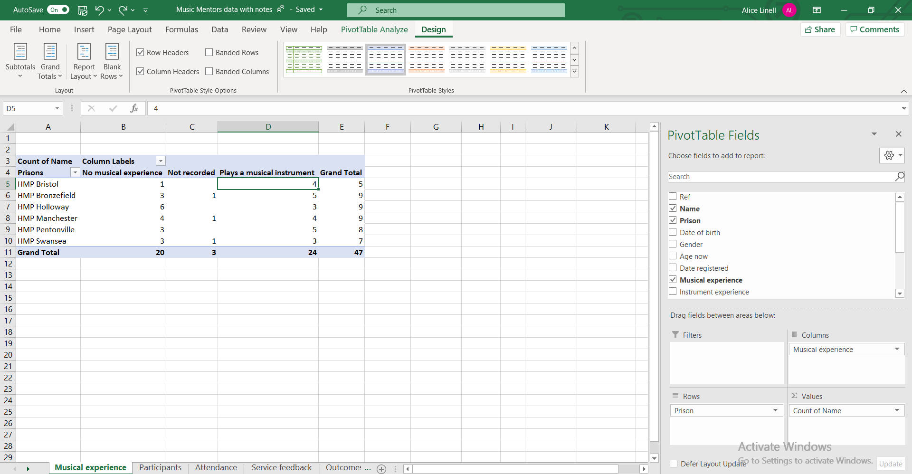
9. Add complexity to your Pivot table. To show how many of the attendees from each prison already had musical experience, add the field Musical experience to the Columns field

Field values
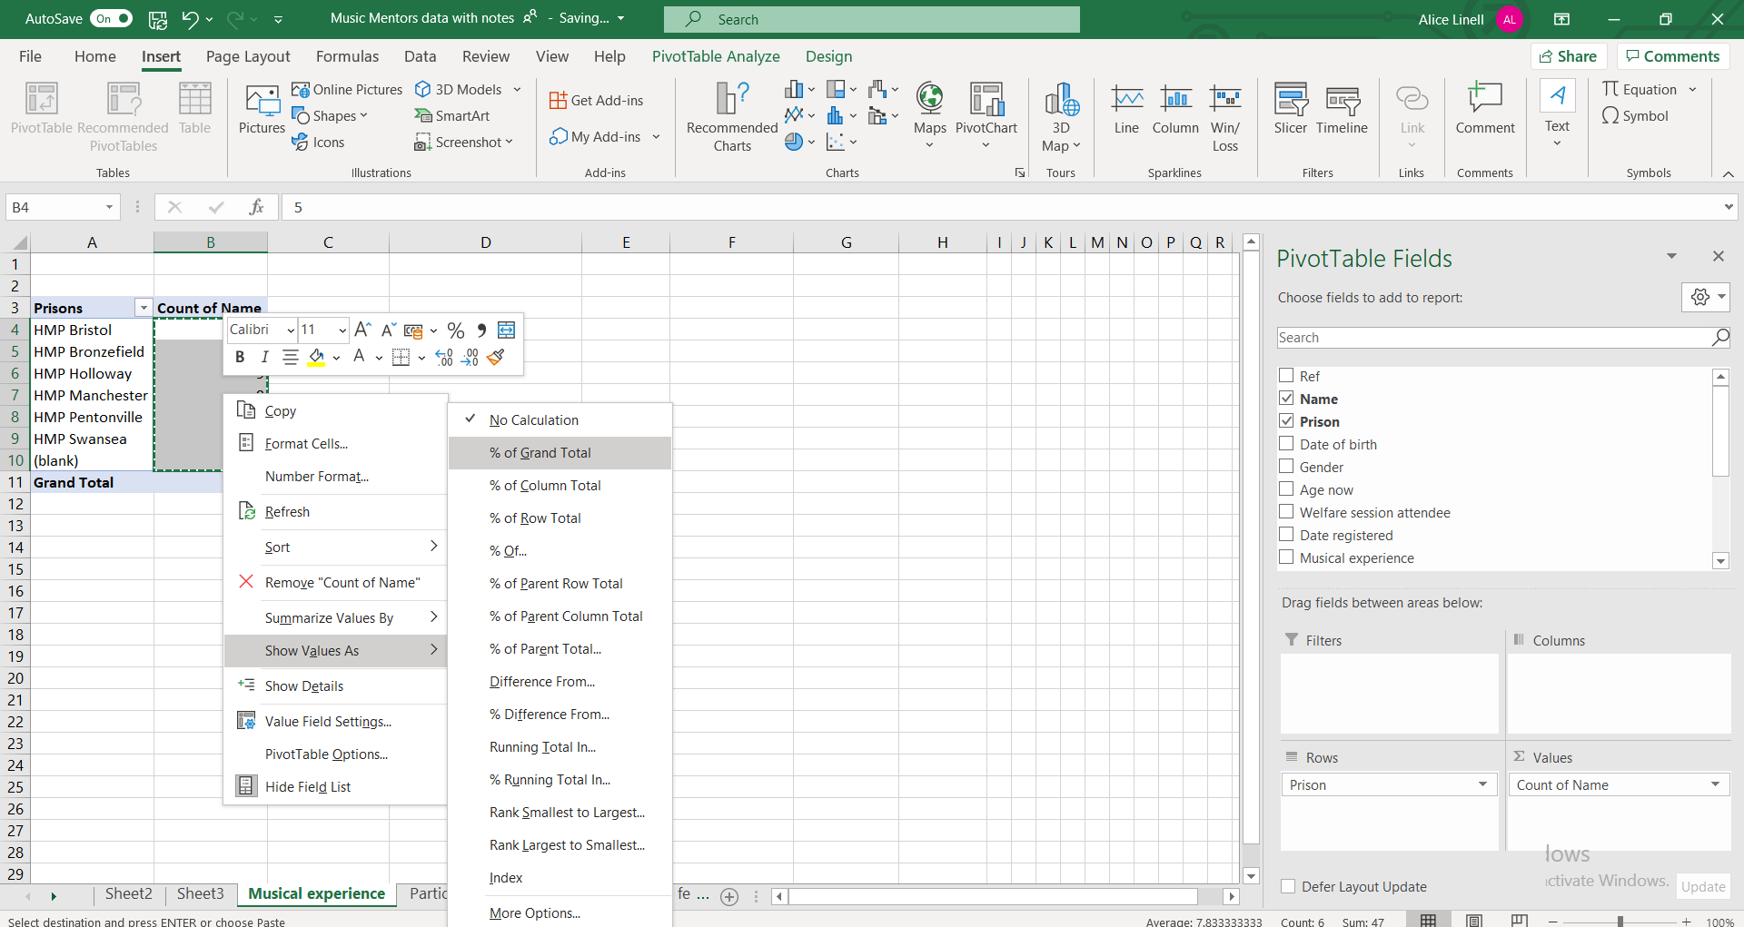
2. Select Show Values As and then % of Grand Total

1.Highlight the fields you want to display as a percentage.

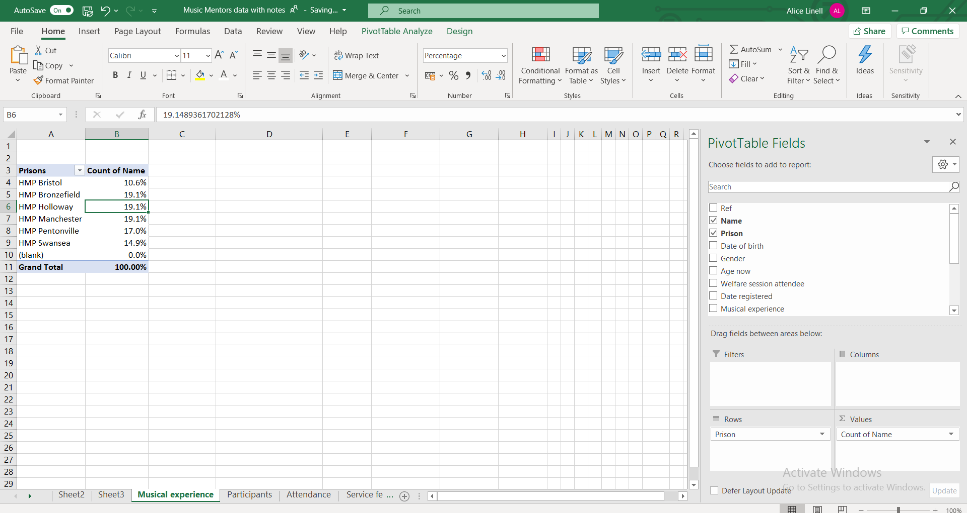
4. Use the Decrease decimal place command button to round numbers.

3. Percentages replace the original numbers

Sorting & Filtering a pivot table
Simple sorting and filtering work exactly the same as elsewhere in Excel.
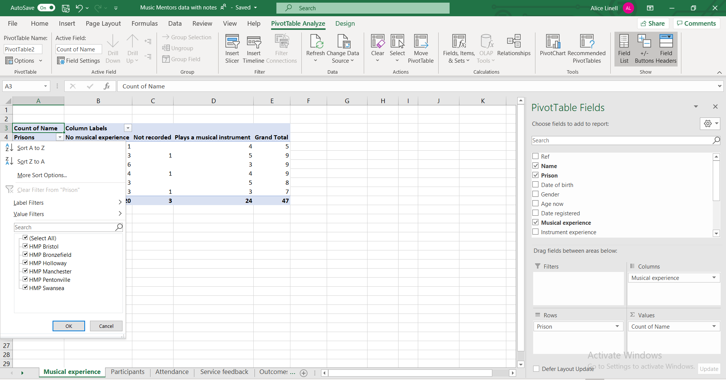
Click next to the row or column heading for sorting and filtering options

Add a Slicer to a pivot table
1. Click on Insert Slicer

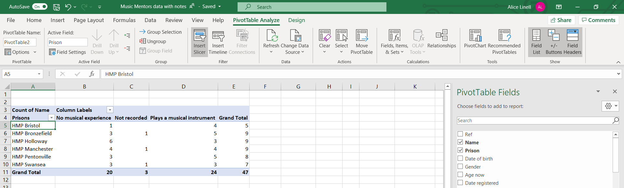

Formatting a pivot table
Like Tables, Pivot Tables can be formatted.
1. Click on the pivot table and then on the Design tab

2. Add and remove specific headers or banding for rows & columns

3. Change the format (colours, banding, outline etc)

Refreshing data in a Pivot table
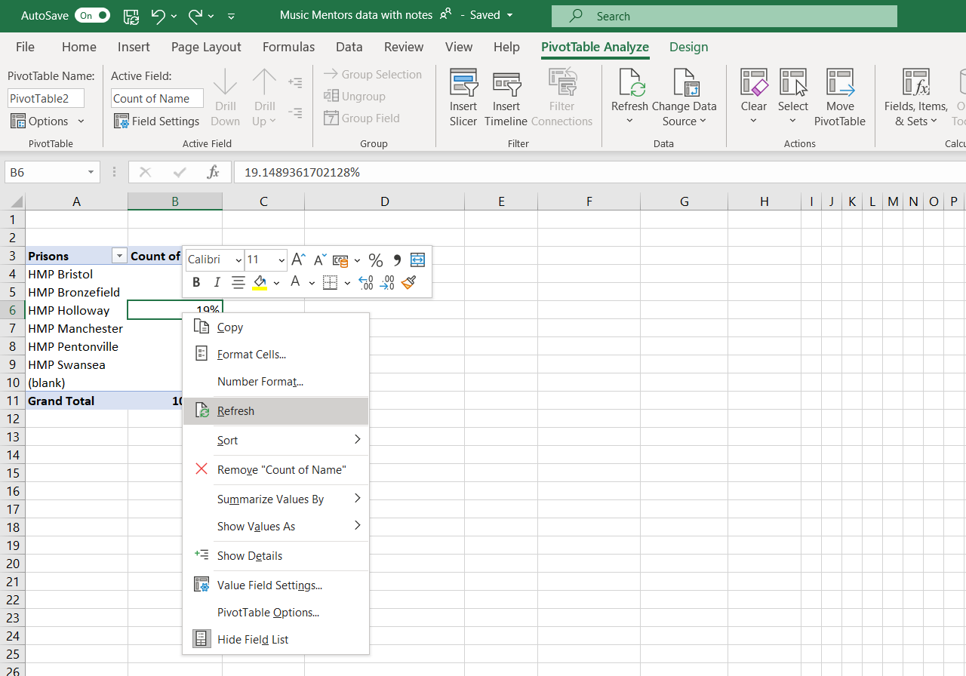
If you make changes to the data set being used to the pivot table, you might need to refresh the chart so that the changes are immediately reflected in the chart.

Recommended Pivot Tables
A short cut to creating pivot tables can be to use the recommended Pivot table function.

Changing value field settings
In pivot tables you can select different types of setting for the values portion of your Pivot table. You can:
- Give the value set a custom (display) name
- Specify how you want to summarise values
- Specify how you want to display values
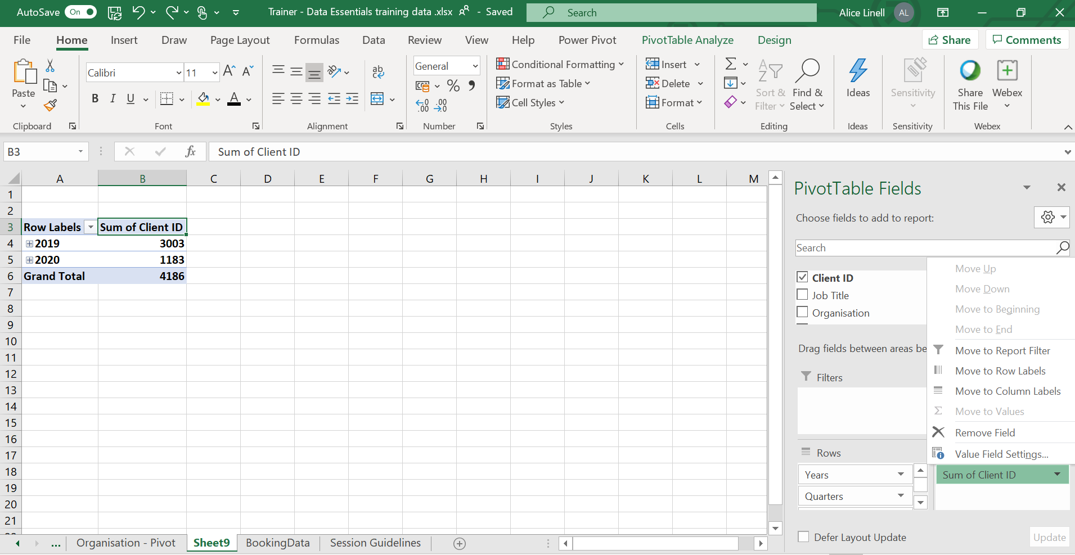
1. Right mouse click on the Value eg Sum of Client ID and select the option Value Field Settings

Custom value name
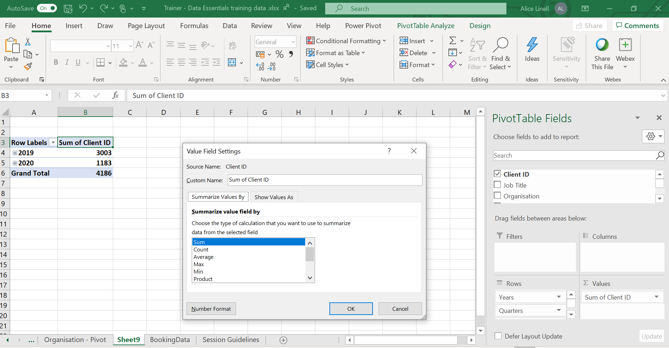
Type in the name you would like to use for the value field.

Summarise values by

2. Select how you want your field summarised
1. Select the tab Summarise Values By
Most common calculations used to summarise data:
Function | Summarizes
Sum | The sum of the values adds all the values in the selected data range. This is the default function for numeric values.
Count | The number of values. The Count summary function works the same as the COUNTA worksheet function. Count is the default function for values other than numbers.
Average | The average of the values. The average is the mean average of the numbers. To calculate: Excel adds up all the numbers, then divides by how many numbers there are. In other words it is the sum divided by the count.
Max | The largest value.
Min | The smallest value.
Product | The product of the values. The product is the result of multiplying the numbers eg the product of 2 and 3 is 6.

Show values As

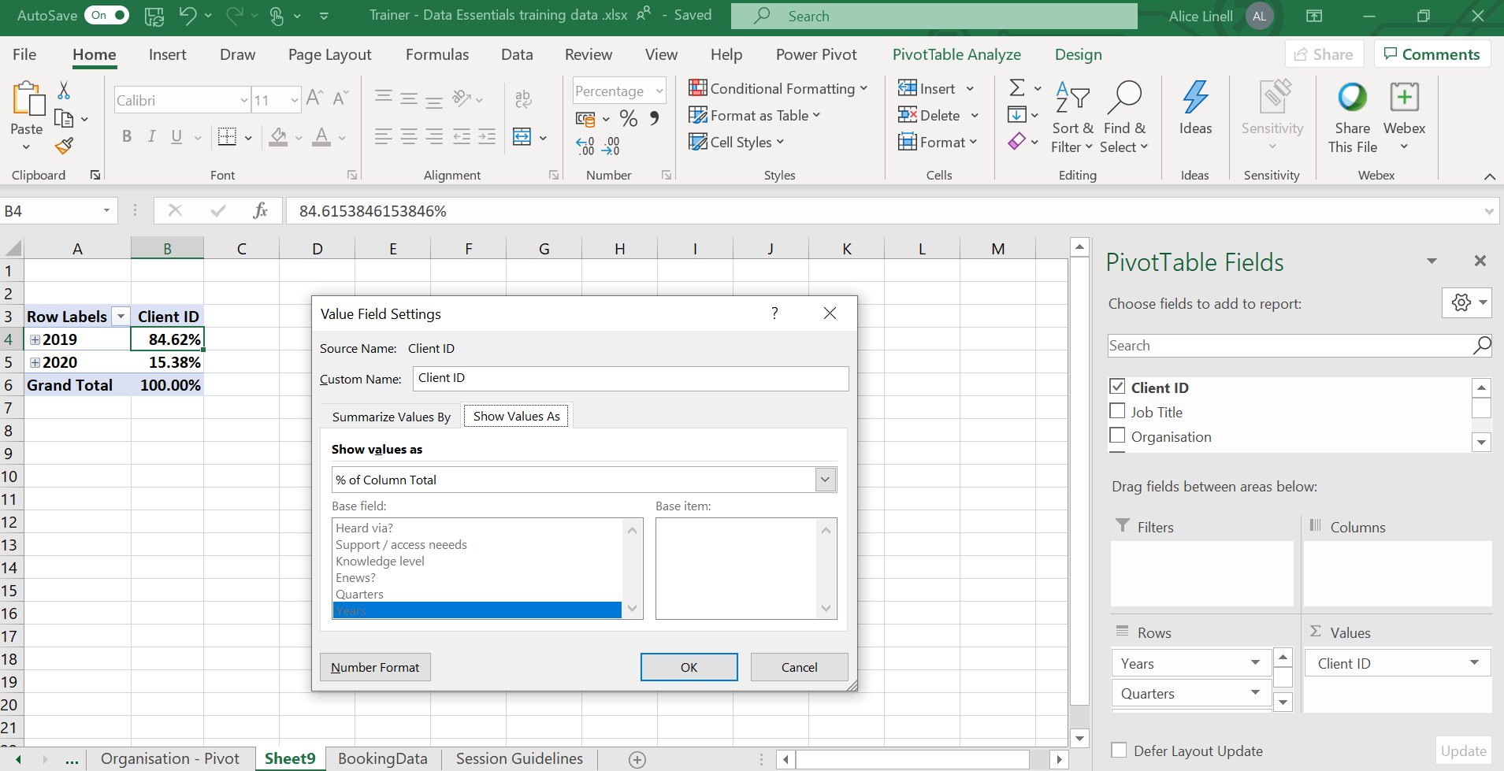
2. Select how you want to display the data
1. Select the tab Show Values As
Most common ways of displaying data:
Use this calculation | To
No calculation | Turn off custom calculation.
% of Column Total | Display all the values in each column or series as a percentage of the total for the column or series.
% of Row Total | Display the value in each row or category as a percentage of the total for the row or category.
Rank smallest to largest | Display the rank of selected values in a specific field, listing the smallest item in the field as 1, and each larger value with a higher rank value. Create a new column for Rank if you want to show the specific amounts too.
Rank largest to smallest | Display the rank of selected values in a specific field, listing the largest item in the field as 1, and each smaller value with a higher rank value. Create a new column for Rank if you want to show the specific amounts too.

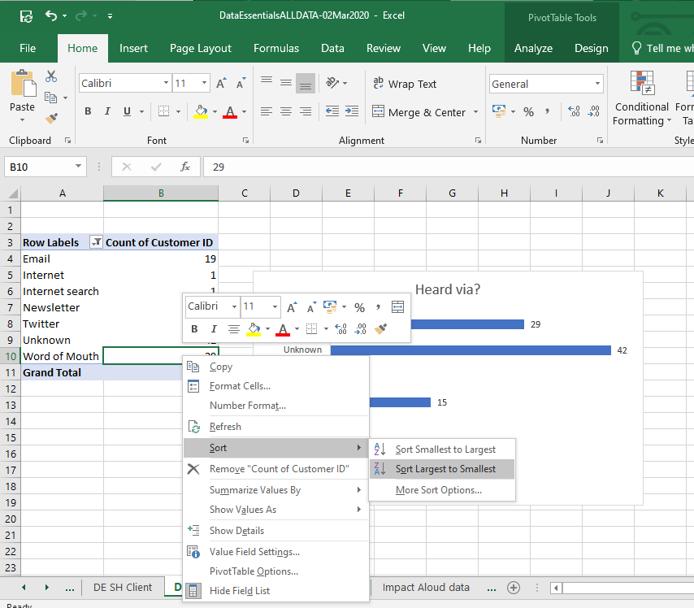
Changing the sort order
More sort options allows you to input a specific sort order
2. Select sort and the sort order you require
1.Right mouse click on a value in the data set you want to sort

Custom sort order
Go to File > Options > Advanced

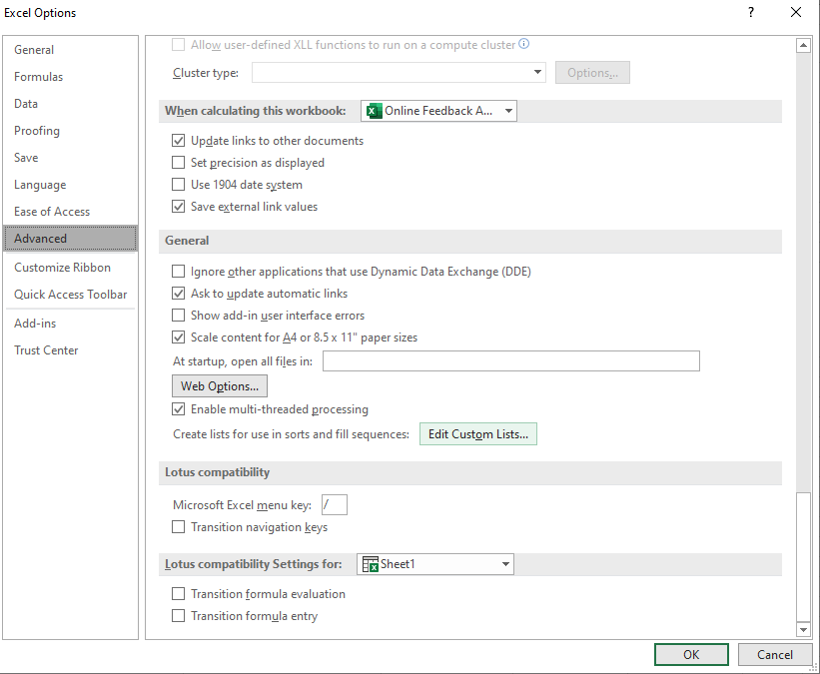
- Select the option Edit Custom Lists

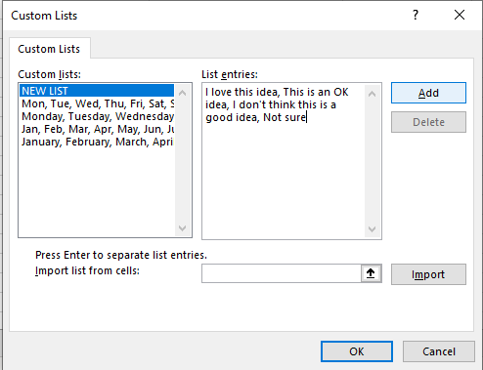
- Click on OK
- Click on Add
- Add your custom sort order separated by commas.
You can also choose to import the values from a range of cells.

Grouping dates

In Excel 2016 forward Excel automatically groups dates by months & quarters. If you are working with an Excel version prior to that or you want to change the automatic grouping you can manually group dates.

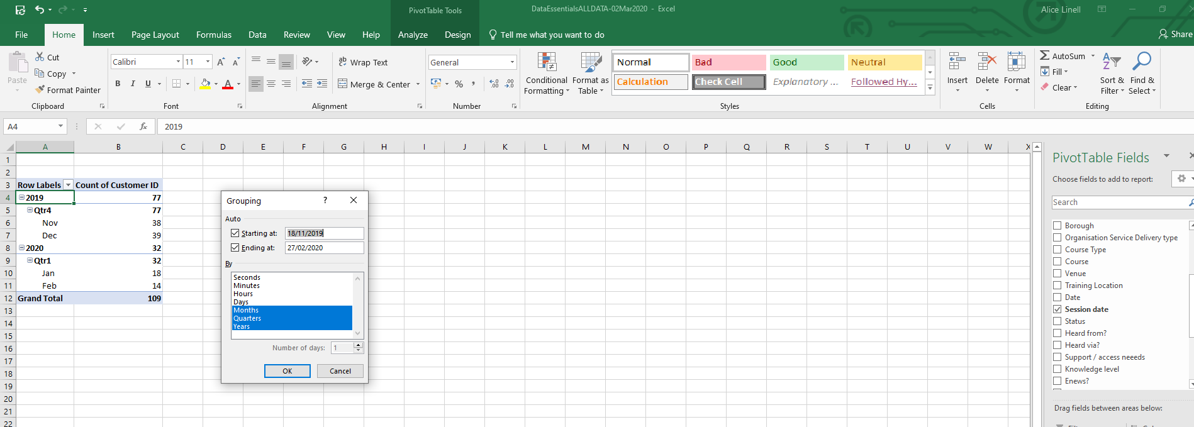
- Select the Grouping you require
- Right mouse click on a date value

Sub totals and Grand totals
- Click Subtotals or Grand Totals to show or not show totals
- Click on the Pivot table
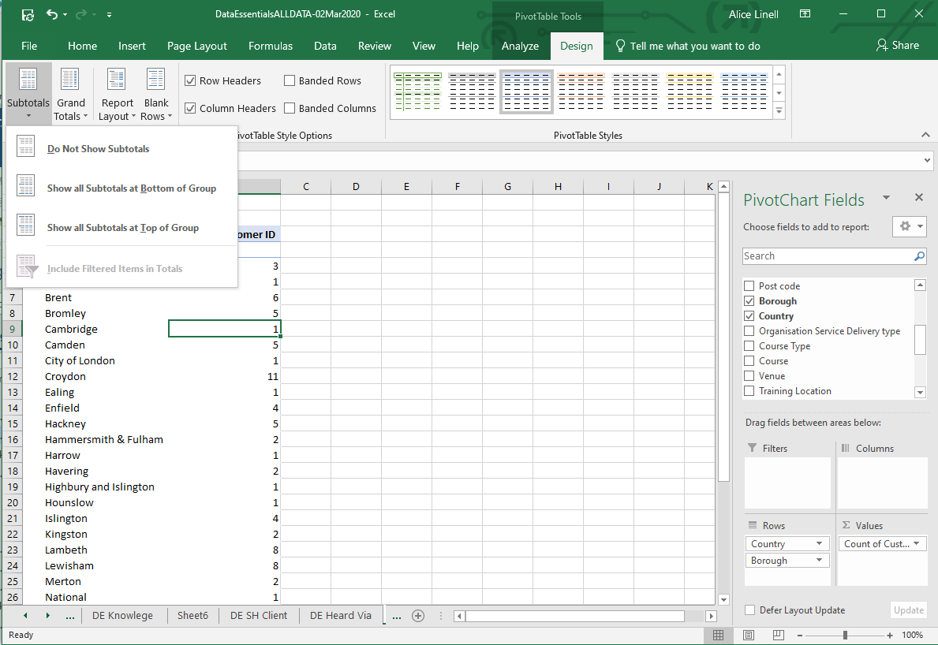

Formulas & Functions

In common business practice, Excel users use the terms formula and function almost interchangeably. From a communication and comprehension perspective, there’s not a big difference. But technically a function is a piece of code that executes a predefined calculation, while a formula is something you create yourself.

Calculations
There 4 most frequently used calculation functions in Excel are:

Sum
Adds up the total value of the cells selected

Average
Returns the mean average of the cells selected. The mean average is calculated by dividing the sum of the values in the set by their number.

Max
Returns the largest or highest value in the cells selected.

Min
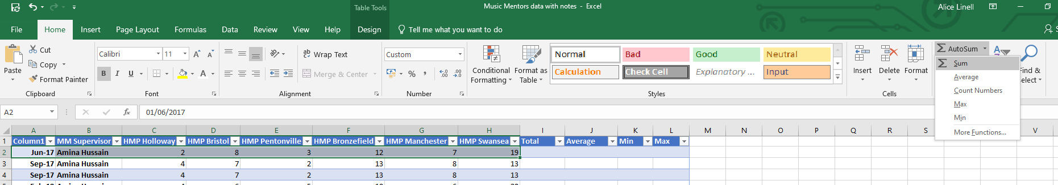
Returns the smallest or lowest value in the cells selected
1. Select the top row of the data you want to calculate
2. Click on the Auto Sum command button. & select the type of calculation you want

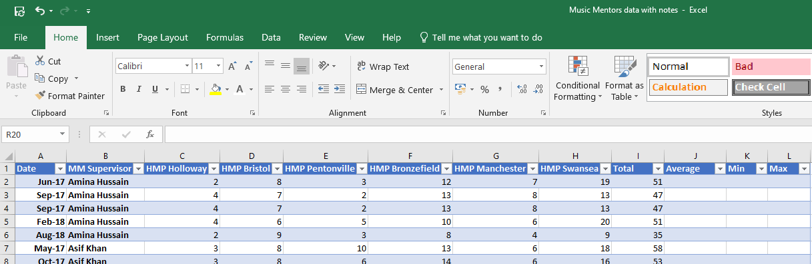
3. Excel calculates the total column for the whole table

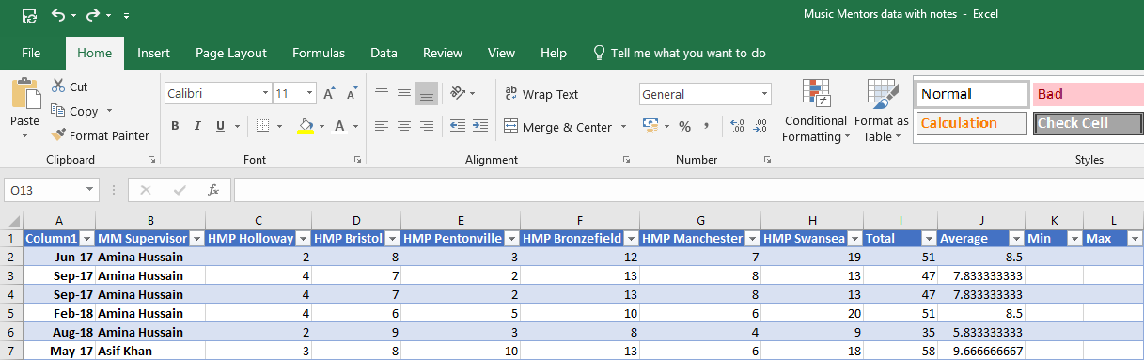
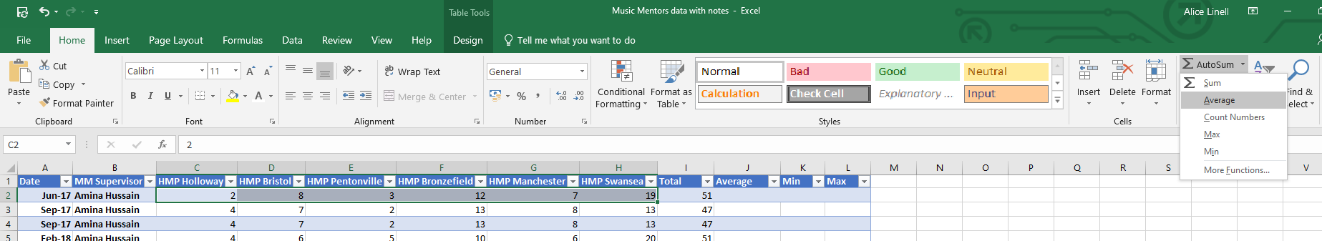
6. Excel automatically puts the next calculation in the next column
7. Use the decimal place command buttons to increase or decrease decimal places
4. If you want to continue adding calculated totals, highlight the data set again.
5. Click on the Auto Sum command button. & select the type of calculation you want

Formulas & Operators
Formulas are built using operators which define what action you want to take.
Common Operators in Microsoft Excel
Plus | +
Minus | -
Multiply | *
Divide | /
Equal to | =
Not Equal to | <>
Greater than | >
Greater than or equal to | >=
Less than | <
Less than or equal to | <=

Always start with an = and then the order of operations is Divide (/) Multipy (*) Add (+) Subtract (-). To ‘force’ Excel to do differently – use Brackets e.g.
5+3*2 = 11
but…
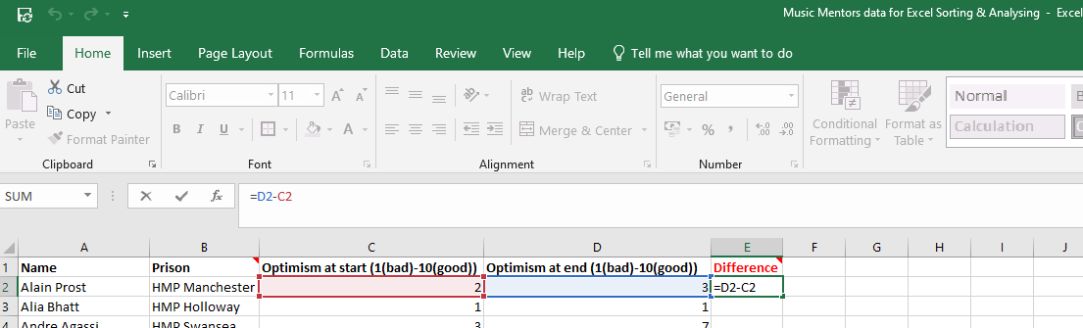
(5+3)*2 = 16
1. Click in the field where you want the formula answer to appear and enter the formula in the formula pane

Copying formulas
Formulas can be copied from one cell to the next by selecting and dragging the highlighted field down.

Absolute Cell references
Sometimes, instead of your formulae automatically updating its references as you copy down / across on a spreadsheet – you may want to include a fixed element in your calculations.
To do this use the $ operator before the letter and number cell reference e.g. $A$D

Age calculation formula
Here is the formula for calculating a person’s age from their date of birth. The D2 in this formula applies to the D2 cell reference in the screen print below, the first date of birth cell in our Date of birth column. To adapt the formula for your data copy the formula into the first cell in your age column and replace the highlighted D2 with the first cell reference in your date of birth column
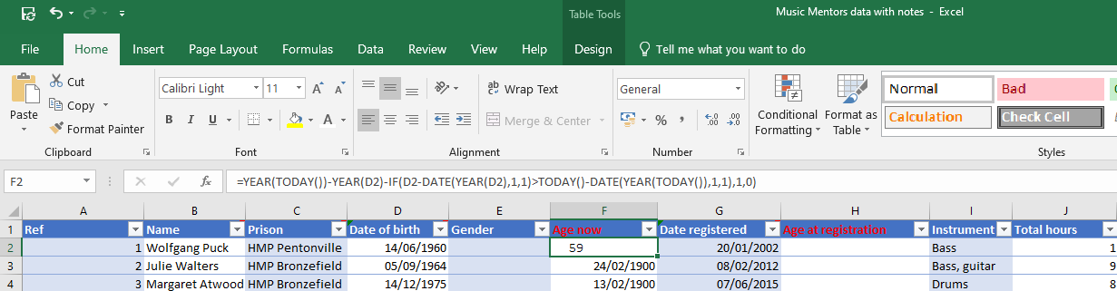
=YEAR(TODAY())-YEAR(D2)-IF(D2-DATE(YEAR(D2),1,1)>TODAY()-DATE(YEAR(TODAY()),1,1),1,0)

IF formula
The IF formula checks whether a condition is met and returns one value if True and another if False
In the example below, if a 2 point increase in optimism, as shown by the Difference column meant your target was met you could use the following formula to return if the target was met or not:
If(E2<2,”No”,”Yes”)
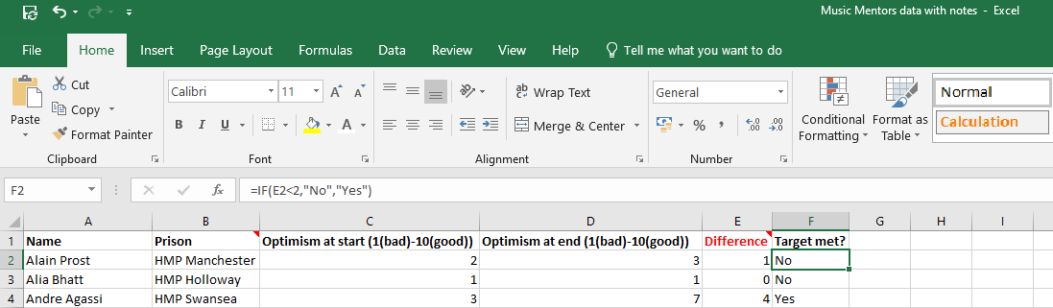

Anatomy of a Function
Excel functions comprise of the function name and arguments, as you can see in the example below:
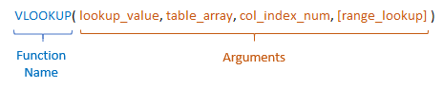

The arguments are the inputs required by the function and are enclosed in parentheses.
Arguments surrounded by square brackets are optional. For example, the VLOOKUP argument; ‘range_lookup’, is optional.
In some cases, if you omit optional arguments Excel will apply a default. This default will be specific to each function.

Count If
In its simplest form, COUNTIF says:
=COUNTIF(Where do you want to look?, What do you want to look for?)
For example:
=COUNTIF(A2:A5,“HMP Belmarsh")
=COUNTIF(A2:A5,A4)
When using tables the cell range can be replaced with the table column:
=COUNTIF(Attendance!C:C,Summary!A4)

VLookup
In its simplest form, the VLOOKUP function says:
=VLOOKUP(What you want to look up, where you want to look for it, the column number in the range containing the value to return, return an Approximate (True) or an Exact match (False))
For Example:
=VLOOKUP(A4,'Prison info’!$A$1:$F$10,6,FALSE)
Will look for the contents of A4 in the range A1 to F10 ($ sign keeps that range fixed) and if it finds a match it will return the value in column 6 for that match. The False means the match must be exact.
Tip 1 : The secret to VLOOKUP is to organize your data so that the value you look up (Prison name) is to the left of the return value (Mentors) you want to find.ate or Exact match – indicated as 1/TRUE, or 0/FALSE).
Tip 2: The range of cells given needs to include the look up value and the value you want returned
Tip 3: Don’t forget about absolute cell references $

