
Excel Bitesize 4- Analysing survey results
Contents
Make your data into a table 3
Name the table 3
Get & Transform data 4
Use a Power Query to Unpivot data (version 1 for tabular data) 4
Use a Power Query to Unpivot data (version 2 for delimited data) 6
What is a delimiter in Excel? 6
Pivot Tables 9
Creating a pivot table 9
Field values 11
Sorting & Filtering a pivot table 12
Sort by count of values 13
Add a Slicer to a pivot table 14
Formatting a pivot table 14
Refreshing data in a Pivot table 15
Recommended Pivot Tables 15
Changing value field settings 15
Custom value name 16
Summarise values by 16
Show values As 18
Changing the sort order 19
Custom sort order 20
Grouping dates 21
Sub totals and Grand totals 22
Open text questions 22
Exercises 23
Multiple Choice Survey Questions 23
Open text question exercises 24

Make your data into a table
2. Click on the Table command button
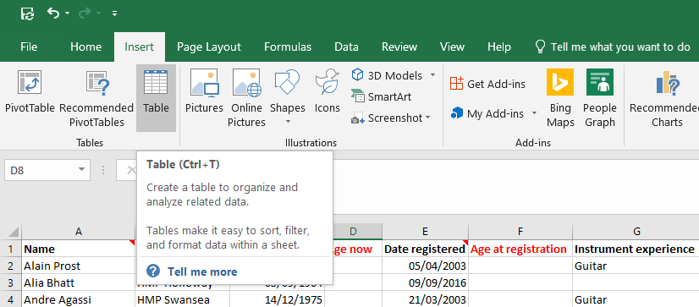
1. Click on the Insert tab
- Alternative shortcut: Ctrl + T
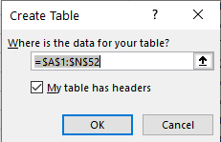
3. A window will open. Confirm the cells to be included in the table and that the data has headers

Name the table
It is good practice to name the table as it makes life much easier later when working with formulas. Naming the formula is basically giving your data set a name which will enable you to recognise which data set you need to be working with.
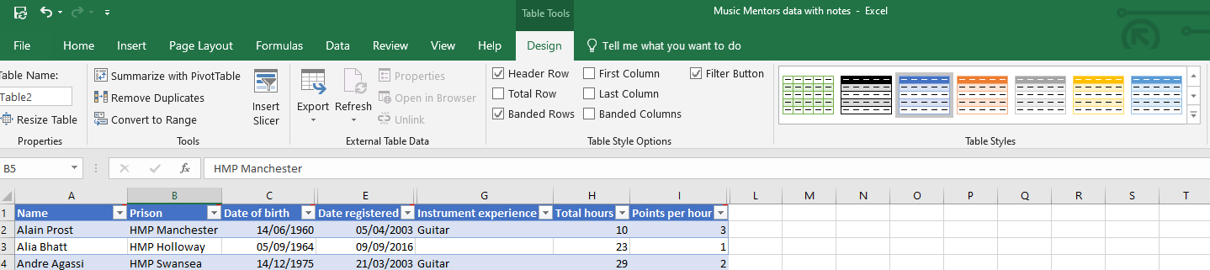
2. Rename the table. For example, “BookingData”
1. Click on the table & select the Design tab

Get & Transform data
Power Query will always create the attribute-value pair by using two columns:
Attribute The name of the column headings that were unpivoted.
Value The values that were underneath each of the unpivoted column headings.

Use a Power Query to Unpivot data (version 1 for tabular data)
Before starting, put the data you want to transform into a Table (see section above for instructions).
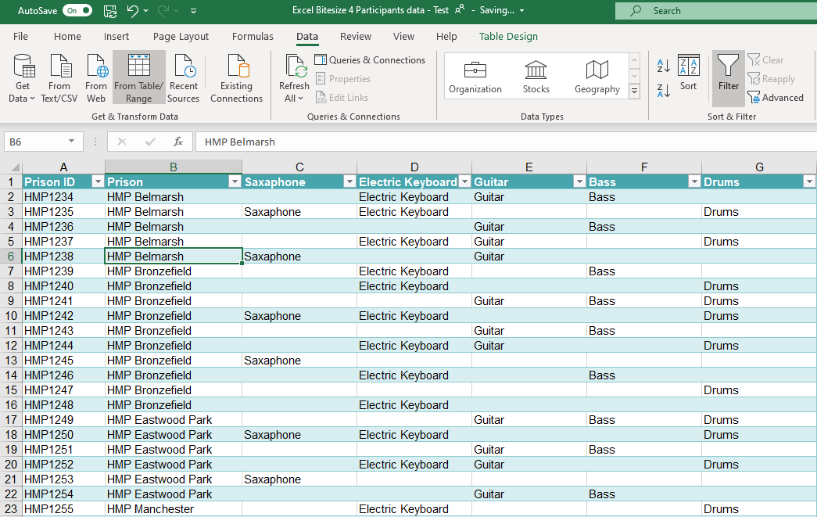
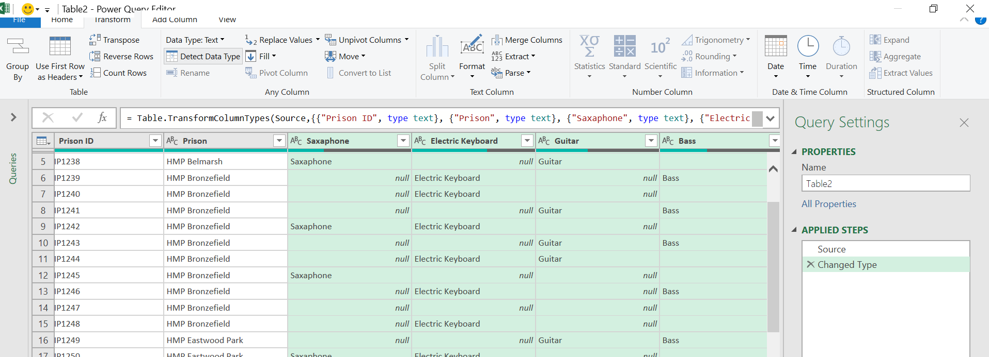
1. Click on From Table/Range to create a query & open the Power Query Editor
1. In the Power Query Editor, select the Transform tab
2. Select the columns you want to unpivot (hold down the shift key to select multiple columns)
3. Click on Unpivot Columns

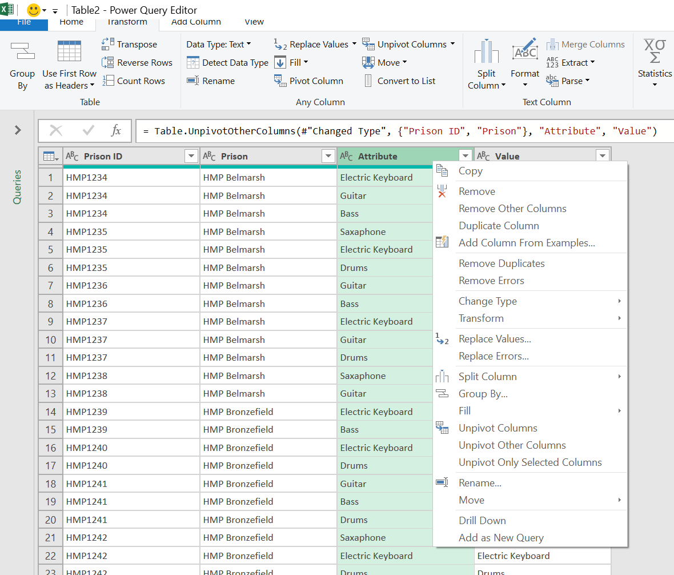
4. Highlight the column, right-mouse click and select Remove
Attribute column = the possible values or column headings.
This column can be deleted as we do not need it.

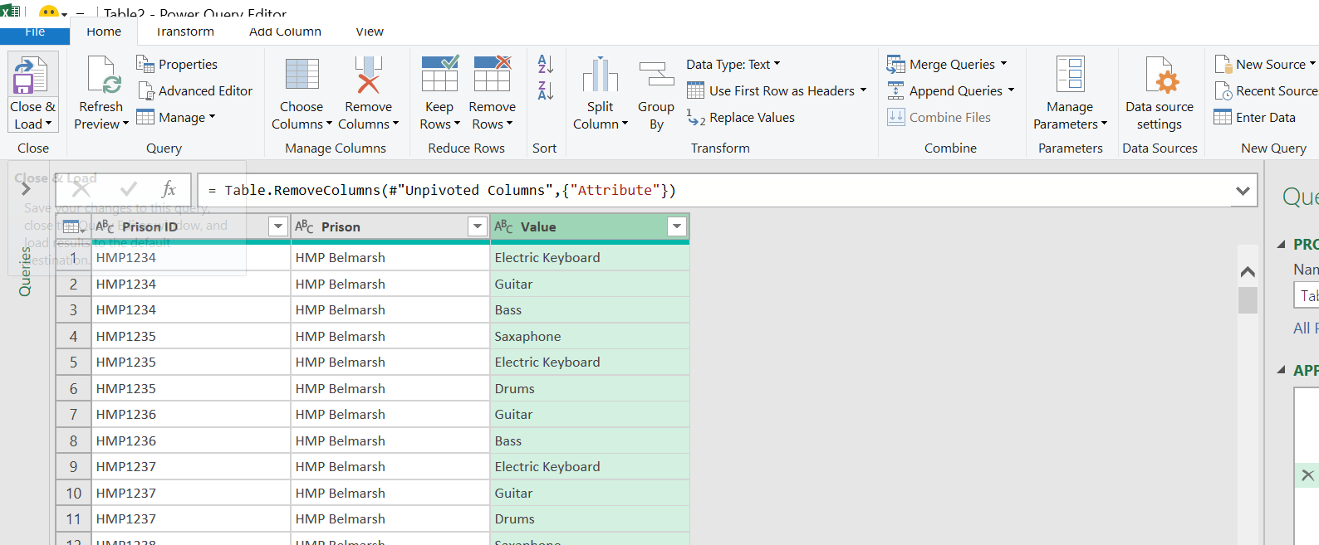
5. Return to the Home tab
6. Click on Close & Load to save the query and return the results to a new worksheet

The results will appear as a table in a new worksheet and you are now ready to use a Pivot table to analyse the data.

Use a Power Query to Unpivot data (version 2 for delimited data)

What is a delimiter in Excel?
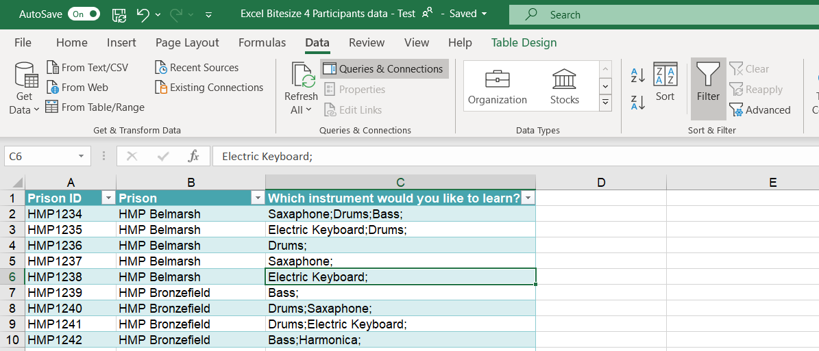
A delimiter is one or more characters that separate text strings. Common delimiters are commas (,), semicolon (;), quotes ( ", ' ), braces ( {}), pipes (|), or slashes ( / ). When a program stores sequential or tabular data, it delimits or separates each item of data with a predefined character.
2. Click on From Table/Range to create a query & open the Power Query Editor
- Click on the Data tab
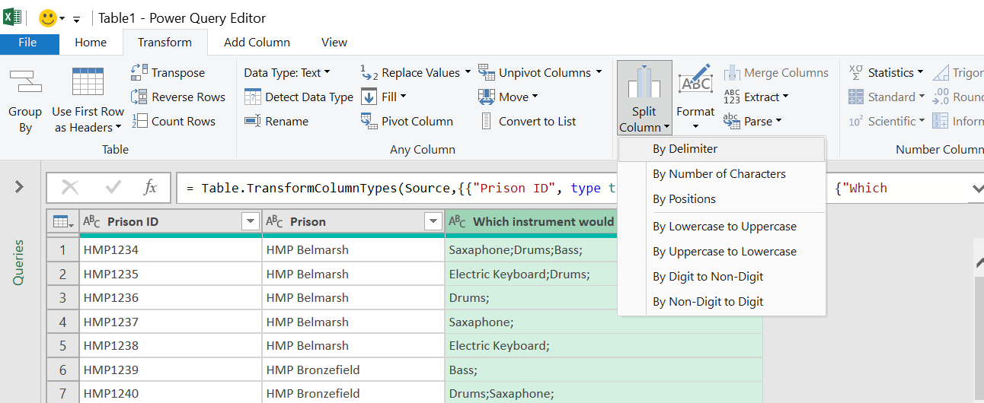
3.Click on the Transform tab
4.Highlight the column you want to unpivot
5.Select By Delimiter from the Split Column dropdown menu
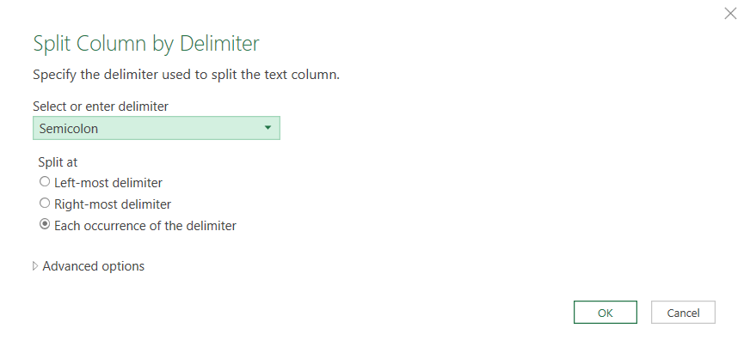
6.Select the type of delimiter
7.Click on OK

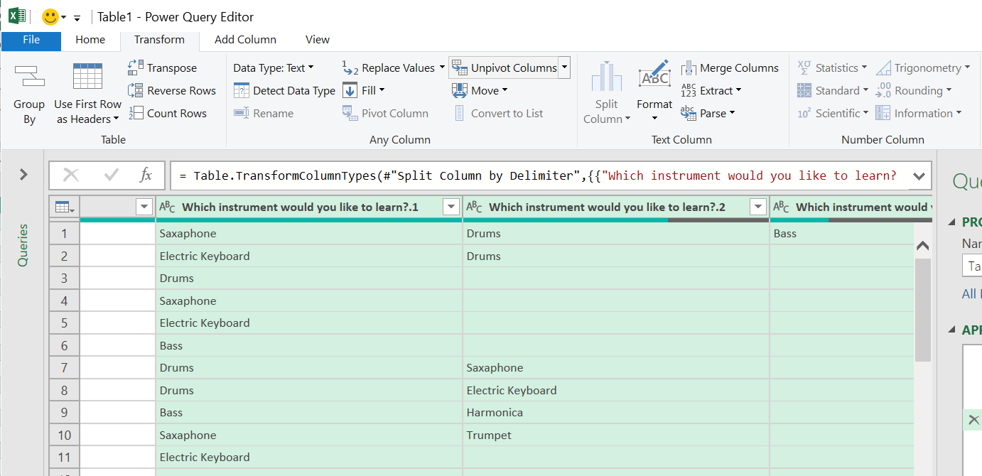
8.Highlight the columns to unpivot
9. In the Transform tab, click on Unpivot columns

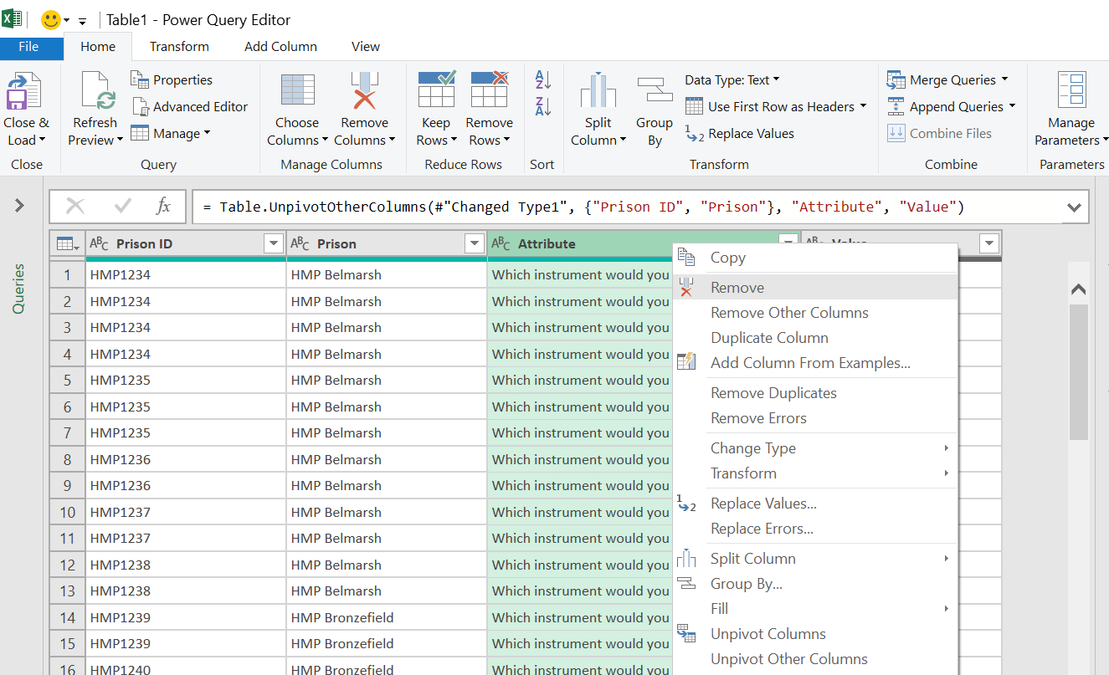
10. Select the Attributes column, right click on the right mouse button & Remove

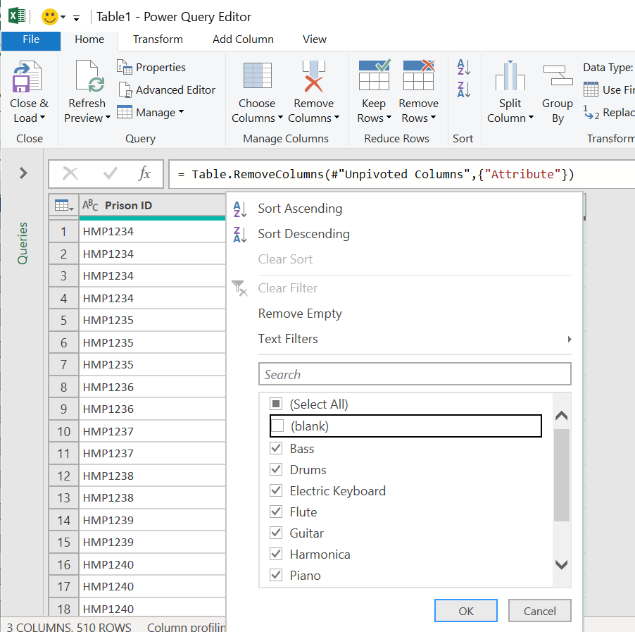
12. In the Home tab, click on Close and Load to save the query and create a worksheet for the results
11. Use the filter on the Value field to remove blanks from the query

Pivot Tables

Creating a pivot table
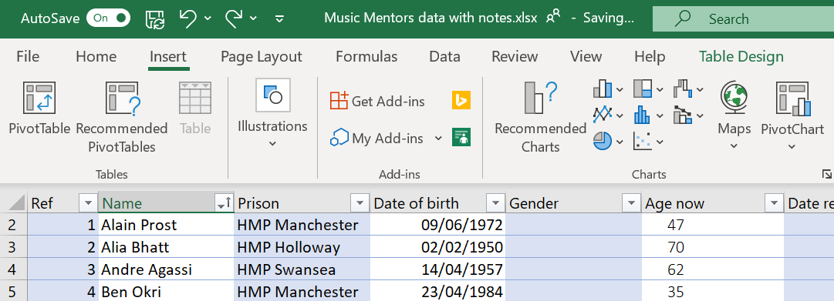
1. Click on the Insert tab
2. Click on Pivot Table

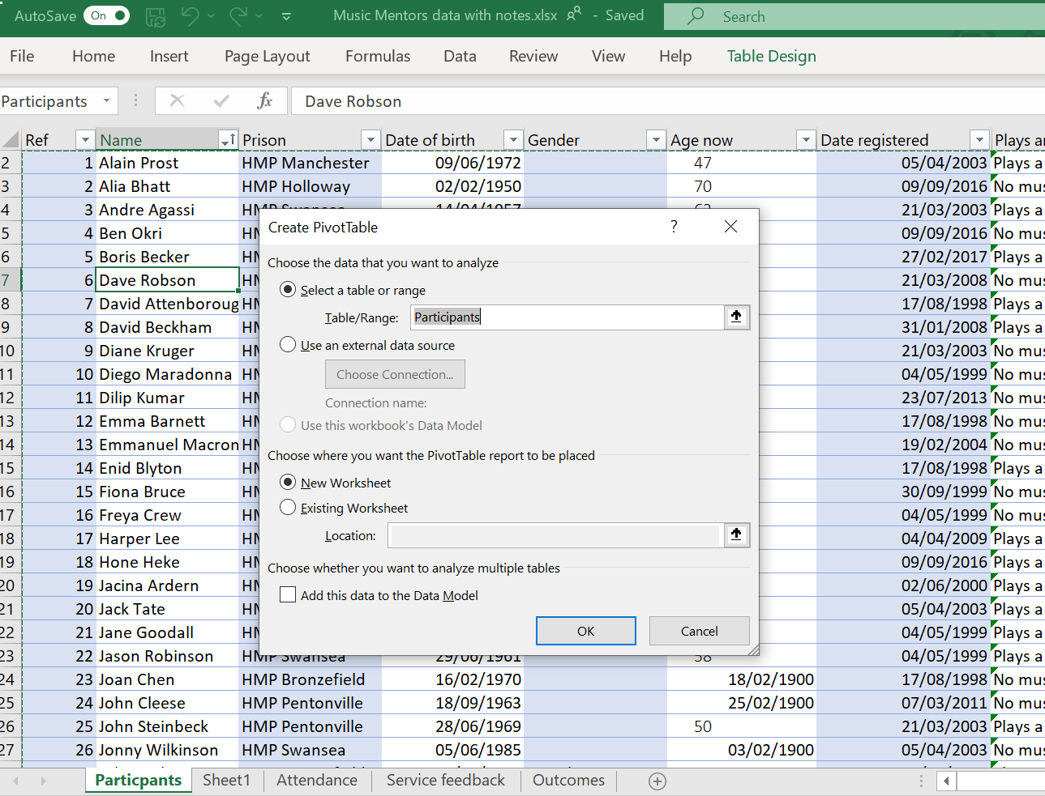
2. Select the table you want to base the pivot table on. Here you can see the table name “participants”. Using a table ensures you have a dynamic data source for your pivot table

3. Select New Worksheet

This will automatically update the table as below, now displaying dates across as columns

5. The columns from your table appear in the fields

4. An empty pivot table is created

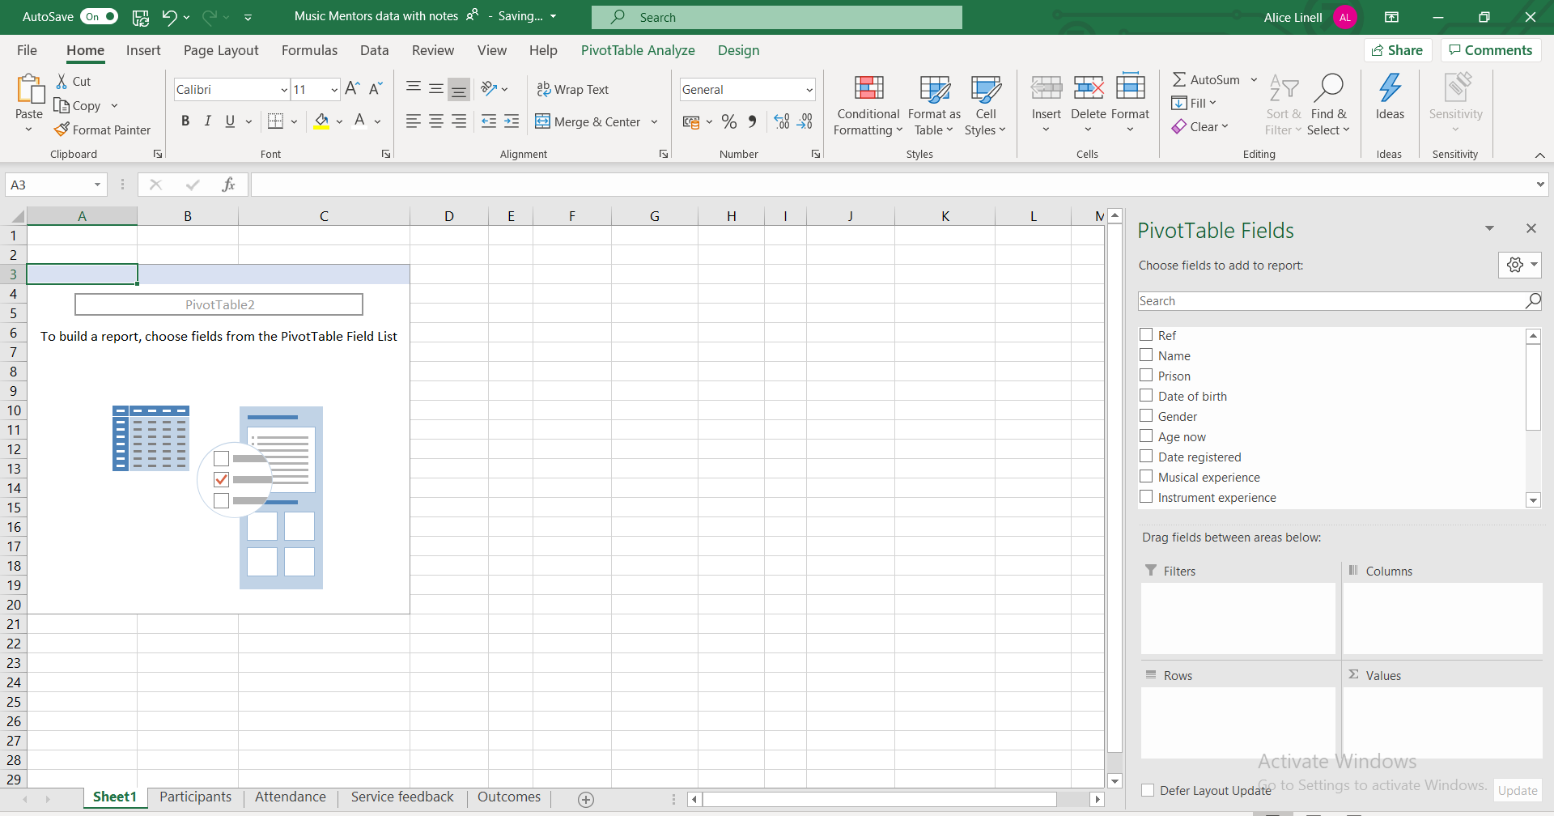
6. To create a simple pivot table that shows the number of prisoners attending sessions from each prison drag and drop the Prison field into the Rows box and the Name field into Values

7. The pivot table now displays how many prisoners attended the music sessions from each prison

8. As the name field is text the pivot table assumes you want to Count the number of records in the Name

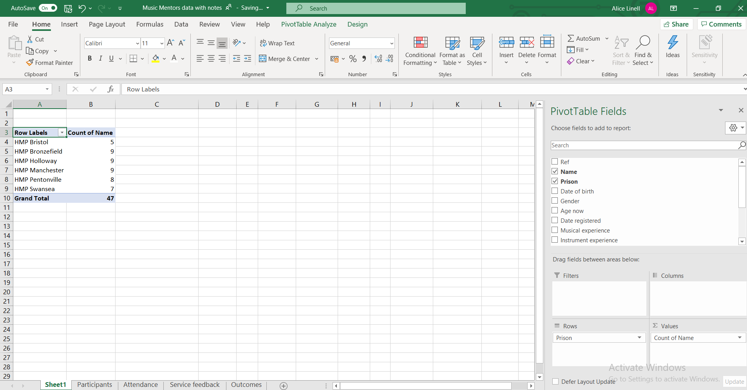

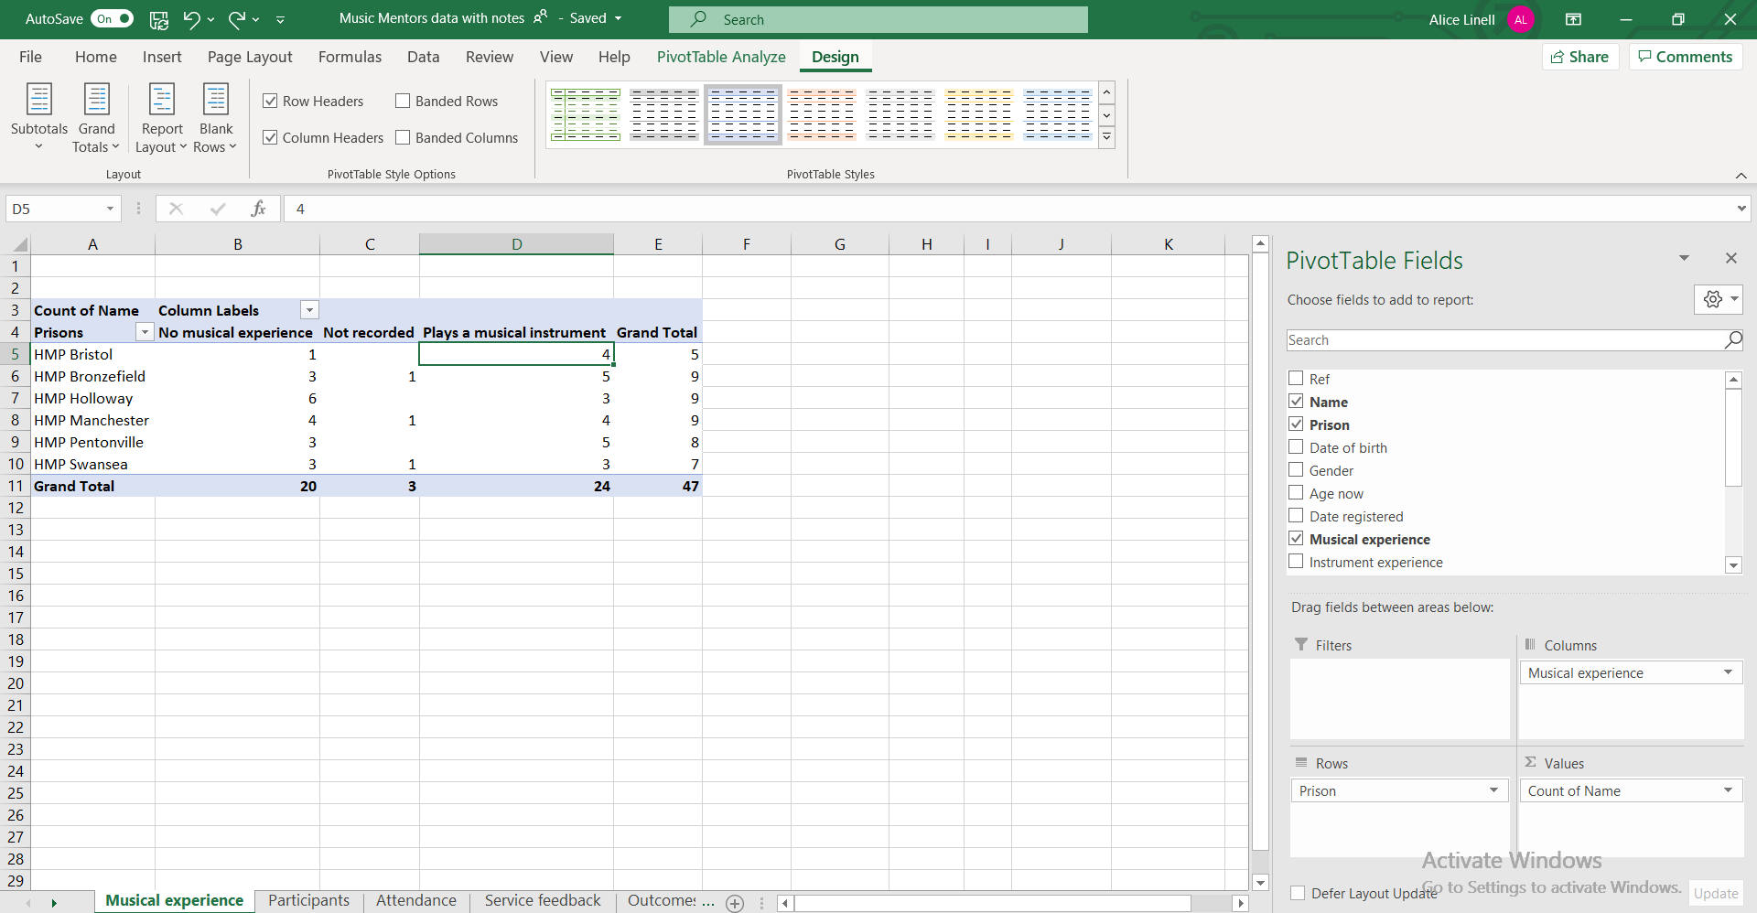
9. Add complexity to your Pivot table. To show how many of the attendees from each prison already had musical experience, add the field Musical experience to the Columns field

Field values
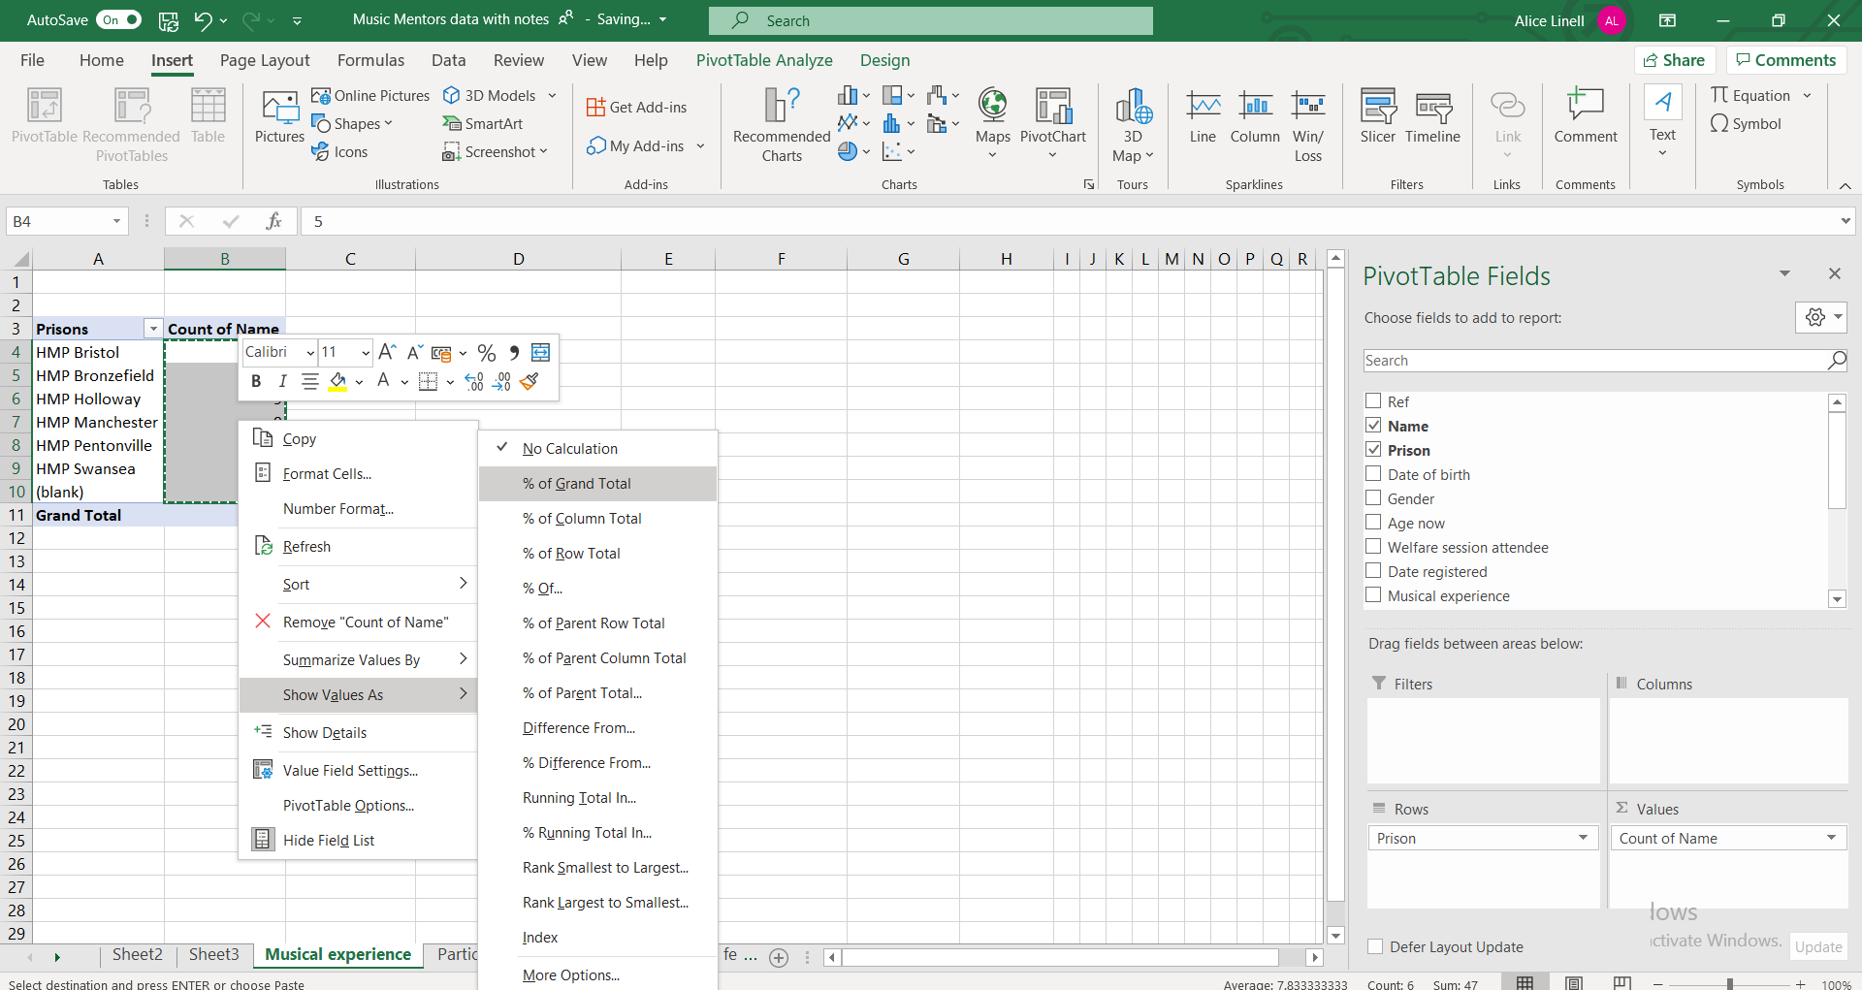
2. Select Show Values As and then % of Grand Total

1.Highlight the fields you want to display as a percentage.

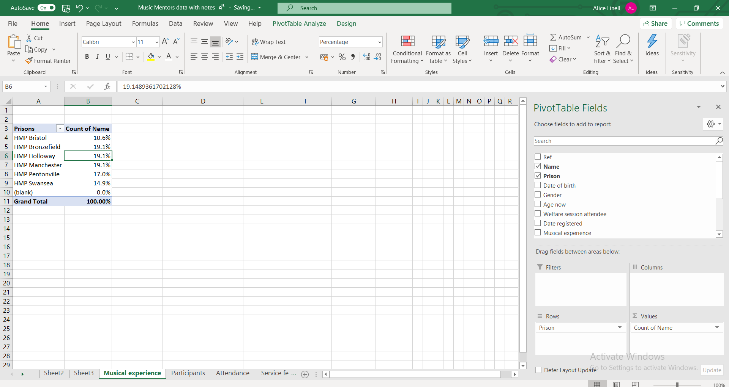
4. Use the Decrease decimal place command button to round numbers.

3. Percentages replace the original numbers

Sorting & Filtering a pivot table
Simple sorting and filtering work exactly the same as elsewhere in Excel.
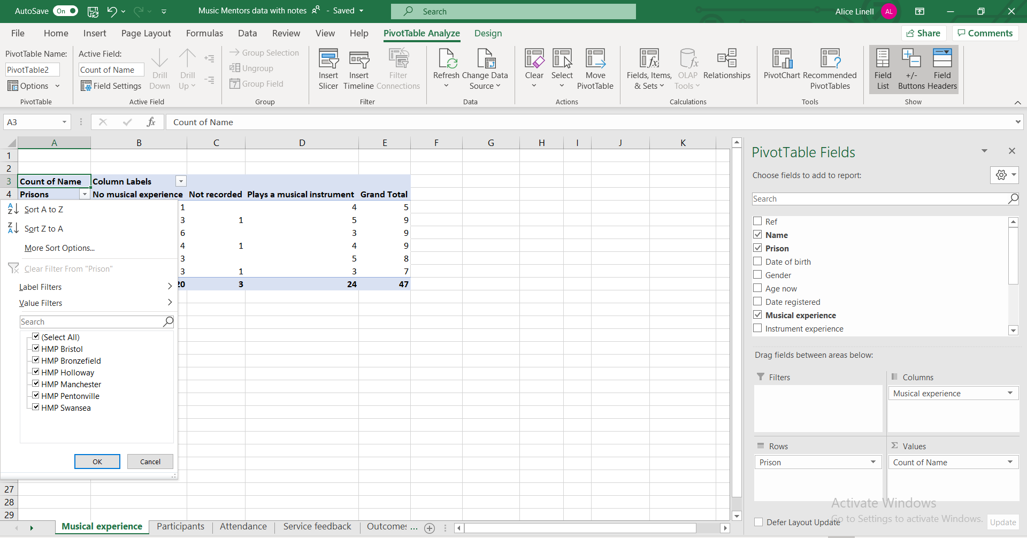
Click next to the row or column heading for sorting and filtering options

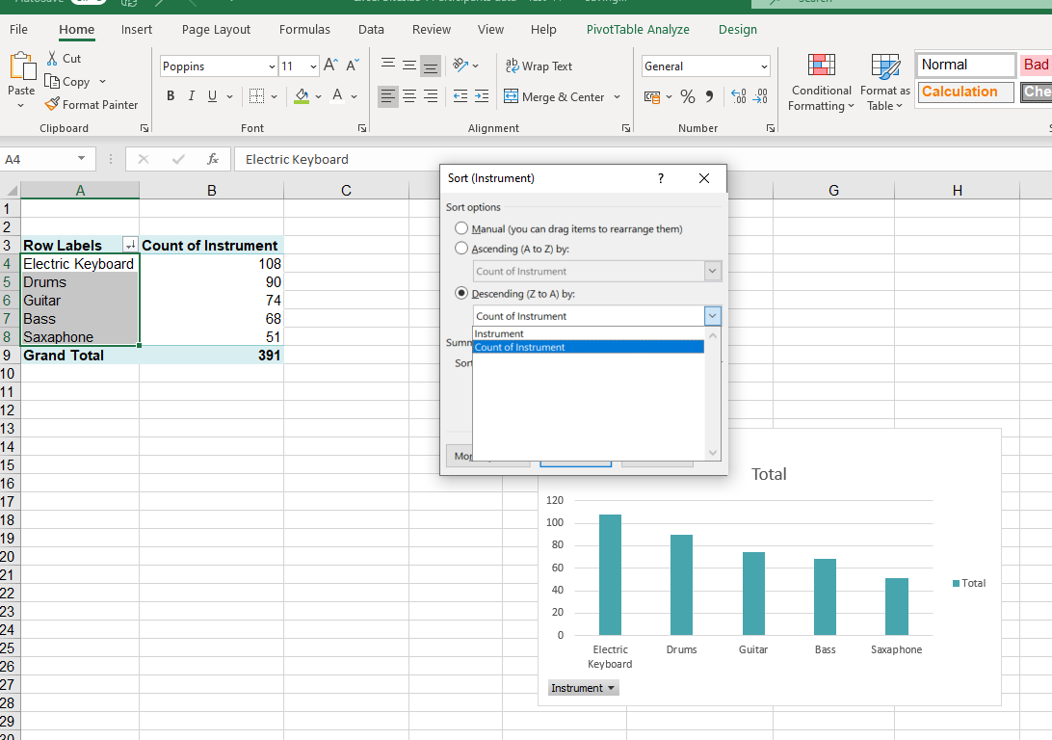
Sort by count of values
- Click on the arrow next to Row labels & select Sort Options

- Select Count of Row name for a numerical not alphabetical sort

- The chart always shows the opposite sort order so select Descending to have the largest column show first

Add a Slicer to a pivot table
1. Click on Insert Slicer

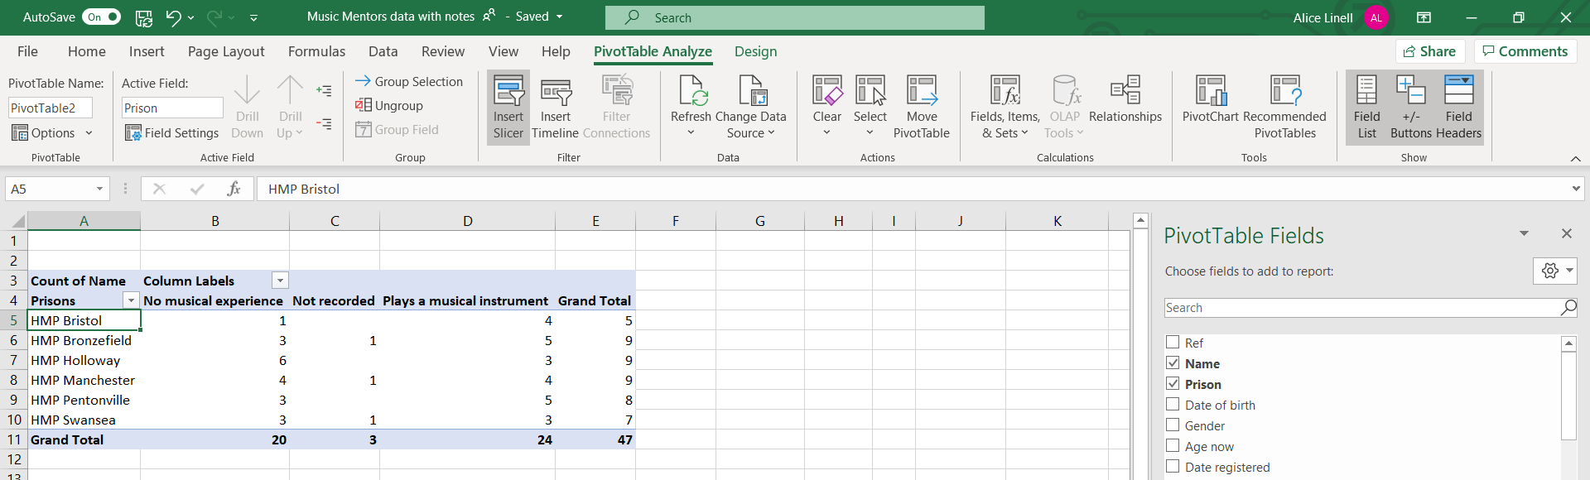

Formatting a pivot table
Like Tables, Pivot Tables can be formatted.
1. Click on the pivot table and then on the Design tab

2. Add and remove specific headers or banding for rows & columns

3. Change the format (colours, banding, outline etc)

Refreshing data in a Pivot table
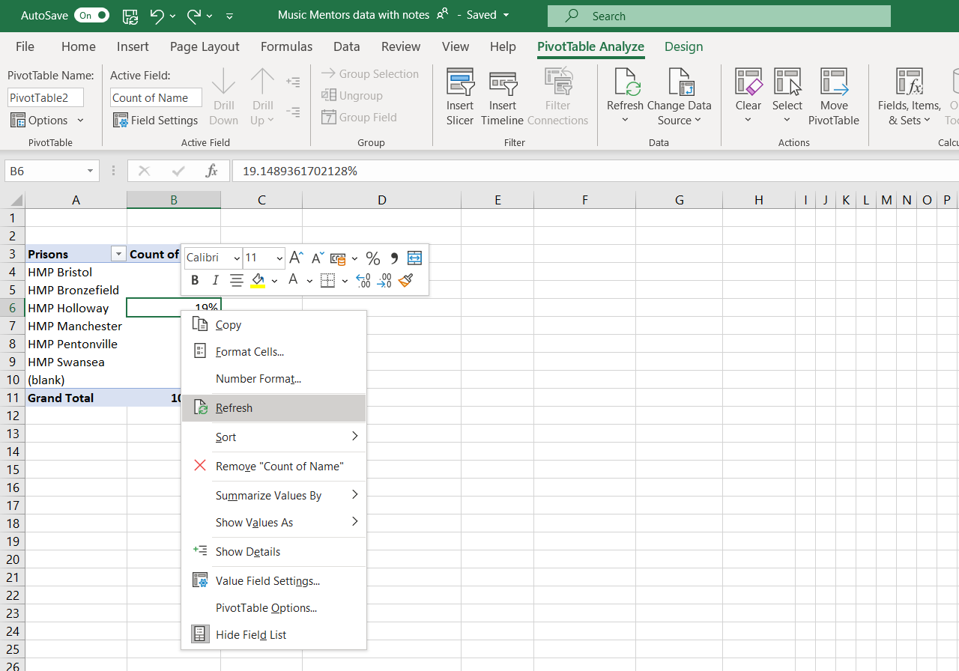
If you make changes to the data set being used to the pivot table, you might need to refresh the chart so that the changes are immediately reflected in the chart.

Recommended Pivot Tables
A short cut to creating pivot tables can be to use the recommended Pivot table function.

Changing value field settings
In pivot tables you can select different types of setting for the values portion of your Pivot table. You can:
- Give the value set a custom (display) name
- Specify how you want to summarise values
- Specify how you want to display values
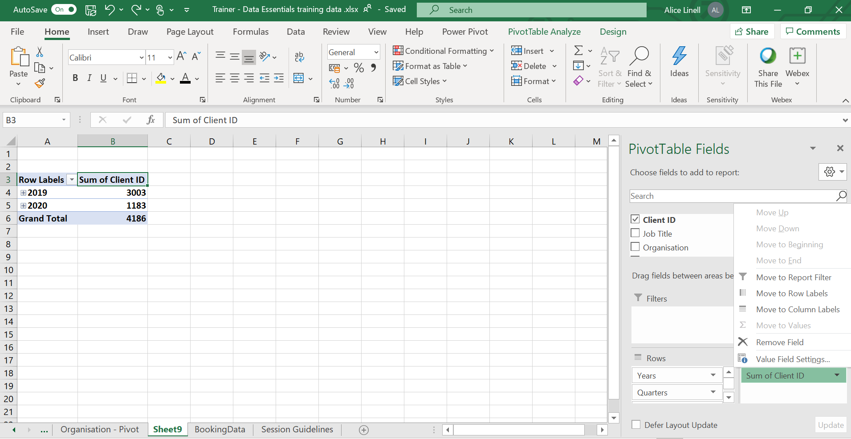
1. Right mouse click on the Value eg Sum of Client ID and select the option Value Field Settings

Custom value name
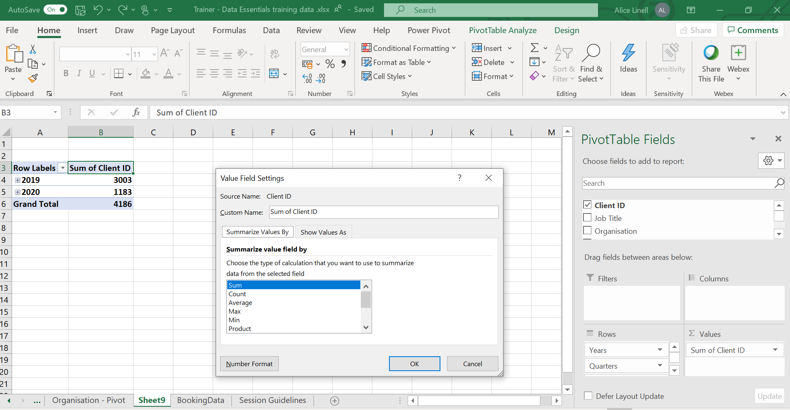
Type in the name you would like to use for the value field.

Summarise values by

2. Select how you want your field summarised
1. Select the tab Summarise Values By
Most common calculations used to summarise data:
Function | Summarizes
Sum | The sum of the values adds all the values in the selected data range. This is the default function for numeric values.
Count | The number of values. The Count summary function works the same as the COUNTA worksheet function. Count is the default function for values other than numbers.
Average | The average of the values. The average is the mean average of the numbers. To calculate: Excel adds up all the numbers, then divides by how many numbers there are. In other words it is the sum divided by the count.
Max | The largest value.
Min | The smallest value.
Product | The product of the values. The product is the result of multiplying the numbers eg the product of 2 and 3 is 6.

Show values As

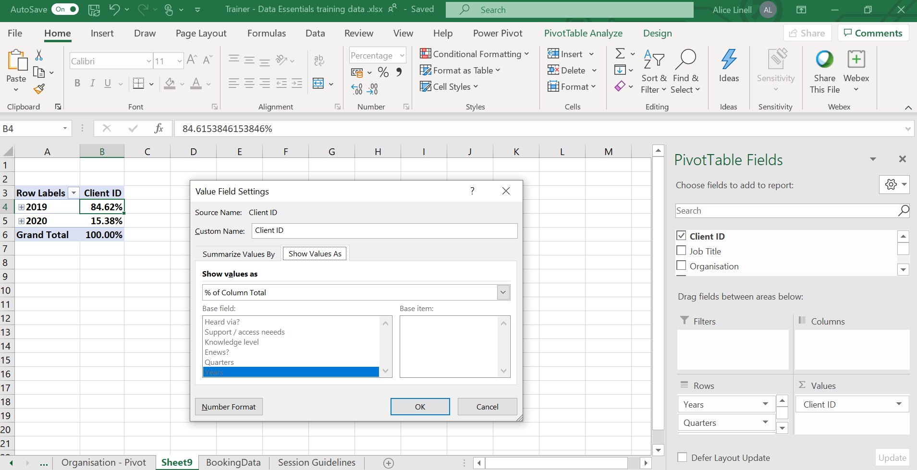
2. Select how you want to display the data
1. Select the tab Show Values As
Most common ways of displaying data:
Use this calculation | To
No calculation | Turn off custom calculation.
% of Column Total | Display all the values in each column or series as a percentage of the total for the column or series.
% of Row Total | Display the value in each row or category as a percentage of the total for the row or category.
Rank smallest to largest | Display the rank of selected values in a specific field, listing the smallest item in the field as 1, and each larger value with a higher rank value. Create a new column for Rank if you want to show the specific amounts too.
Rank largest to smallest | Display the rank of selected values in a specific field, listing the largest item in the field as 1, and each smaller value with a higher rank value. Create a new column for Rank if you want to show the specific amounts too.

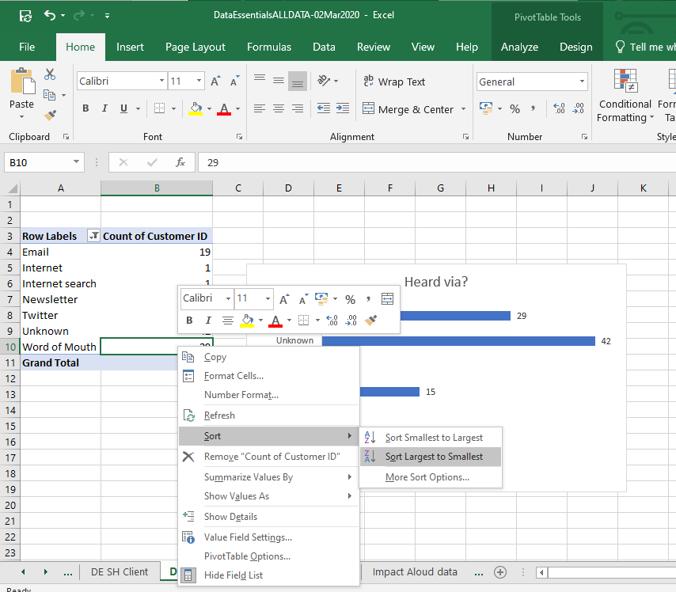
Changing the sort order
More sort options allows you to input a specific sort order
2. Select sort and the sort order you require
1.Right mouse click on a value in the data set you want to sort

Custom sort order
Go to File > Options > Advanced

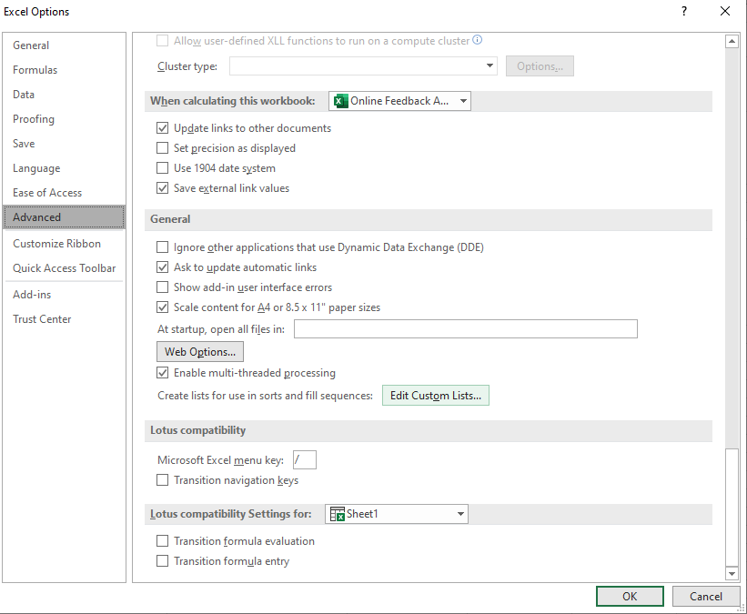
- Select the option Edit Custom Lists

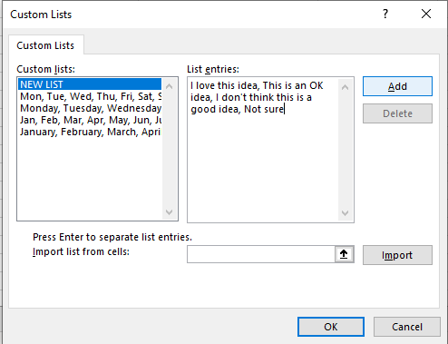
- Click on OK
- Click on Add
- Add your custom sort order separated by commas.
You can also choose to import the values from a range of cells.

Grouping dates

In Excel 2016 forward Excel automatically groups dates by months & quarters. If you are working with an Excel version prior to that or you want to change the automatic grouping you can manually group dates.

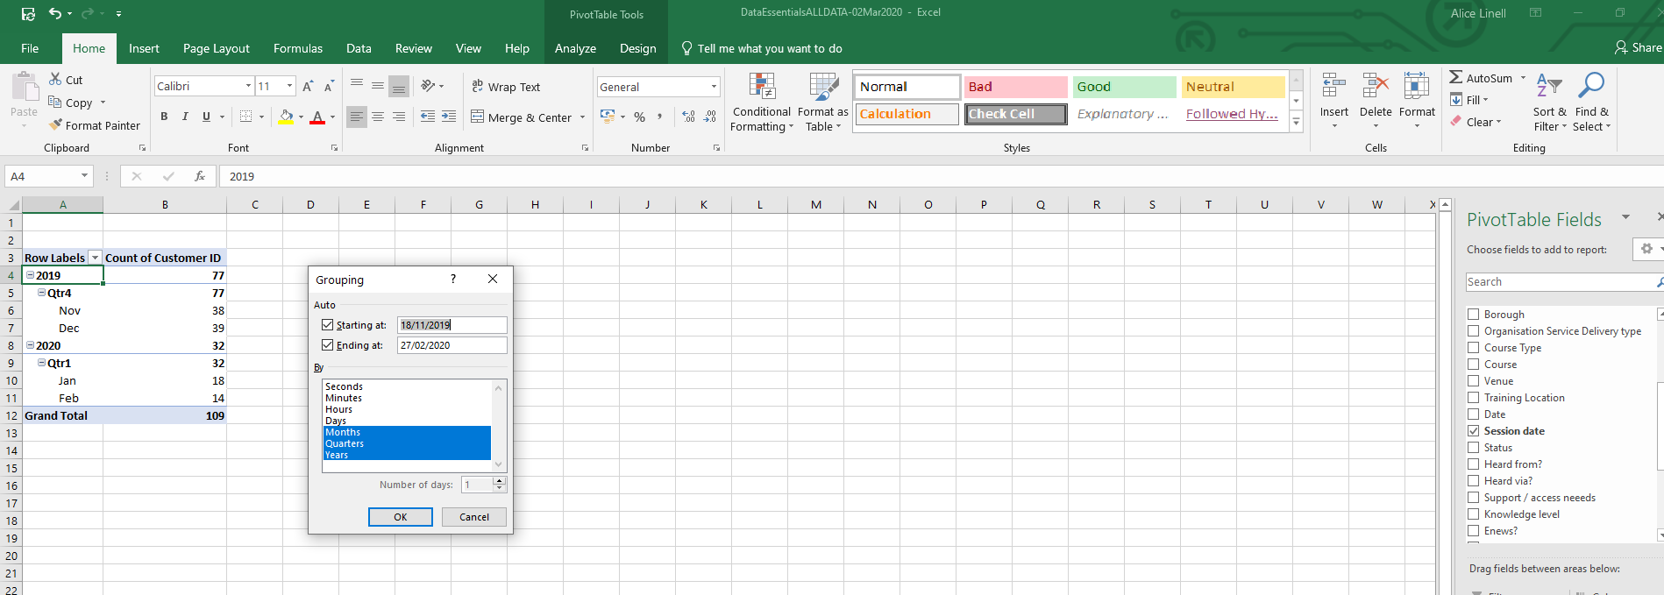
- Select the Grouping you require
- Right mouse click on a date value

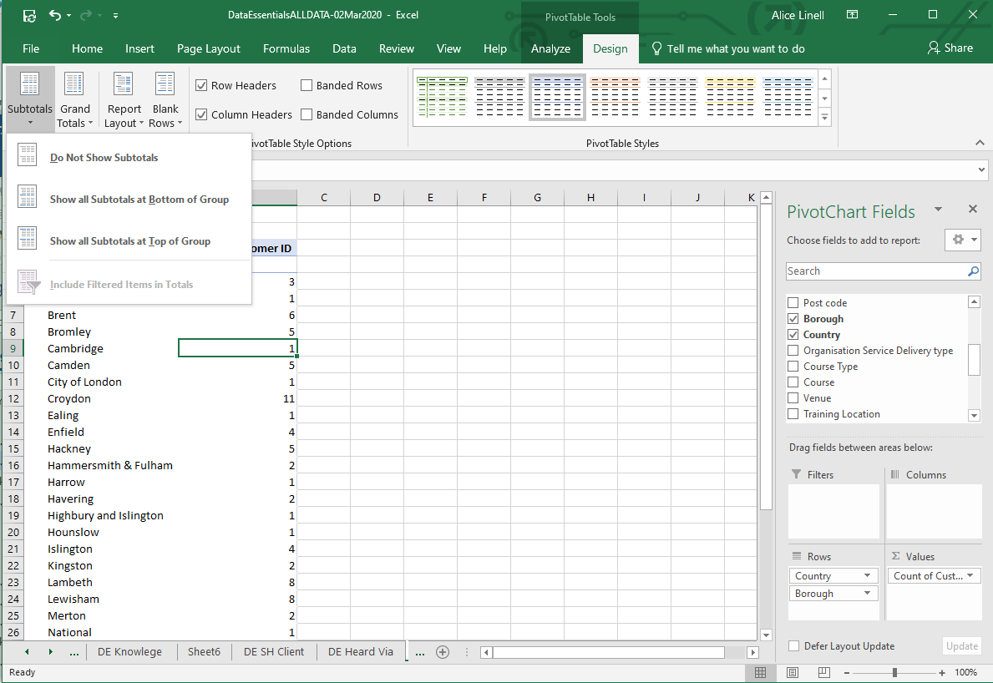
Sub totals and Grand totals
- Click Subtotals or Grand Totals to show or not show totals
- Click on the Pivot table

Open text questions
Tips
- Add a text box to your sheet to record your code
- Identify the key recurring themes
- Assign a numerical code to each theme e.g.1 = Instrument choice/availability
- Go through all the answers assigning codes to each answer
- Add your coding to the column heading so you can refer to it
- Use Power query to split columns & unpivot data

Exercises

Multiple Choice Survey Questions

Exercise 1
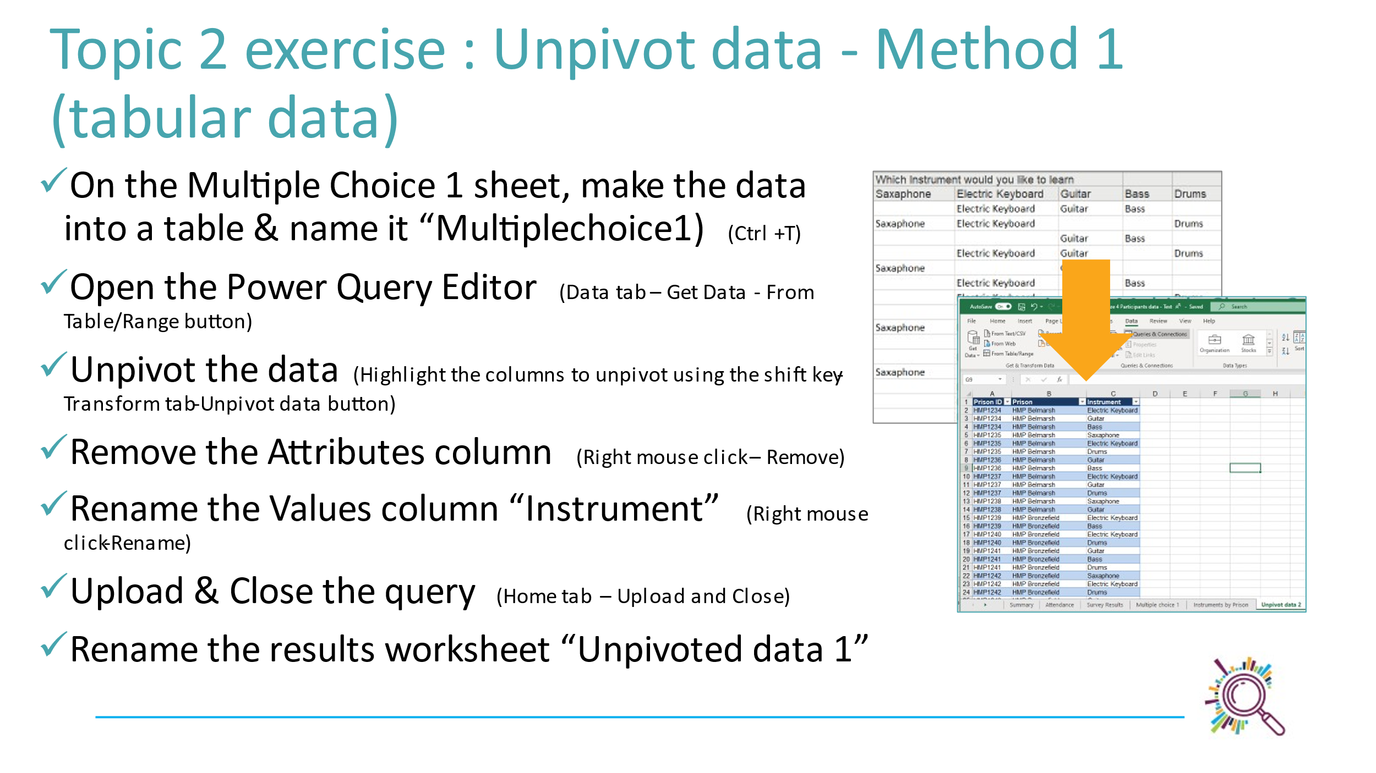

Exercise 2
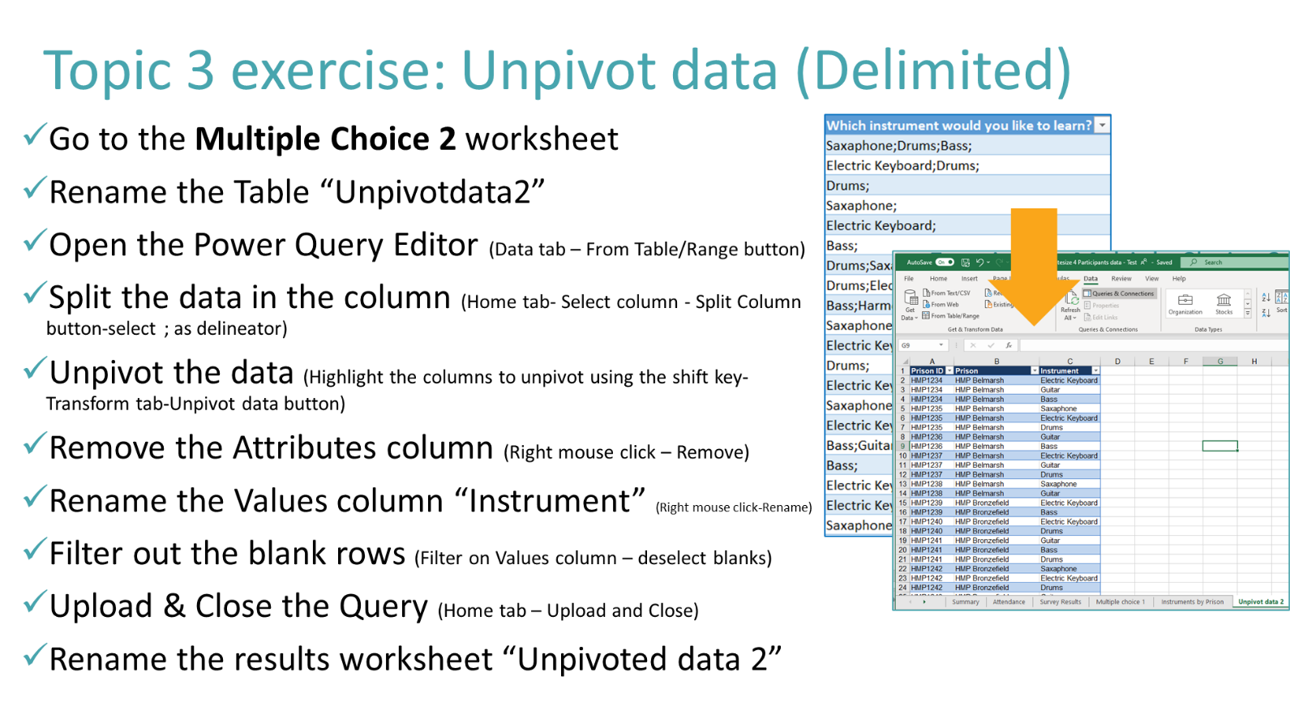

Exercise 3
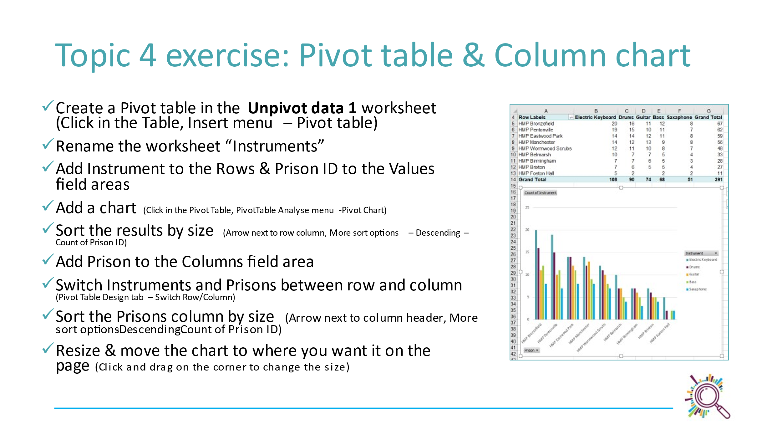

Open text question exercises

Exercise 4
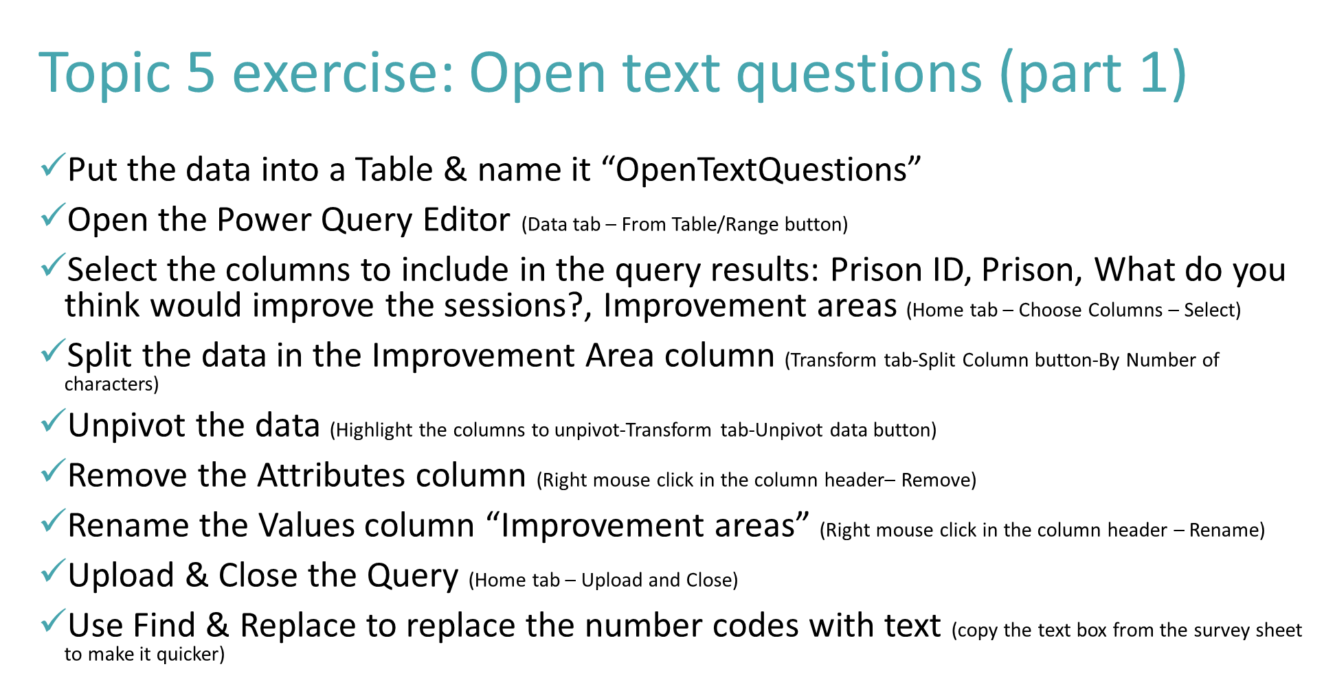

Exercise 5


