 Word Cloud Step by Step using Word It Out and Monkey Learn
- Go to www.worditout.com and click Create

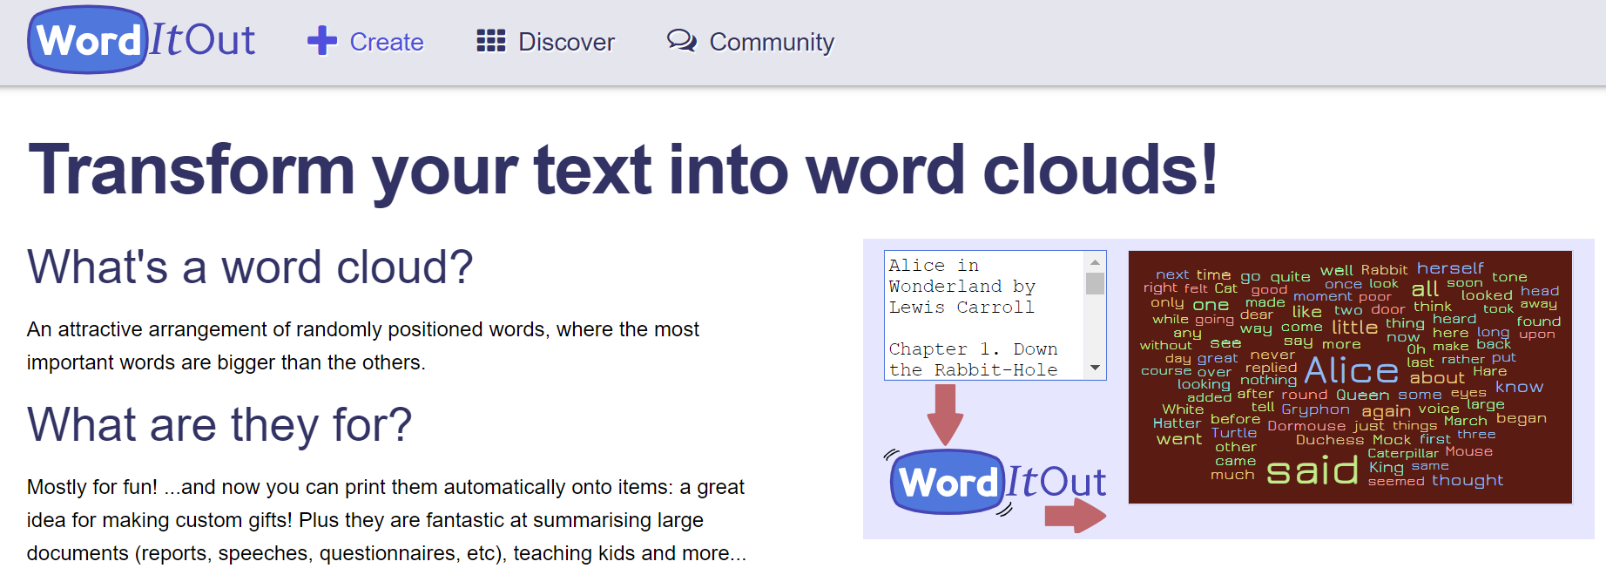

- Now copy and paste your text into the Original text box

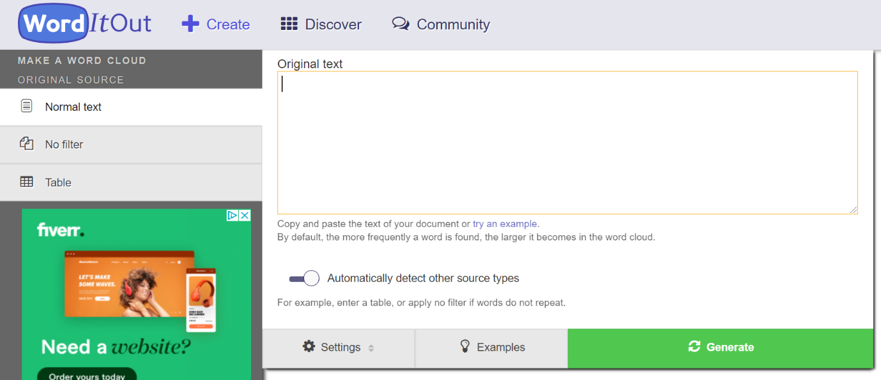

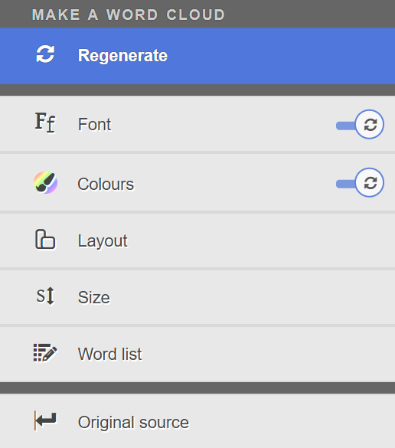
- Click on the left hand menu options of Font, Colour, Layout and Size to change the design of your word cloud.

(Tip: Uncheck the Random on Regenerate option for Fonts)

- Then click on Regenerate for your choices to be applied.

- Click on Original source to go back to the initial screen where you can select Settings and make changes to how words are included in your Word Cloud as follows:
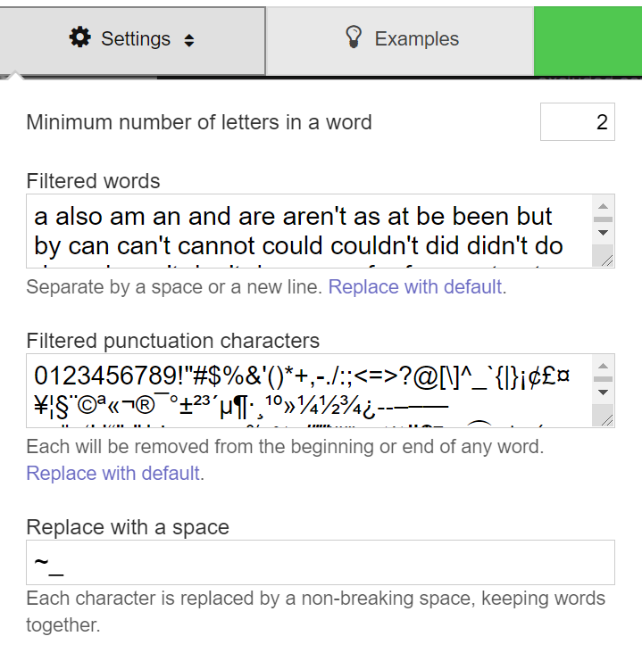

- Here you can change the number of letters in a word (this is 2 by default)

- You can add to or change the Filtered words that are automatically discounted

- You can amend the punctuation characters that are automatically discounted too

- And specify that where a certain character is used e.g. hyphen – this will be replaced by a space (useful if you want to include phrases in your Word Cloud)

See our example Word Cloud using the text you’ve been provided with:
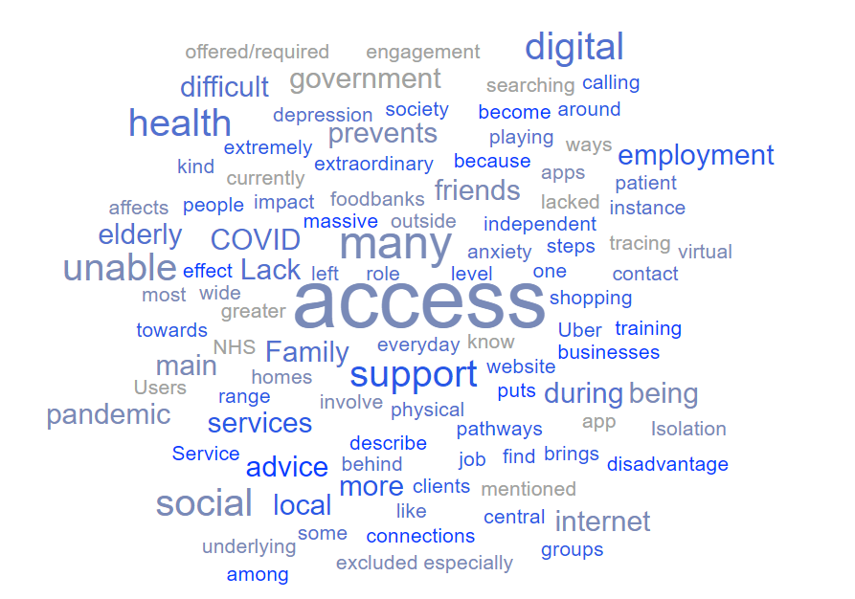

- Now select the Word list option in the left hand menu.

You can make changes to the number of times a word appears in your text in order for it to appear in your Word Cloud.
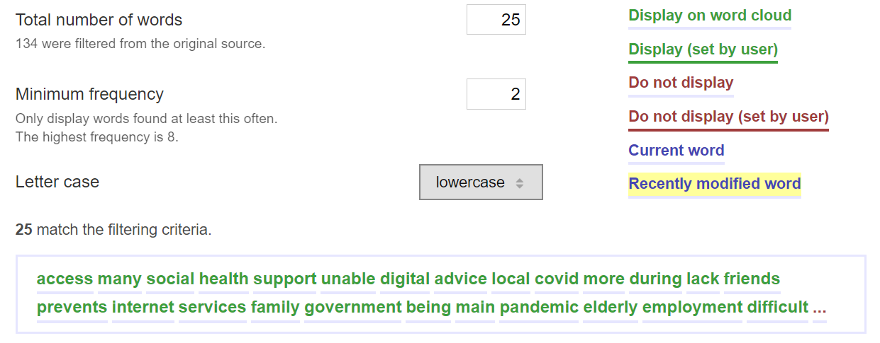

- Changing the above to 2, now reduces the number of words appearing from 100 to 25, which will now display a Word Cloud as below:

- Remember to click on ‘Regenerate’ to see your changes made in the Word Cloud.

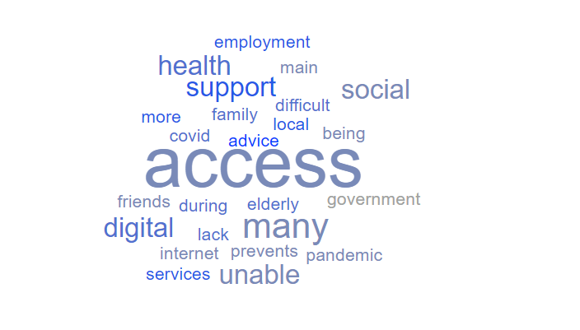

- You might now want to go back and e.g. remove the words ‘being’, ‘main’, and maybe others from the list?

- Now go to https://monkeylearn.com/word-cloud and paste the same text into the Source text box and click on Generate cloud button

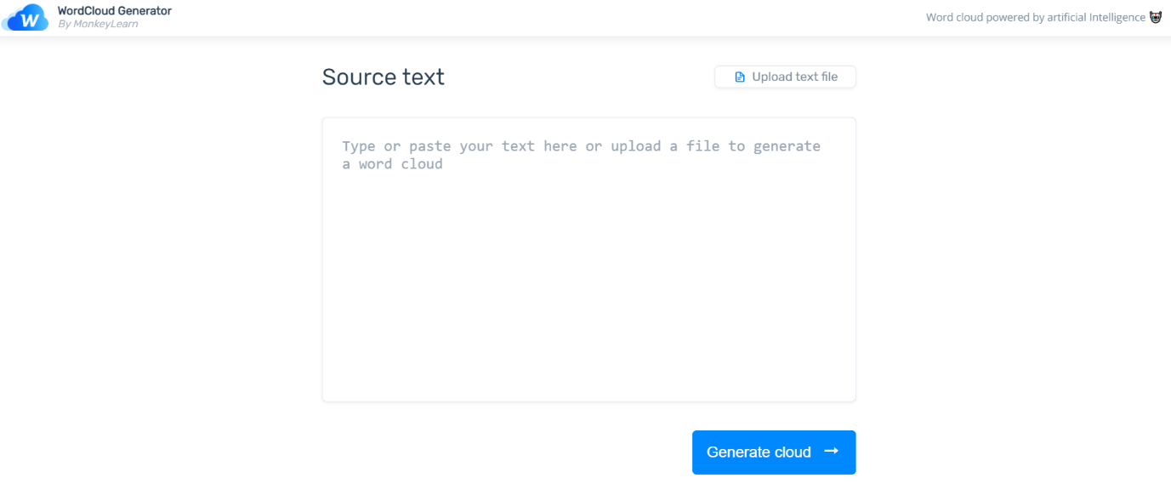

- What difference do you notice between the two Word Clouds?

MonkeyLearn’s word cloud generator uses Artificial Intelligence techniques, so you’ll see it has prioritised words based on relevance and included phrases (although these aren’t always accurate!).
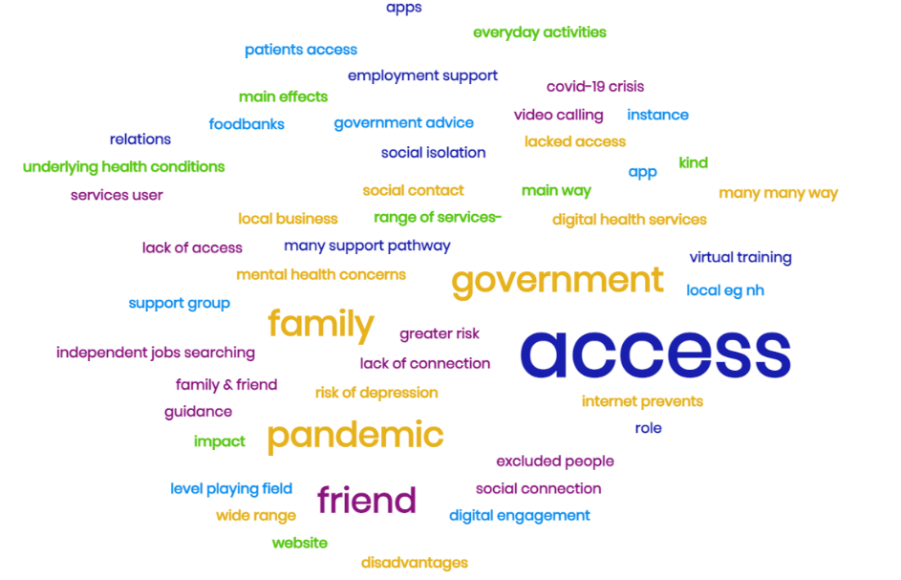
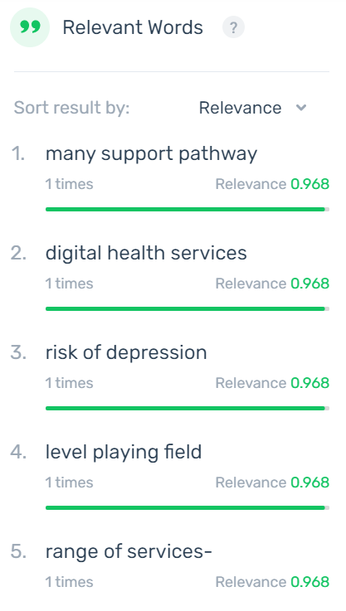

- Both tools allow you to download the Word Clouds you create as Image files. Alternatively use the Snipping Tool (Windows) to take screenshots to paste into reports or presentations or save as images.

- Word It Out also provides you with an Embed Code to add the Word Cloud to your website.

