
Creating a Dashboard in Microsoft Excel
Contents
Tables 4
1. Make your data into a table 4
2. Name the table 4
Pivot Tables 5
1. Creating a pivot table 5
2. Field values 7
3. Sorting & Filtering a pivot table 8
4. Refreshing data in a Pivot table 9
5. Recommended Pivot Tables 9
6. Pivot table charts 10
Working with Pivot tables 11
7. Changing value field settings 11
Custom value name 12
Summarise values by 12
Show values As 13
8. Changing the sort order 14
9. Custom sort order 15
10. Grouping dates 16
Working with Charts 17
11. Anatomy of a chart 17
12. Creating Pivot charts 18
13. Chart design 19
14. Change chart type 19
15. Chart elements 20
16. Hide Value field button settings 21
17. Changing the data series 22
Making Rows/columns broader 22
Make each data point a different colour 23
Creating an Excel Dashboard 24
18. Preparing your Workbook 24
19. Formatting your Dashboard 24
Add Title 24
Hide Gridlines, Headers & the formula bar 24
Formulas 24
GETPIVOTDATA 24
IFERROR 25
Slicers 25
Formatting a Slicer 25
Linking the slicer to your charts 26
Refreshing the Dashboard 27
Session Exercises 28

Introduction to Dashboards
A Dashboard is a type of graphical user interface which provides at-a-glance, interactive views of key performance indicators relevant to a particular objective. Or more simply put, in Microsoft Excel it’s simply a collection of pivot charts on a worksheet.

Dashboard Best Practice
- Decide what you want to say to your audience and make sure that all everything on the dashboard is telling that story.
- Don’t over complicate – it’s better to have a clean, simple dashboard than one brimming with so many charts it’s impossible to take it all in.
- Keep colour schemes consistent and simple.
- Think about how your audience is going to be viewing it – on a PC/laptop or on a mobile device
- Security – Excel dashboards sit in spreadsheets full of data. Make sure you think about who is going to have access and how much data they can have access to.
- Printing - make sure it fits on one page

Questions to ask before you begin building your dashboard
- Why are you creating this dashboard? Are you trying to prove or disprove a hypothesis? Is this dashboard for a specific task, like showing status of a project, or does it need to achieve a broader goal, like measuring business performance? Understanding why you are building the dashboard will help guide the design and data.
- Do you need to track certain KPIs? Your dashboard should only highlight data that adds value. Make sure you understand the most important KPIs and create the dashboard around those metrics. Anything outside those main KPIs aren’t necessary.
- Who needs to see the dashboard? Is this for your colleagues, your management team, your board of trustees? How do these people prefer to digest information? How much time do they have to look at this dashboard? Think about who you’re making the dashboard for and keep their preferences in mind.
- Where will the data come from? Do you need to manually import data into your dashboard or will you use an integration or connector to automatically sync and refresh data? What other tools do you use to gather data?
- How up to date does the dashboard need to be? Can you update your dashboard weekly or monthly, or does it always need to show real-time, updated information? Depending on what you chose, this will change the way you build your dashboard.
- What format does the dashboard need to be in? Are you emailing a static dashboard or providing a link to a dynamic one? Does the dashboard need to be embedded in presentations or decks? Do you want to share read-only access or do you want to provide editing capabilities to certain people?

Tables

Make your data into a table
2. Click on the Table command button
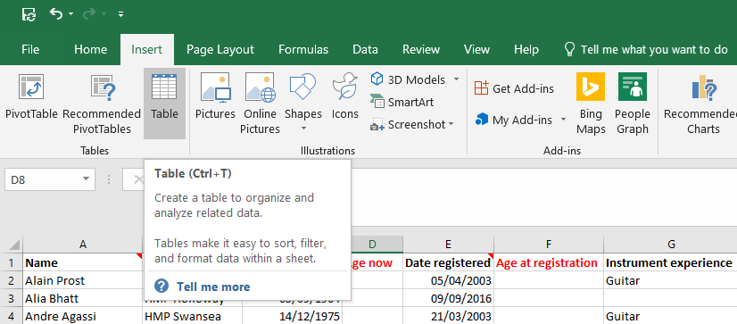
1. Click on the Insert tab
- Alternative shortcut: Ctrl + T
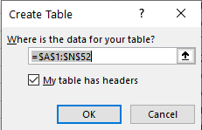
3. A window will open. Confirm the cells to be included in the table and that the data has headers

Name the table
It is good practice to name the table as it makes life much easier later when working with formulas. Naming the formula is basically giving your data set a name which will enable you to recognise which data set you need to be working with.
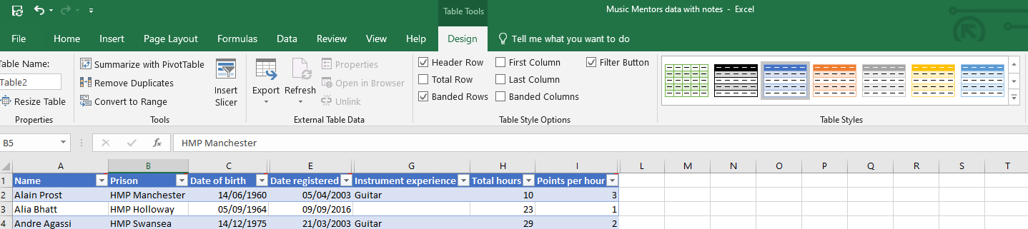
2. Rename the table. For example, “BookingData”
1. Click on the table & select the Design tab

Pivot Tables

Creating a pivot table
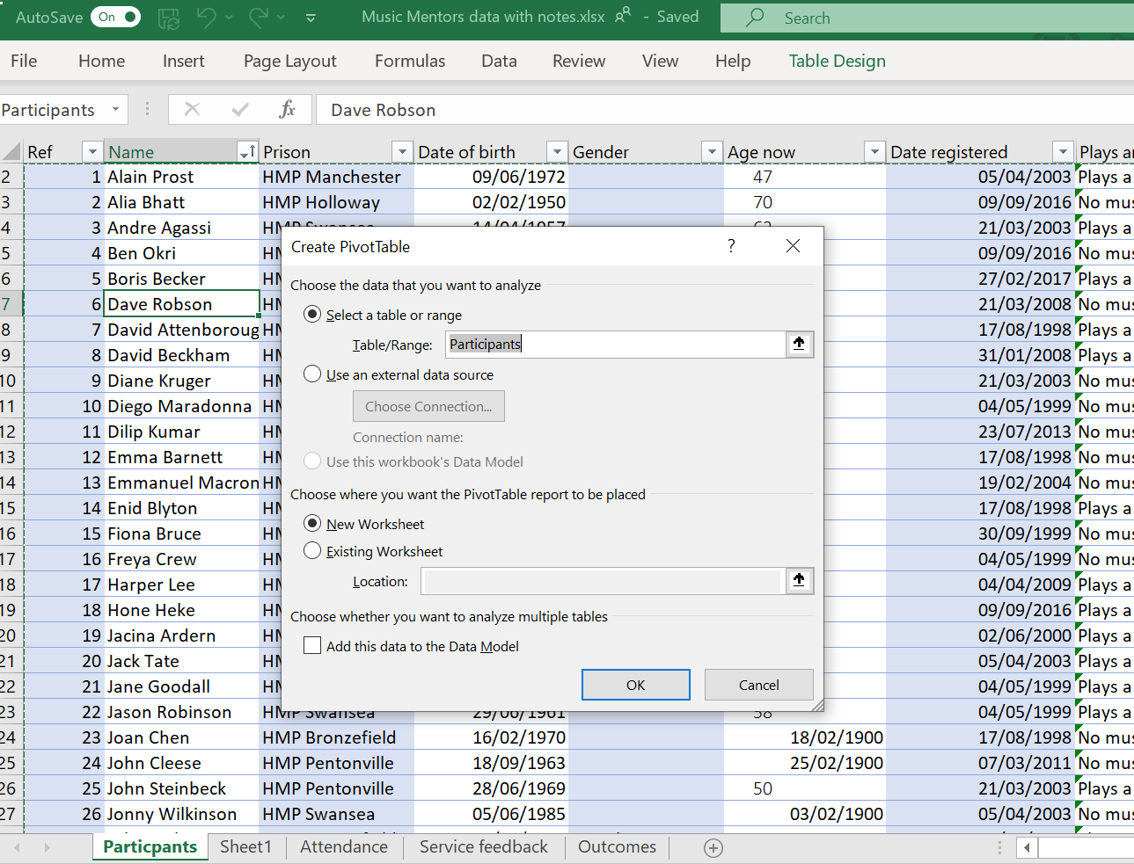
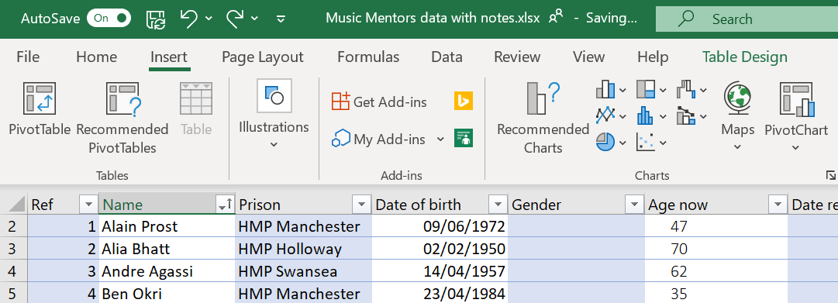
2. Select the table you want to base the pivot table on. Here you can see the table name “participants”. Using a table ensures you have a dynamic data source for your pivot table

3. Select New Worksheet

1. Click on the Insert tab
2. Click on Pivot Table

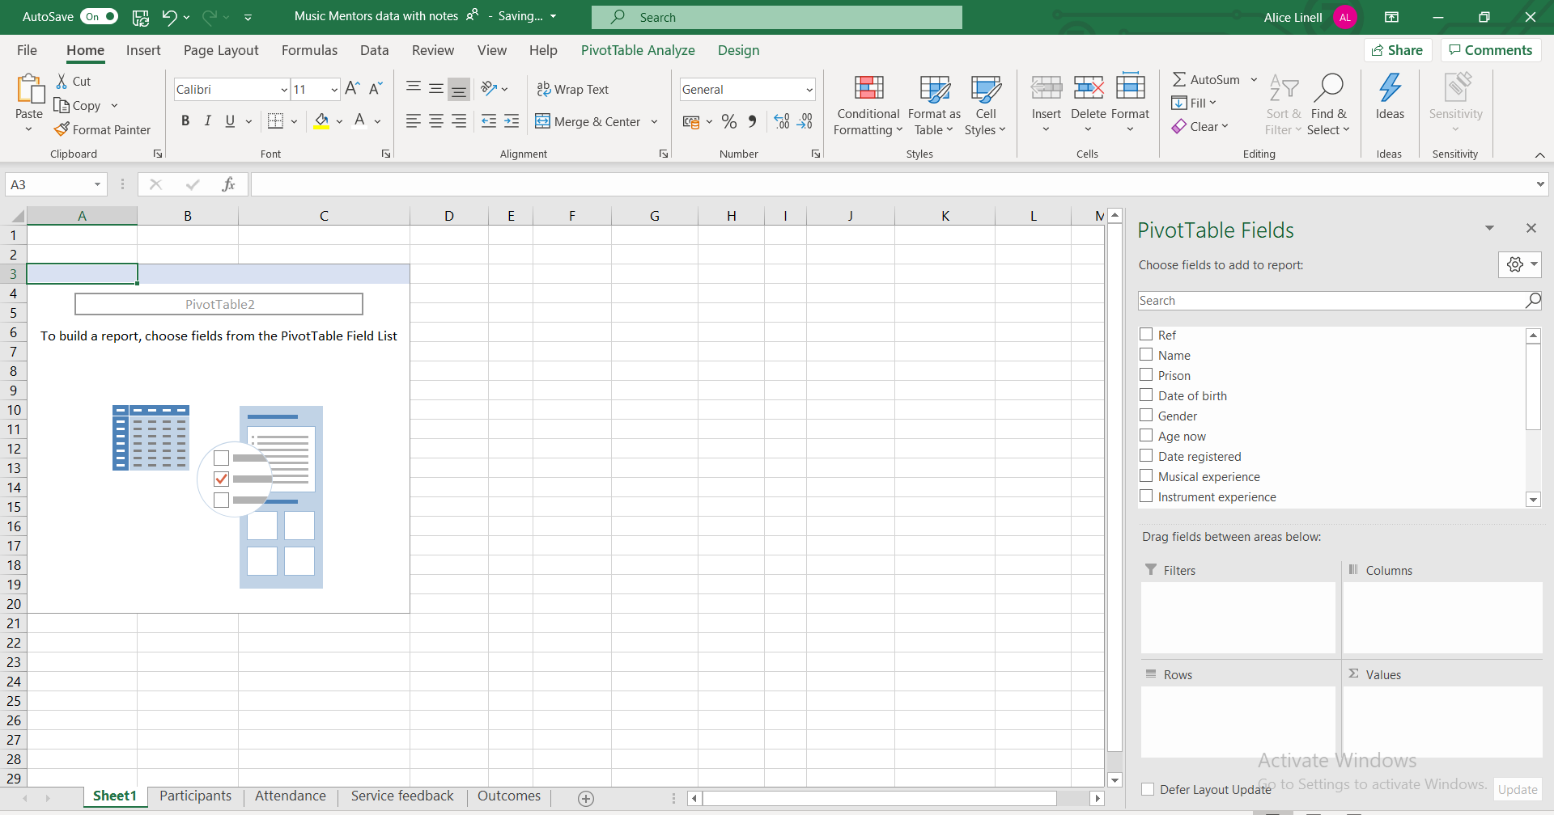
4. An empty pivot table is created

5. The columns from your table appear in the fields

6. To create a simple pivot table drag and drop the field you want to organise into the Rows box and the Name field into Values

7. The pivot table now displays how many prisoners attended the music sessions from each prison

8. As the name field is text the pivot table assumes you want to Count the number of records in the Name

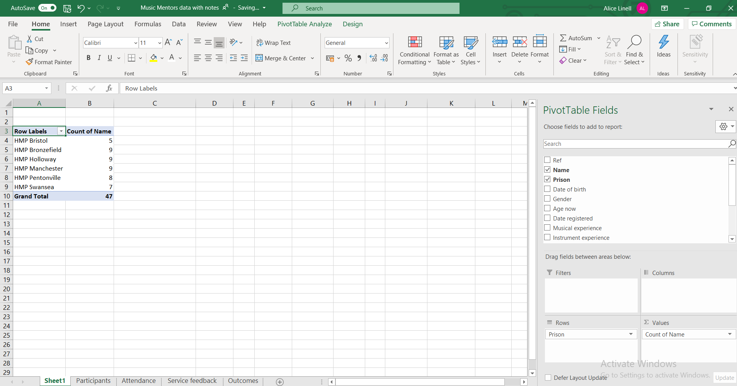

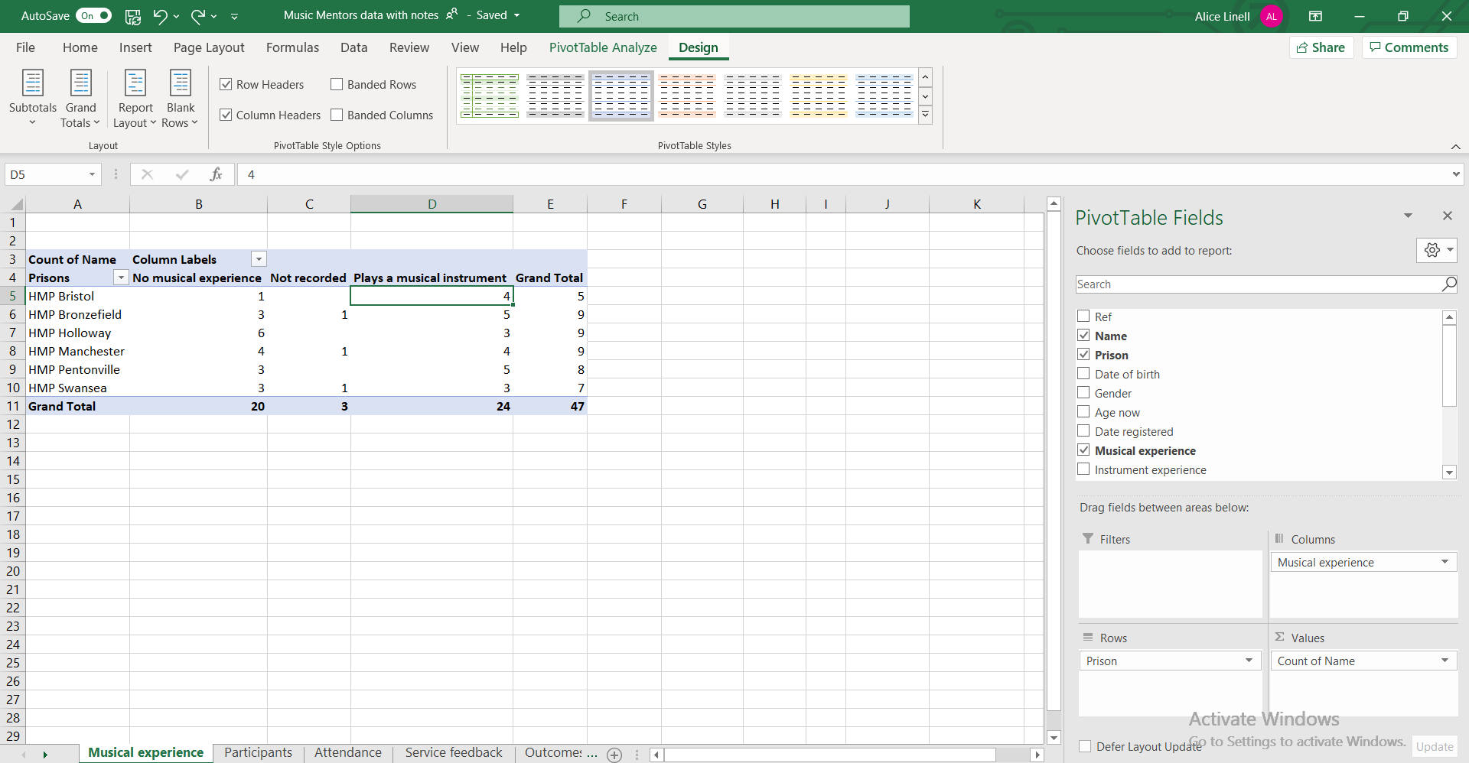
9. Add complexity to your Pivot table. To show how many of the attendees from each prison already had musical experience, add the field Musical experience to the Columns field

Field values
Numerical fields can be displayed in a number of ways in Pivot tables, for example you can display fields as a percentage of the grand total.
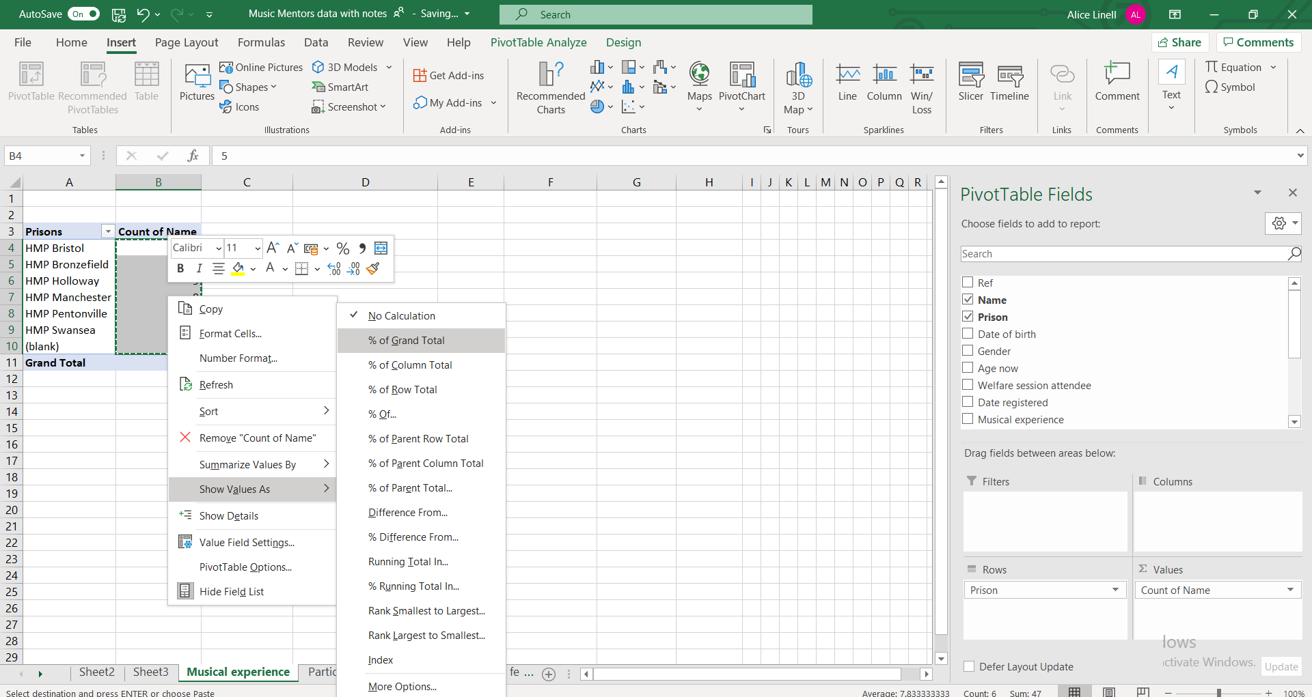
2. Select Show Values As and then % of Grand Total

1.Highlight the fields you want to display as a percentage.

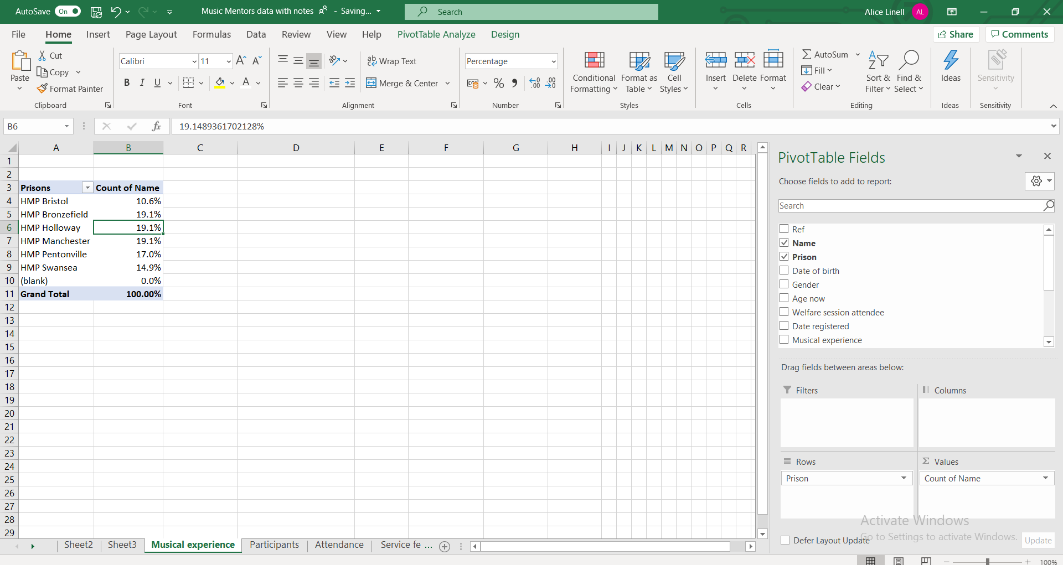
4. Use the Decrease decimal place command button to round numbers.

3. Percentages replace the original numbers

Sorting & Filtering a pivot table
Simple sorting and filtering work exactly the same as elsewhere in Excel.
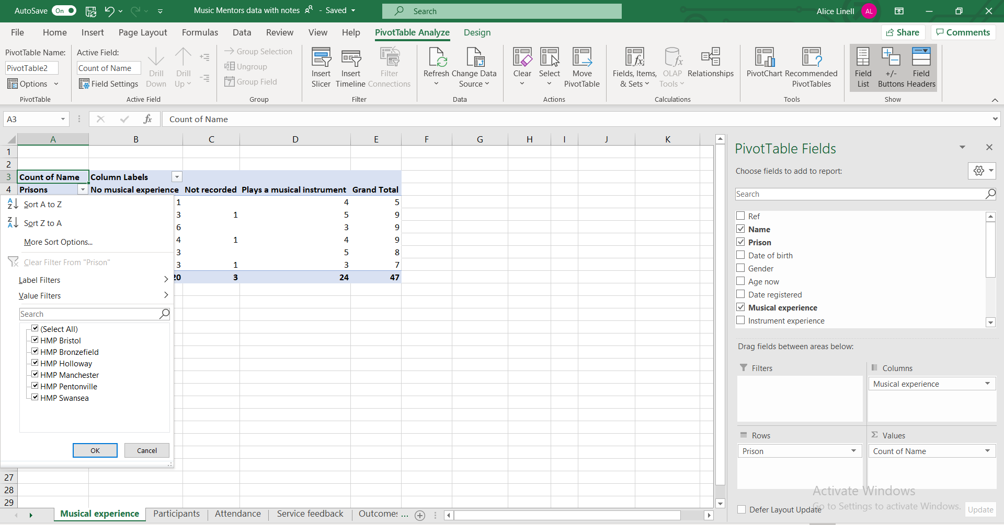
Click next to the row or column heading for sorting and filtering options

Refreshing data in a Pivot table
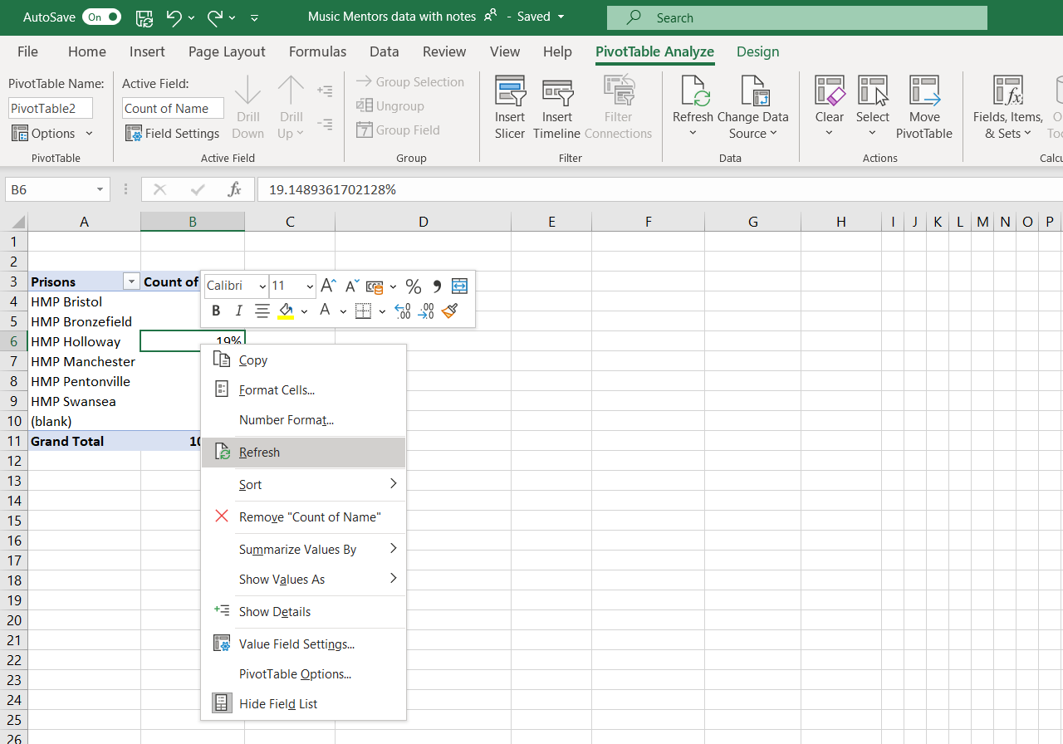
If you make changes to the data set being used to the pivot table, you might need to refresh the chart so that the changes are immediately reflected in the chart.

Recommended Pivot Tables
A short cut to creating pivot tables can be to use the recommended Pivot table function.

Pivot table charts
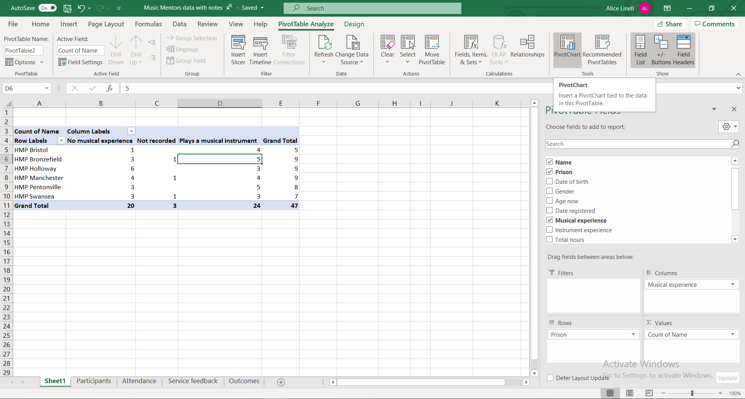
1. Click on the pivot table and then on the PivotChart command button

2. Choose the chart type

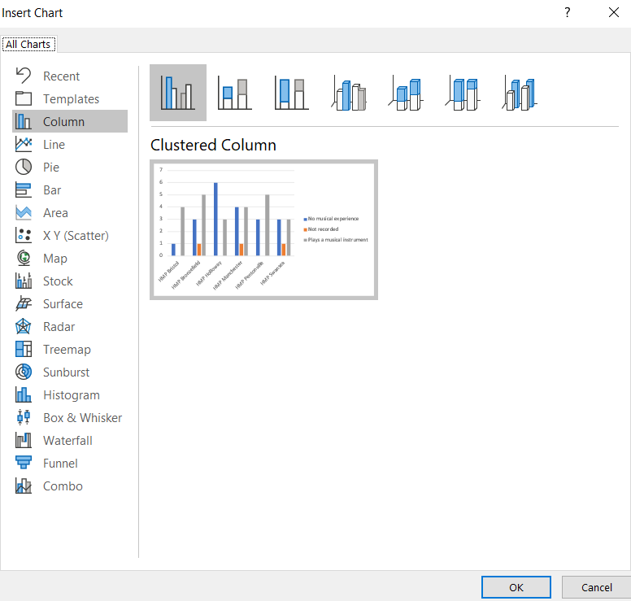
  - (red for any less than 2)

3. Choose the chart format

Working with Pivot tables

Changing value field settings
In pivot tables you can select different types of setting for the values portion of your Pivot table. You can:
- Give the value set a custom (display) name
- Specify how you want to summarise values
- Specify how you want to display values
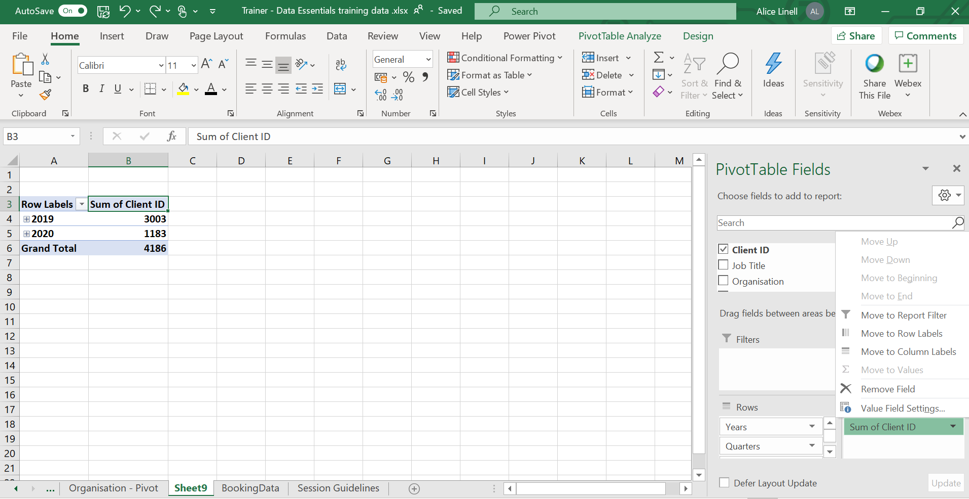
1. Right mouse click on the Value eg Sum of Client ID and select the option Value Field Settings

Custom value name
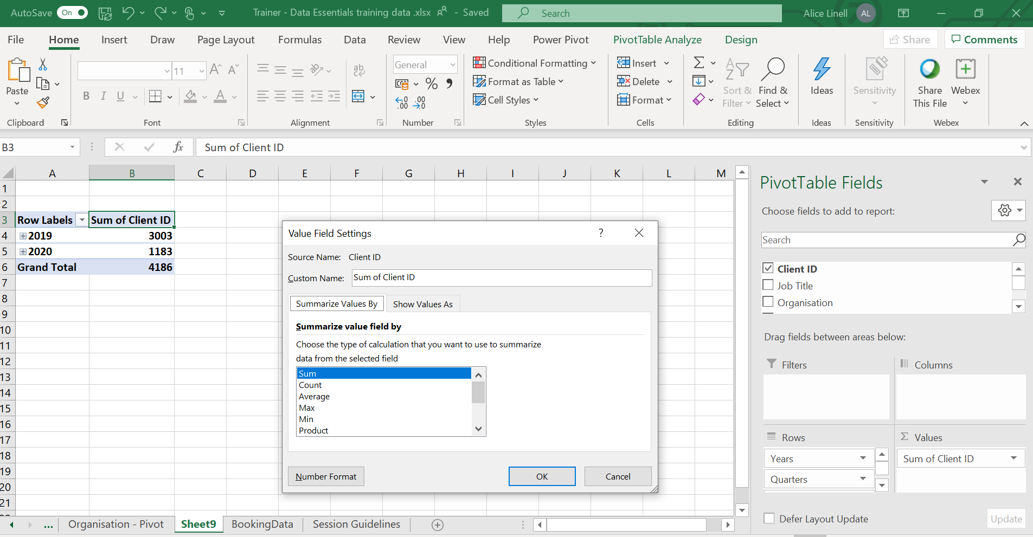
Type in the name you would like to use for the value field.

Summarise values by

1. Select the tab Summarise Values By
2. Select how you want your field summarised

Most common calculations used to summarise data:
Function | Summarizes
Sum | The sum of the values adds all the values in the selected data range. This is the default function for numeric values.
Count | The number of values. The Count summary function works the same as the COUNTA worksheet function. Count is the default function for values other than numbers.
Average | The average of the values. The average is the mean average of the numbers. To calculate: Excel adds up all the numbers, then divides by how many numbers there are. In other words it is the sum divided by the count.
Max | The largest value.
Min | The smallest value.
Product | The product of the values. The product is the result of multiplying the numbers eg the product of 2 and 3 is 6.

Show values As

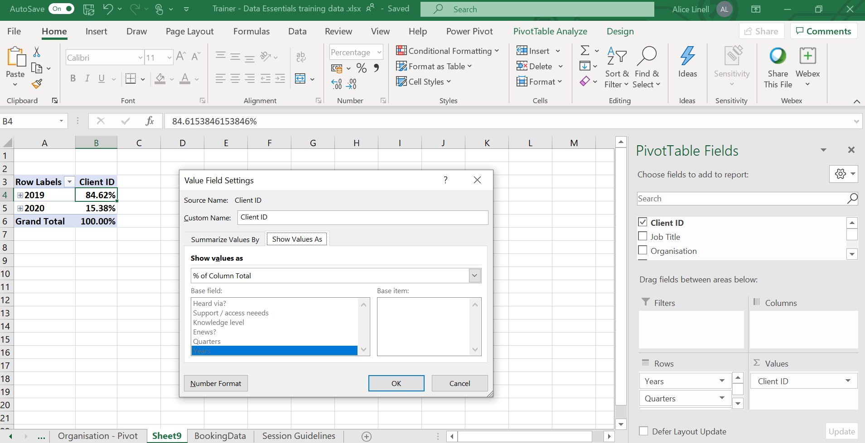
3. Change the number format
2. Select how you want to display the data
1. Select the tab Show Values As
Most common ways of displaying data:
Use this calculation | To
No calculation | Turn off custom calculation.
% of Column Total | Display all the values in each column or series as a percentage of the total for the column or series.
% of Row Total | Display the value in each row or category as a percentage of the total for the row or category.
Rank smallest to largest | Display the rank of selected values in a specific field, listing the smallest item in the field as 1, and each larger value with a higher rank value. Create a new column for Rank if you want to show the specific amounts too.
Rank largest to smallest | Display the rank of selected values in a specific field, listing the largest item in the field as 1, and each smaller value with a higher rank value. Create a new column for Rank if you want to show the specific amounts too.

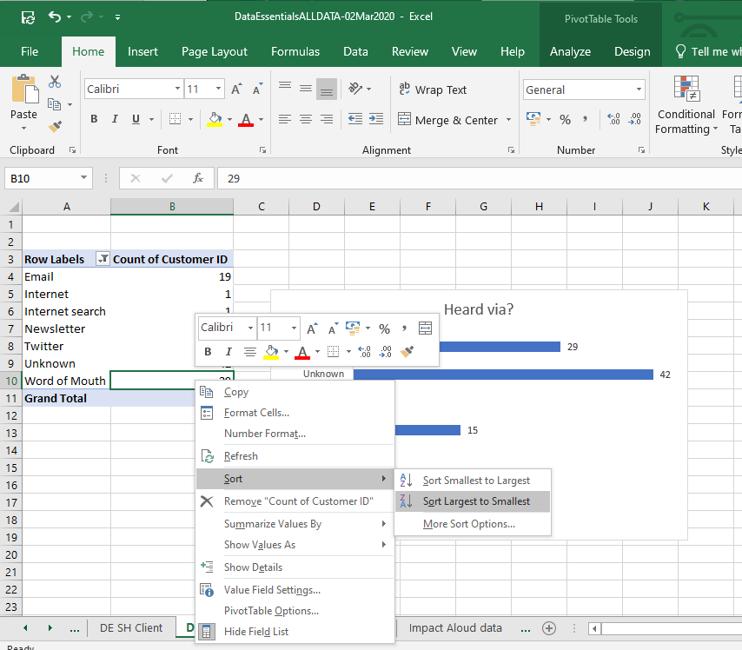
Changing the sort order
More sort options allows you to input a specific sort order
2. Select sort and the sort order you require
1.Right mouse click on a value in the data set you want to sort

Custom sort order
Go to File > Options > Advanced

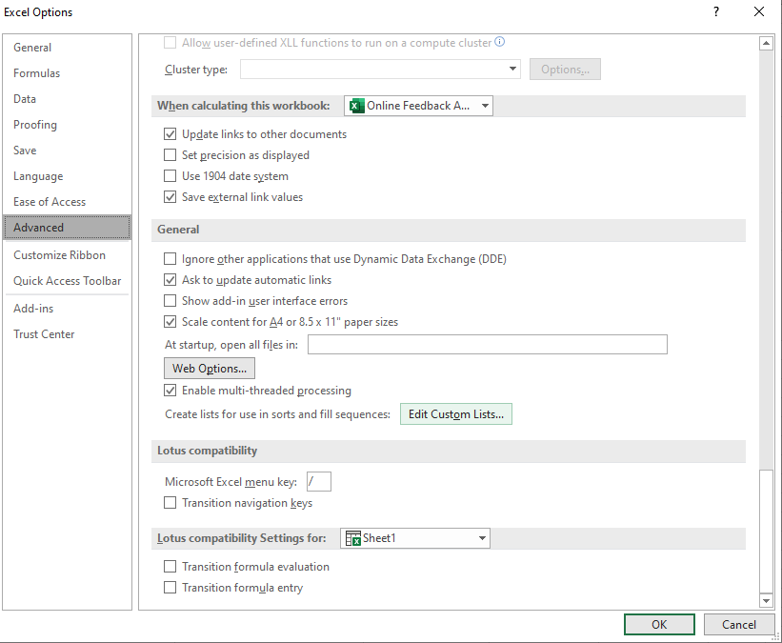
- Select the option Edit Custom Lists

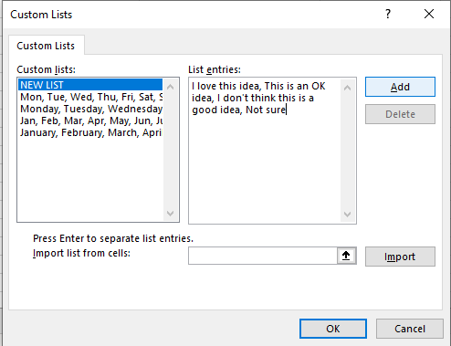
- Click on OK
- Click on Add
- Add your custom sort order separated by commas.
You can also choose to import the values from a range of cells.

Grouping dates
In Excel 2016 forward Excel automatically groups dates by months & quarters. If you are working with an Excel version prior to that or you want to change the automatic grouping you can manually group dates.

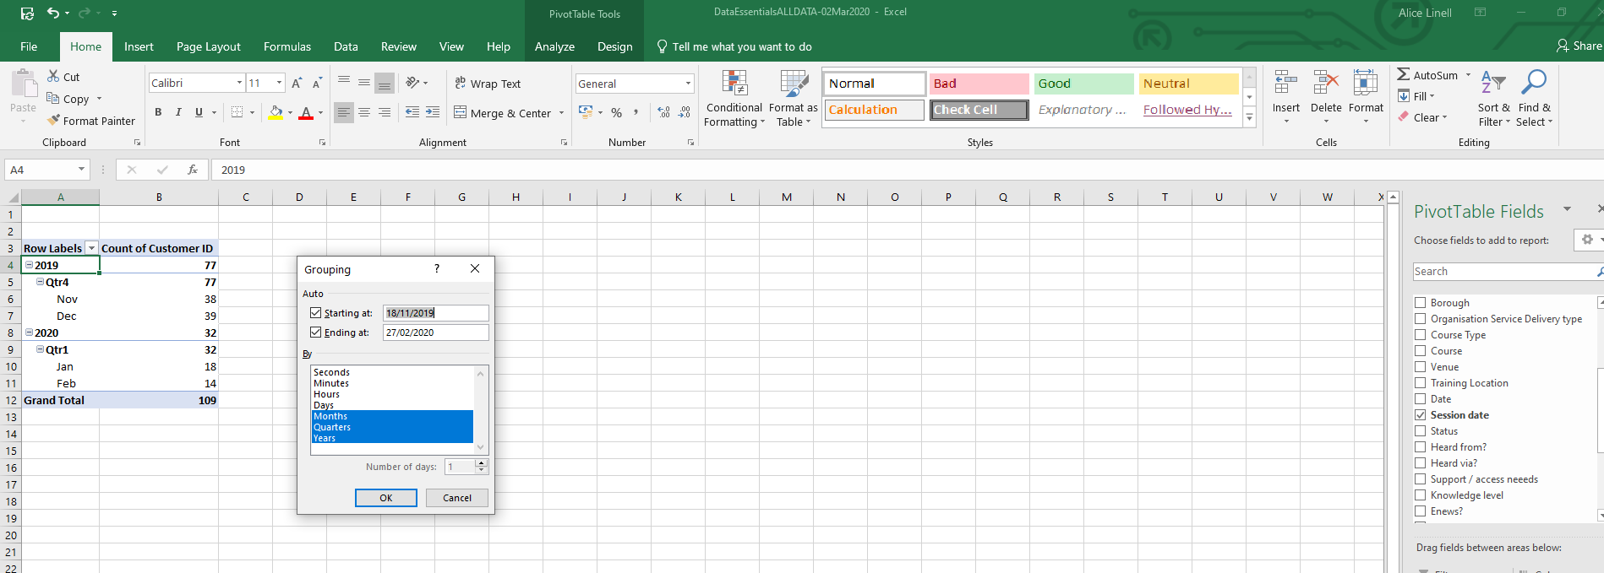
- Right mouse click on a date value
- Select the Grouping you require

Working with Charts

Anatomy of a chart
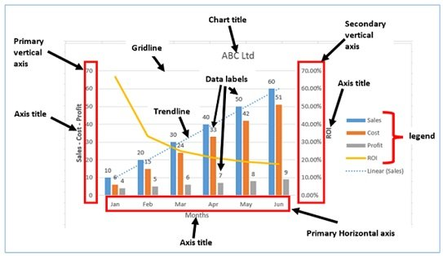

Creating Pivot charts
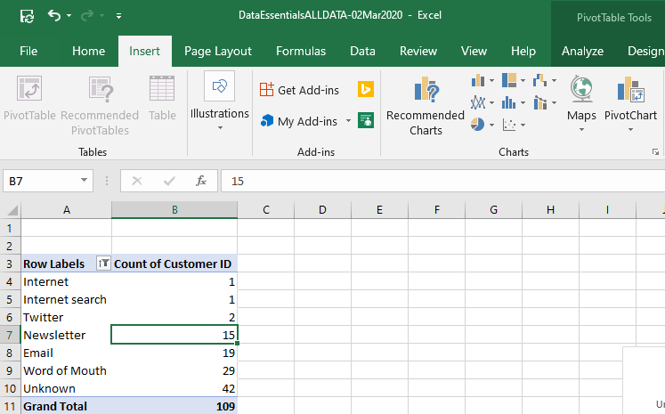
1.Click on the Pivot table you want to make into a chart

2. Click on Pivot Chart

3. Choose the chart type

4. Choose the chart format

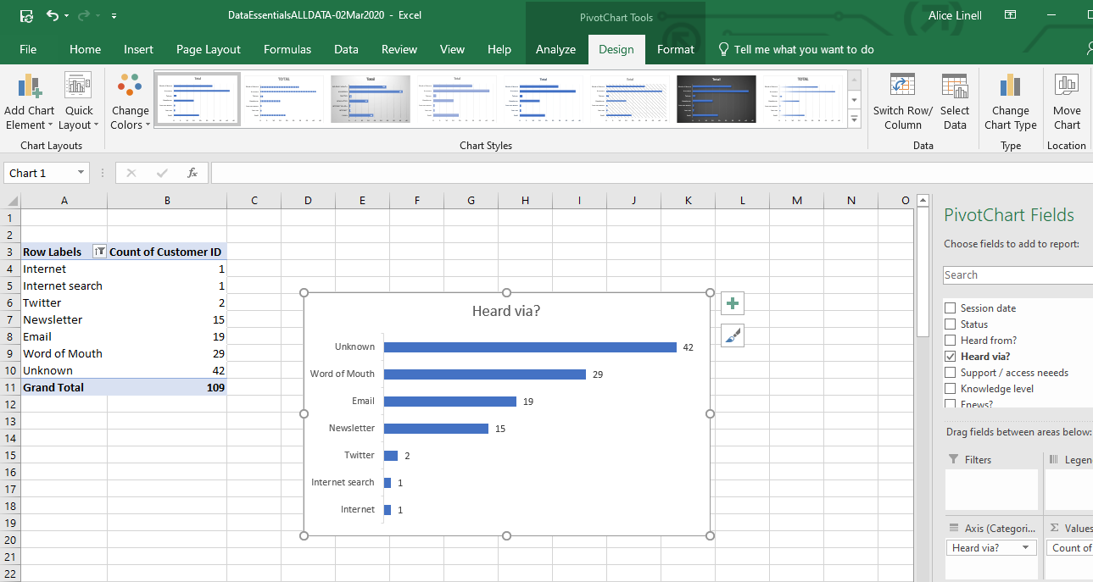
Chart design
Change the colour palette

Select the chart style

Change chart type
Change the chart type

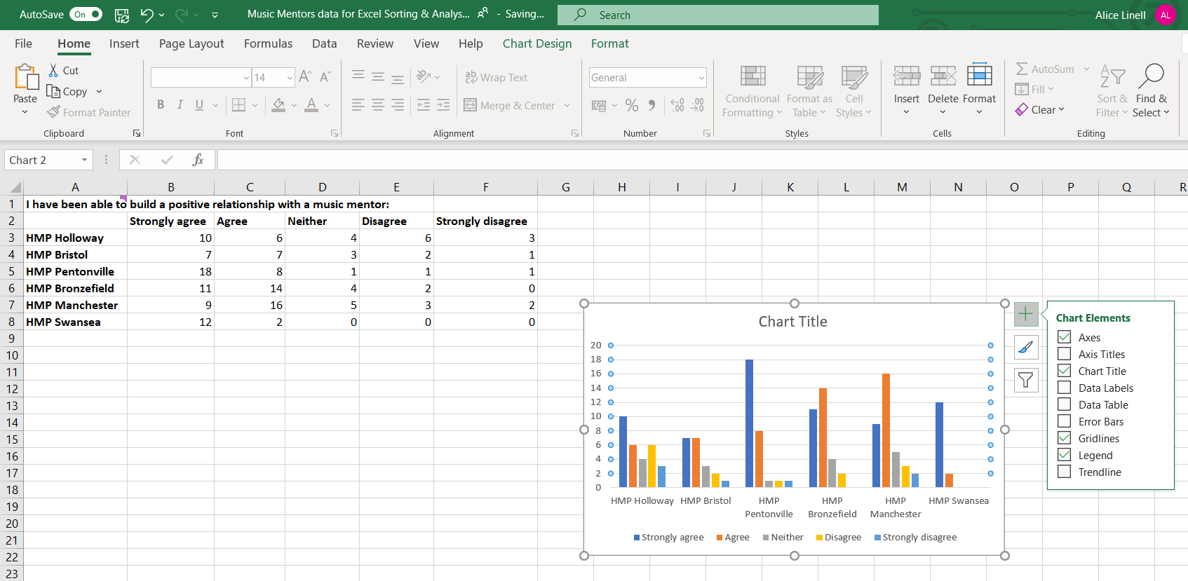
Chart elements
Click on the + symbol to reveal the chart elements. (De)select to add and remove chart elements

Different Chart Elements options will appear depending on the type of chart

Drill down to select more options

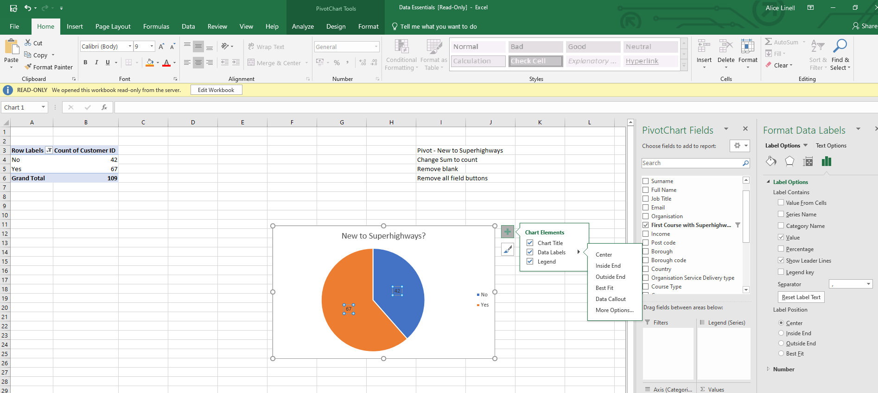
Click on the arrow next to the chart element to reveal a drop-down menu of options

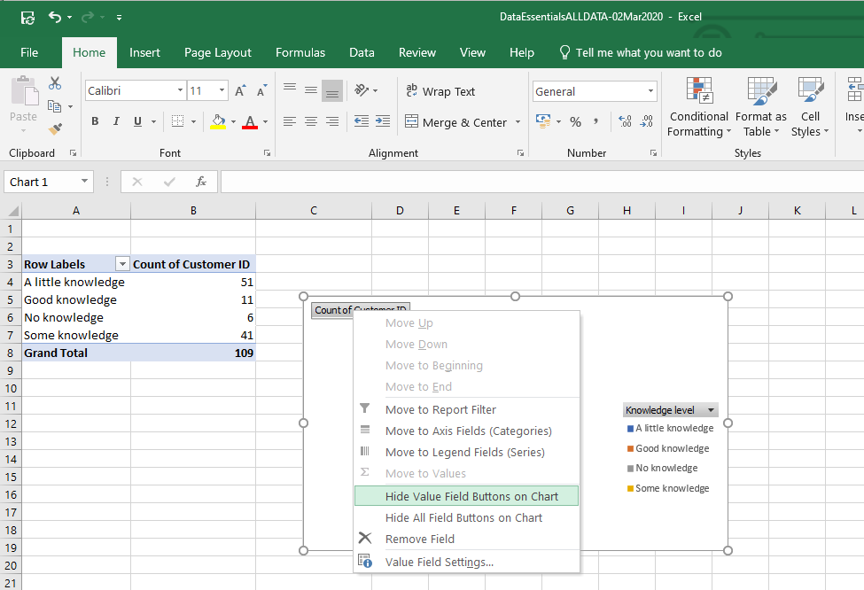
Hide Value field button settings
- Click on a value field button in the chart

- Select hide the selected button or hide all

Changing the data series

Making Rows/columns broader
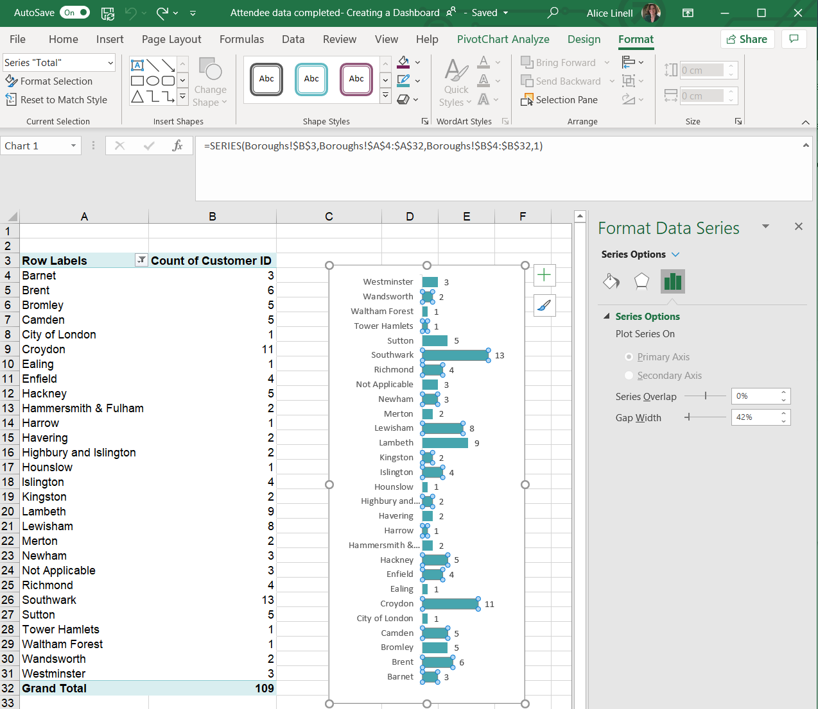
3. Change the Gap width to increase the width of the bars

2. The Format window will open

- Click on the data series (in this instance the bars in the chart) to select

Make each data point a different colour
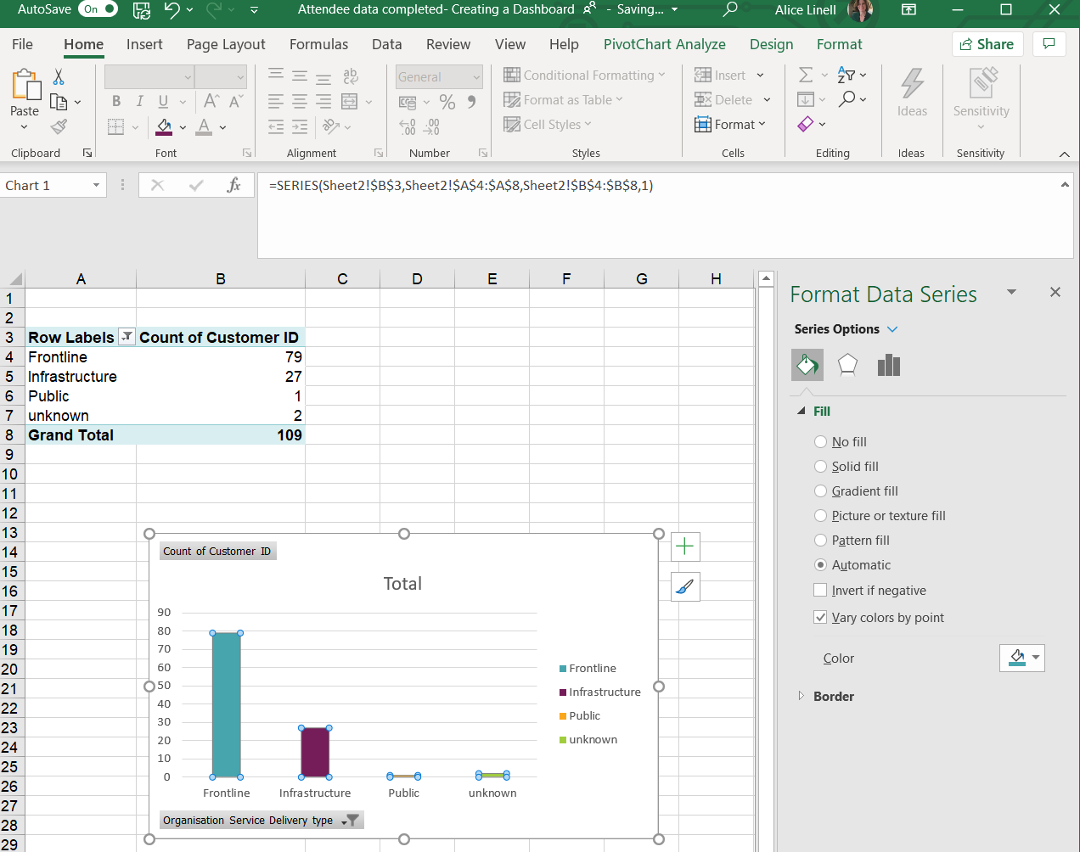
3. Check the Vary Colours by point option

- Click on the data series (in this instance the columns in the chart) to select it.

2. In the format window click on the Fill & Line command button

Creating an Excel Dashboard

Preparing your Workbook
Create worksheets in your workbook as follows:
- Data
- Analysis
You can create these as you begin to work on the data. Ideally create one worksheet for each pivot table.
- Dashboard
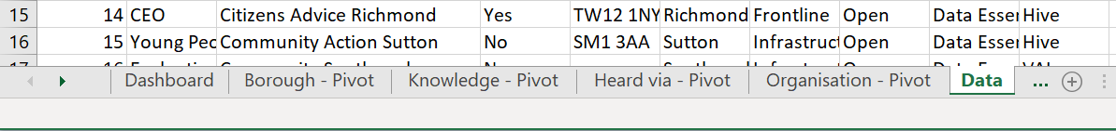
1
2
3

Formatting your Dashboard

Add Title
Add a text box to add a title to your chart
Copy and paste charts in from other sheets, hold Alt key down when moving to snap charts to the gridlines

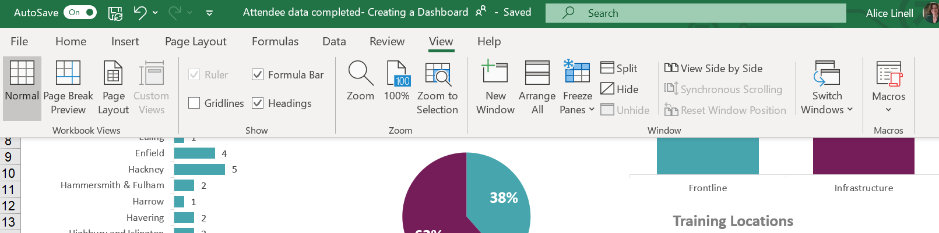
Hide Gridlines, Headers & the formula bar
On the view tab, check/uncheck
Sheet elements you wish to show/hide

Formulas

GETPIVOTDATA
Created by simply entering a = in the destination cell and then clicking on the source cell. Excel creates the formula, like the one in the example below, for you so there is no need to type it in.
GETPIVOTDATA("Count of Customer ID",Attendance!$A$3,"Status","Attended")

IFERROR
Wrap the IFERROR formula around formulas so that if no data or incorrect data causes an error your formula will return a value of your choosing. In the formula below we use the IFERROR to return a 0 if there is an error in the data
- =IFERROR(GETPIVOTDATA("Count of Customer ID",Attendance!$A$3,"Status","Attended"),0)

Slicers
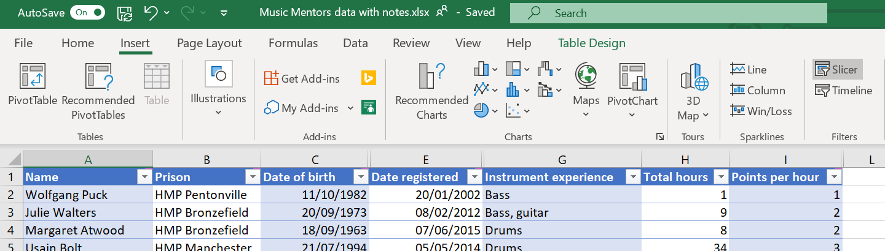
1. Click on the Insert tab

2. Click on Slicer

2. Select the column(s) you would like to use for filtering

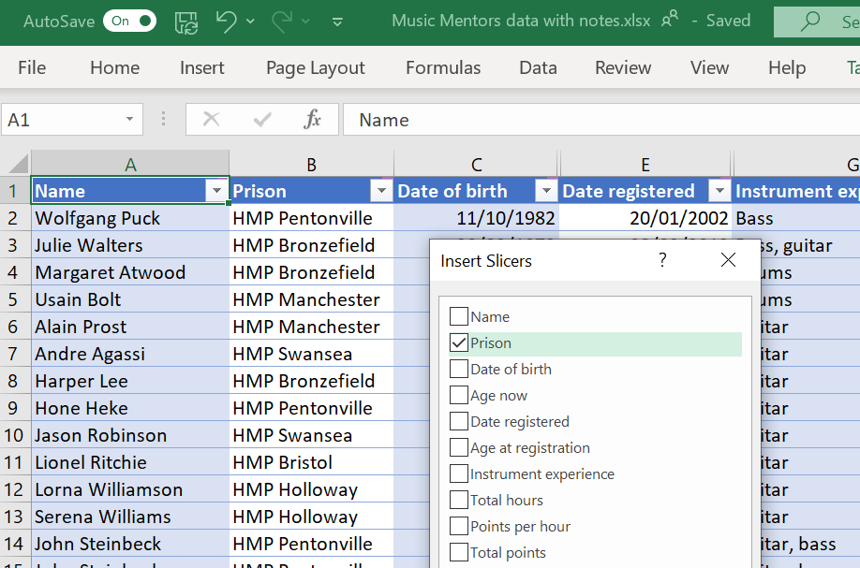
3. Select the field you want to use as a filter

Formatting a Slicer
When using a slicer it is a good idea to only include only filters for where data exists otherwise the filter will return no results.
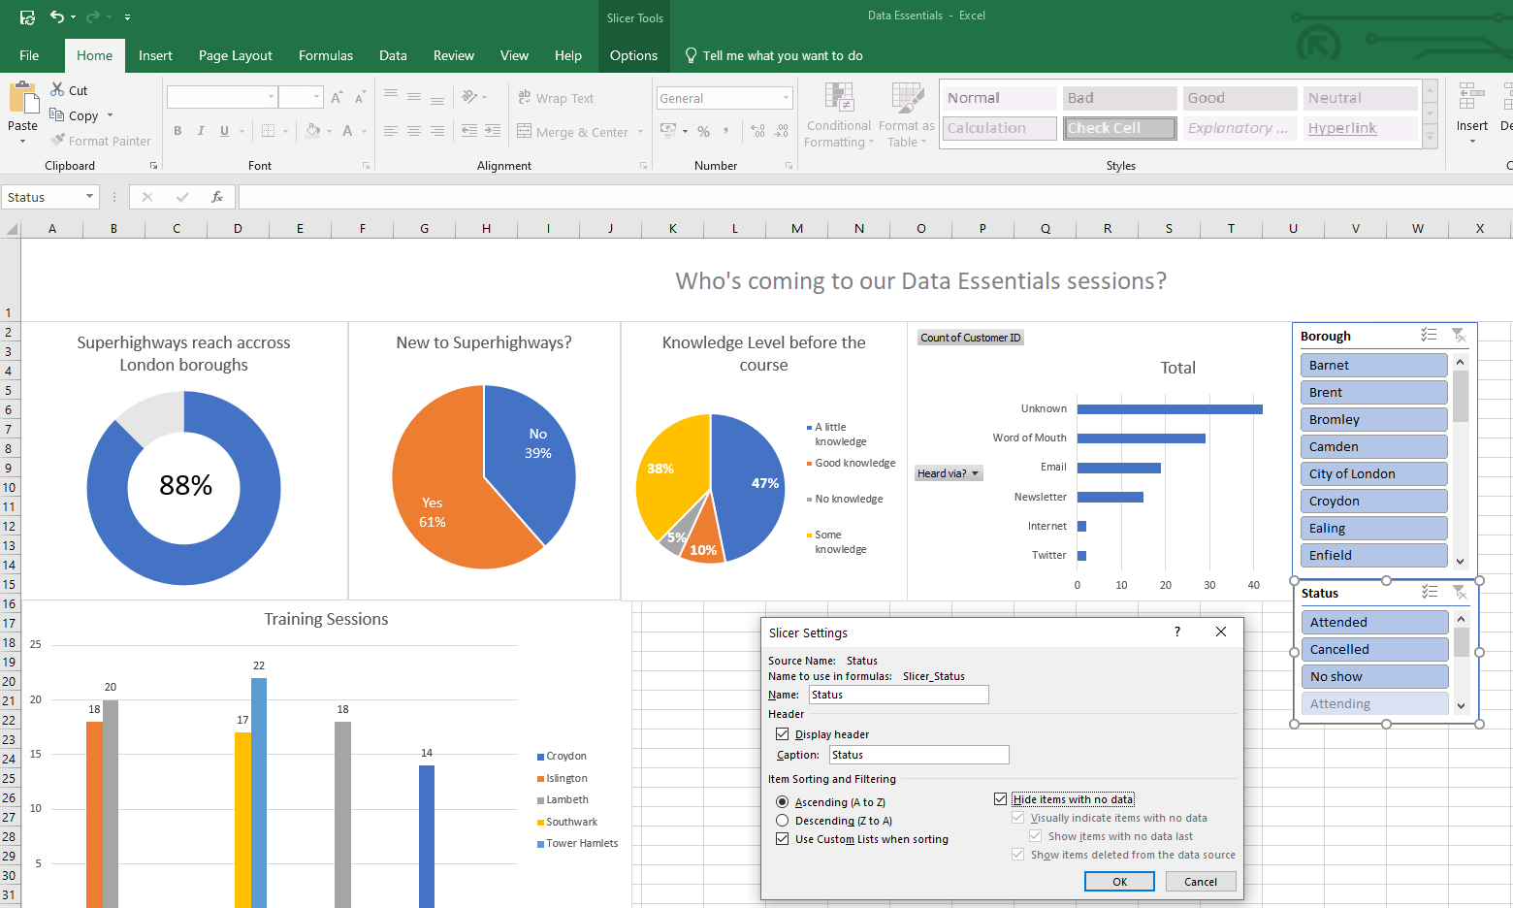
- Right click on Slicer and select the option Slicer Settings. Then tick the box Hide items with no data.

Linking the slicer to your charts
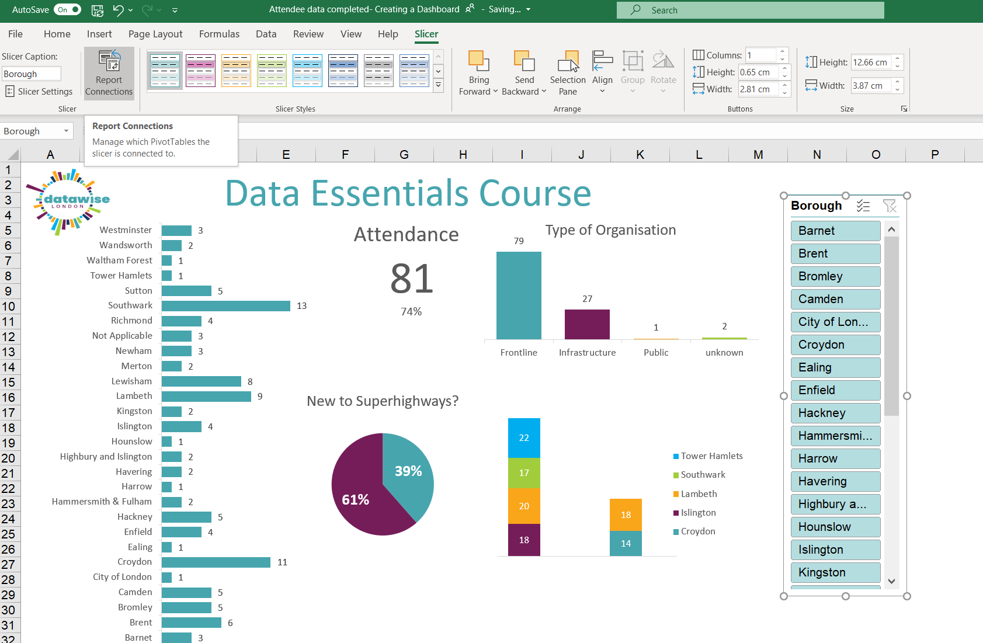
- Select the Slicer
- In the Slicer tab ribbon, click on Report Connections in the Slicer Tab

Refreshing the Dashboard

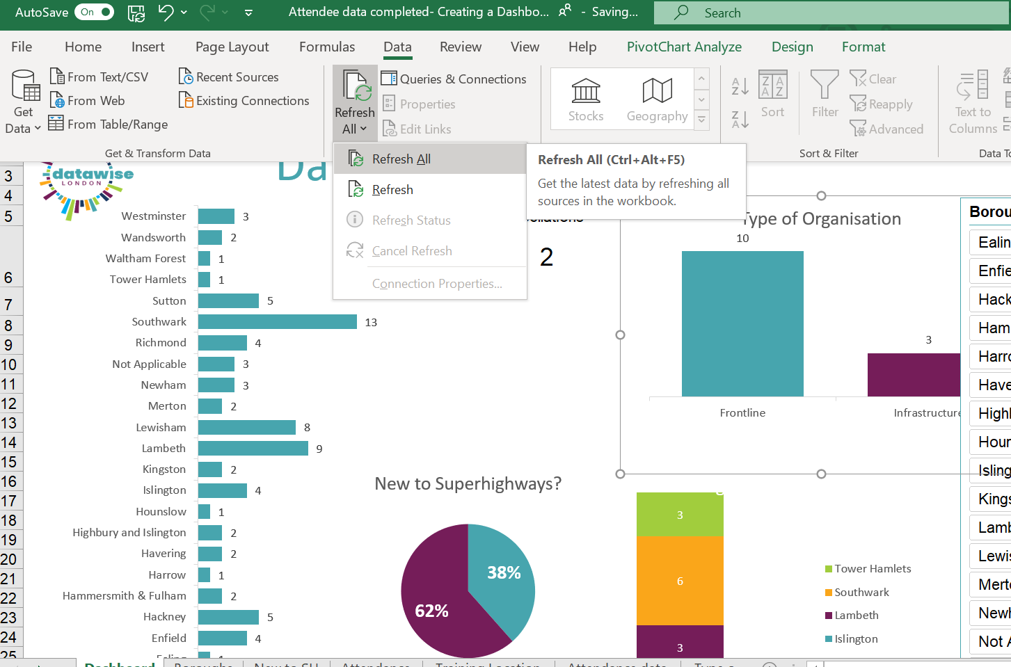
Select Refresh All on the Data tab

Session Exercises



