
Introduction to Power BI
Contents
1. Getting Set up: Office 365 Users 3
Power BI Service 3
Power BI Desktop 4
2. Bring data from Excel into PowerBI 5
3. Review the data 6
4. Use Transform data to combine data from multiple Excel tables 7
5. Create a visual on the report canvas 9
Create a Card 10
6. Create a map visual 10
7. Publish the report internally or with a named person 11
8. Publishing the report publicly 11
9. Training Session Exercises 12

Getting Set up: Office 365 Users

Power BI Service

Power BI Service is included in Microsoft 365, if you do not have Microsoft 365 then talk to your IT provider to find out how to upgrade.
- Log into Office 365
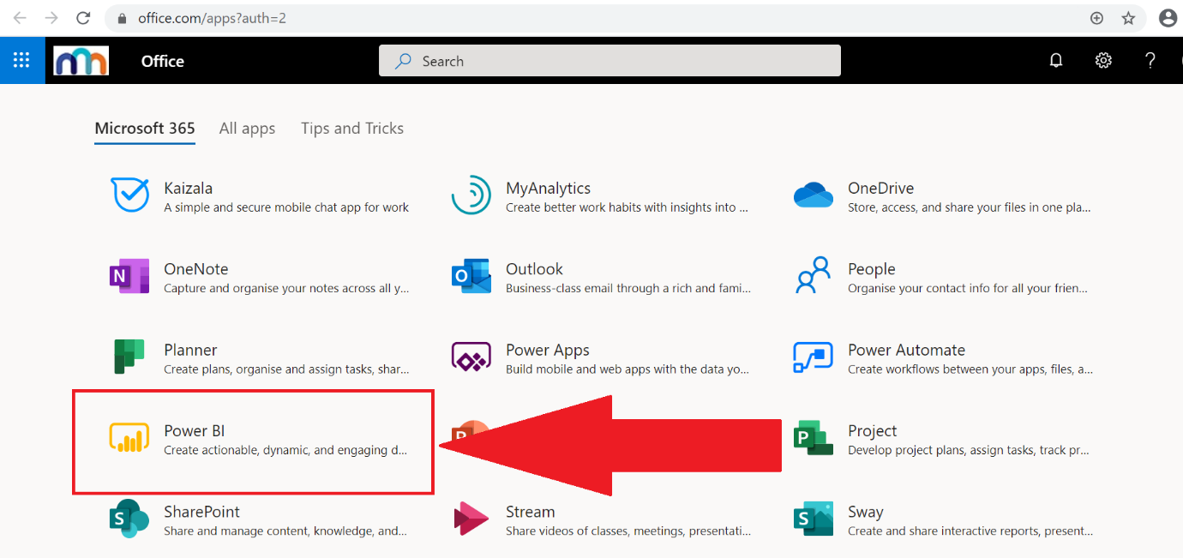
- Click on Power BI icon to launch the Power BI service
If you cannot see the Power BI icon, first try using the search function to find it. If it does not appear you will need to ask your IT provider to enable the application for you.

Power BI Desktop
There are 2 ways of downloading Power BI desktop:
- Download from https://www.microsoft.com/en-gb/download/details.aspx?id=58494 and follow the installation instructions.
- Download via the Power BI service by following the steps below:
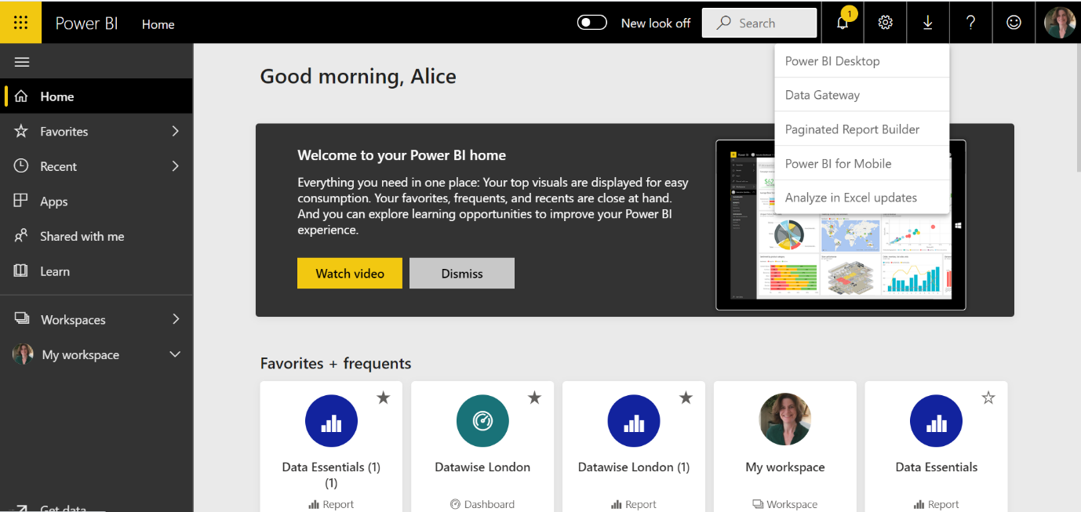
1.Click on the download button.
2. Select Power BI Desktop

Bring data from Excel into PowerBI
- Use one of the 3 options below to start the process of getting data from Excel
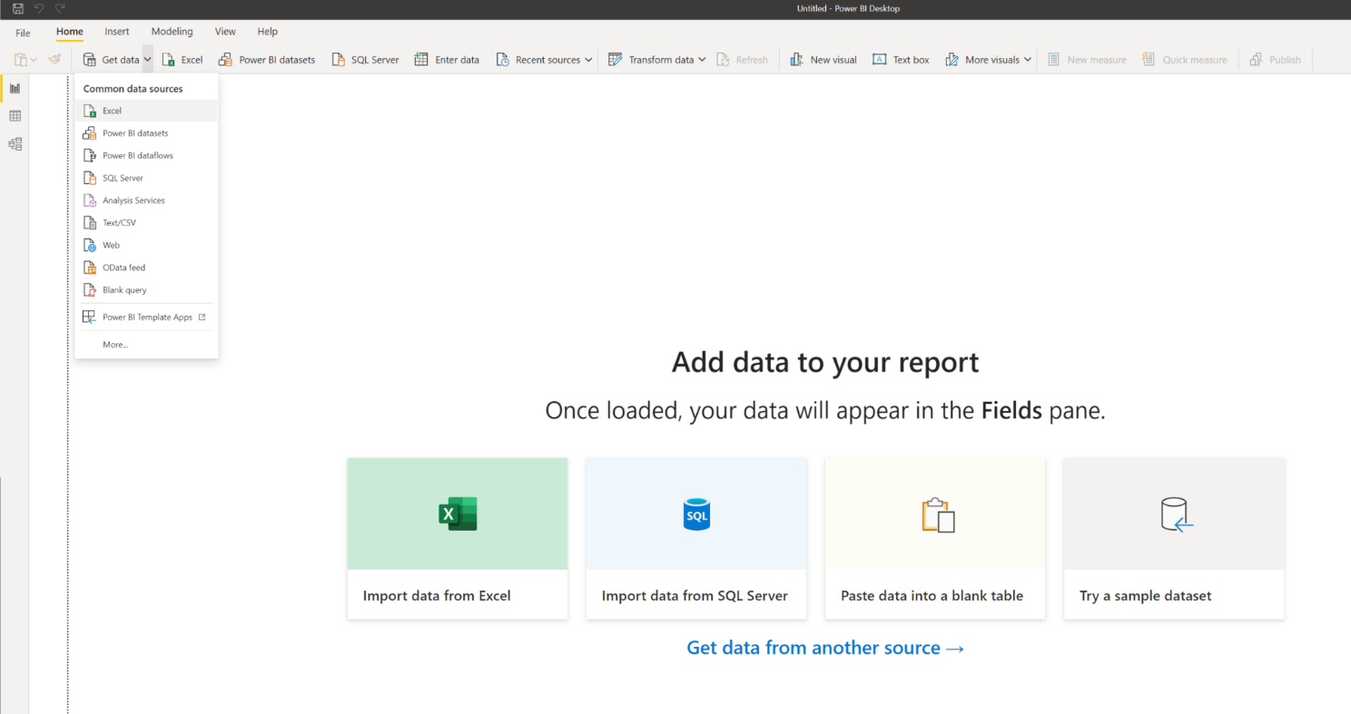
1
2
3

- Click on Get Data

- Find and select the Excel file required
- Click on Open
- In the Navigator pane select the worksheets and/or tables you want to import

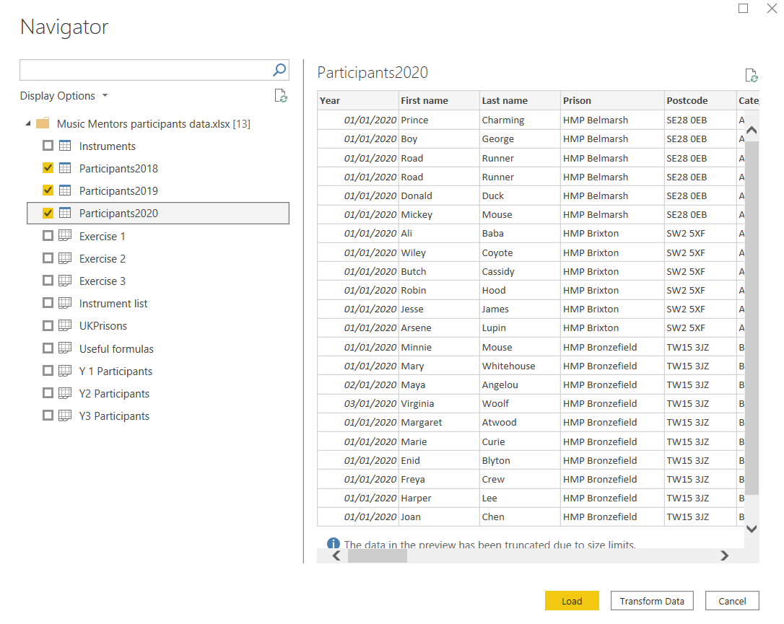
1. Select the tables you require (a blue top on the icon shows that its a table)
2. The right-hand pane shows a preview of the data
3. Click on Load to bring the data into Power BI

Review the data
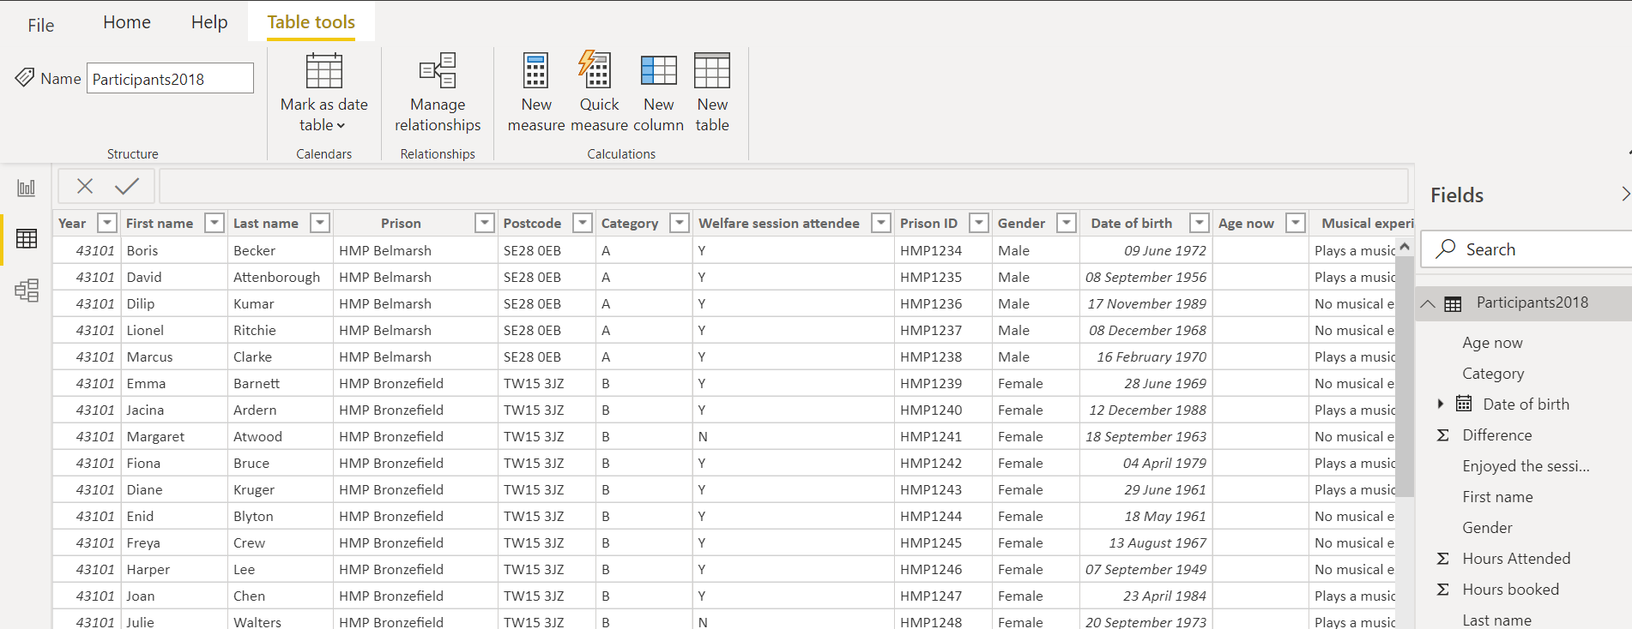
- Click on the data view
- Click on the arrows next to the the tables to reveal the fields

Use Transform data to combine data from multiple Excel tables
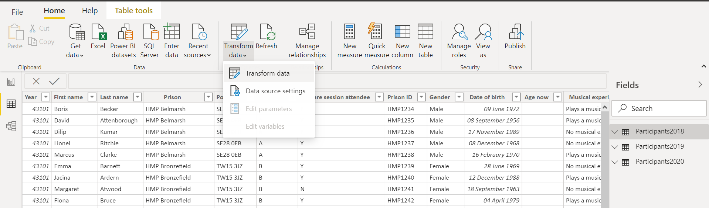
- Click on Transform data to open the Power Query Editor

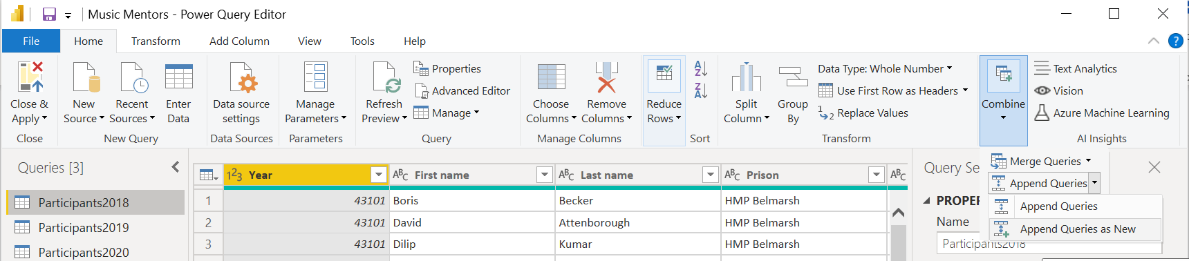
- From the Combine menu, select Append Queries as New
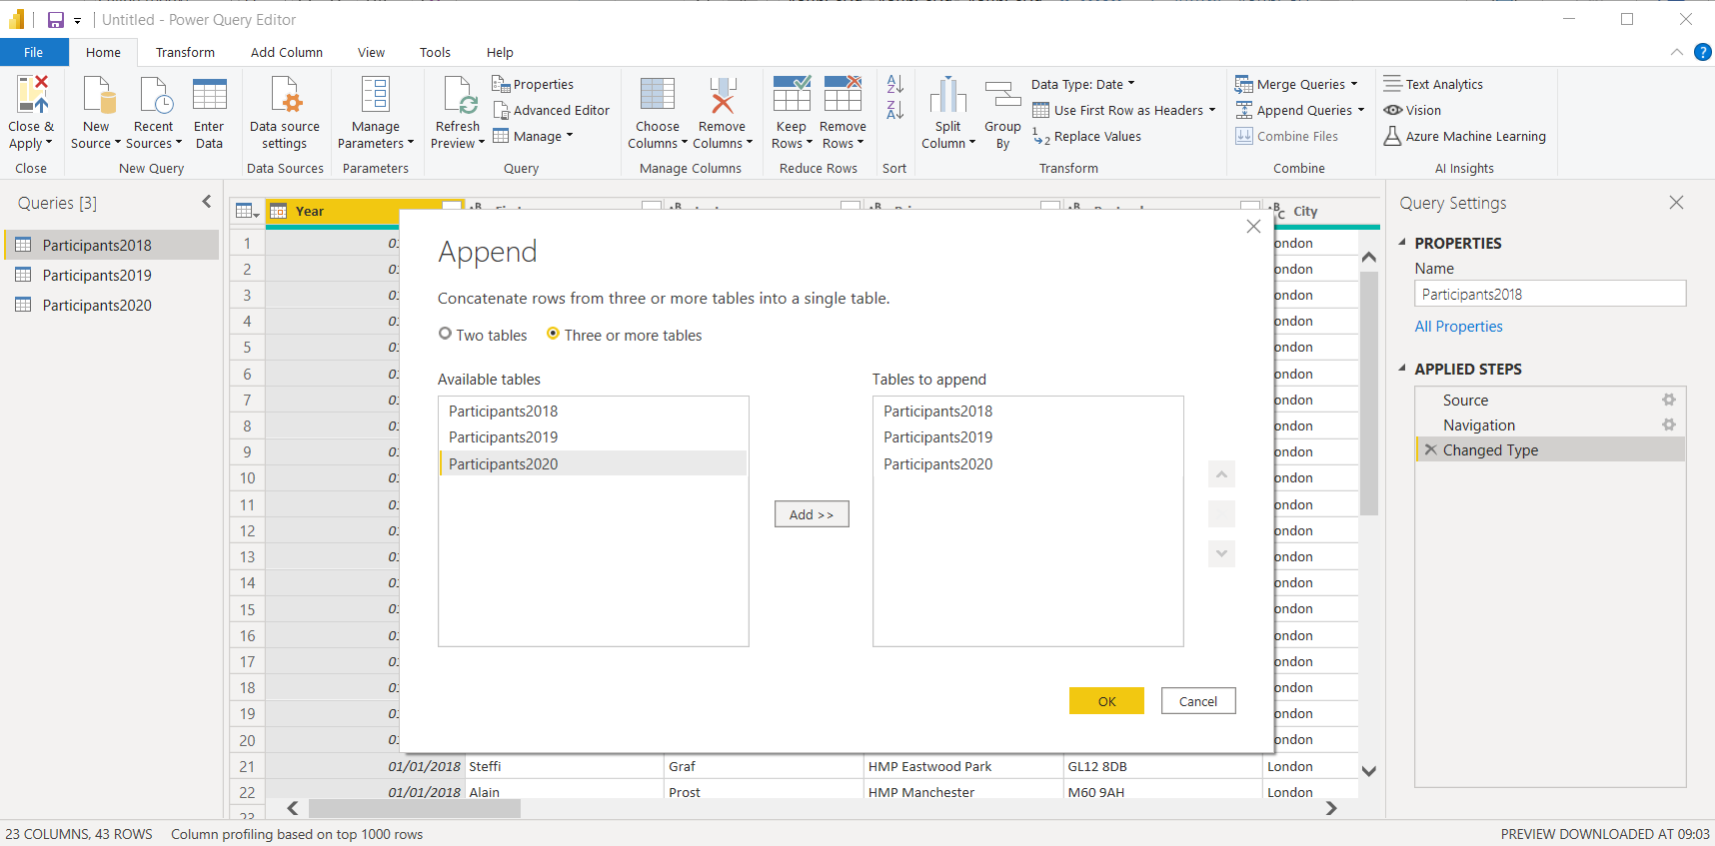
3. Use the Add>> button to add the data from multiple data sources into one table

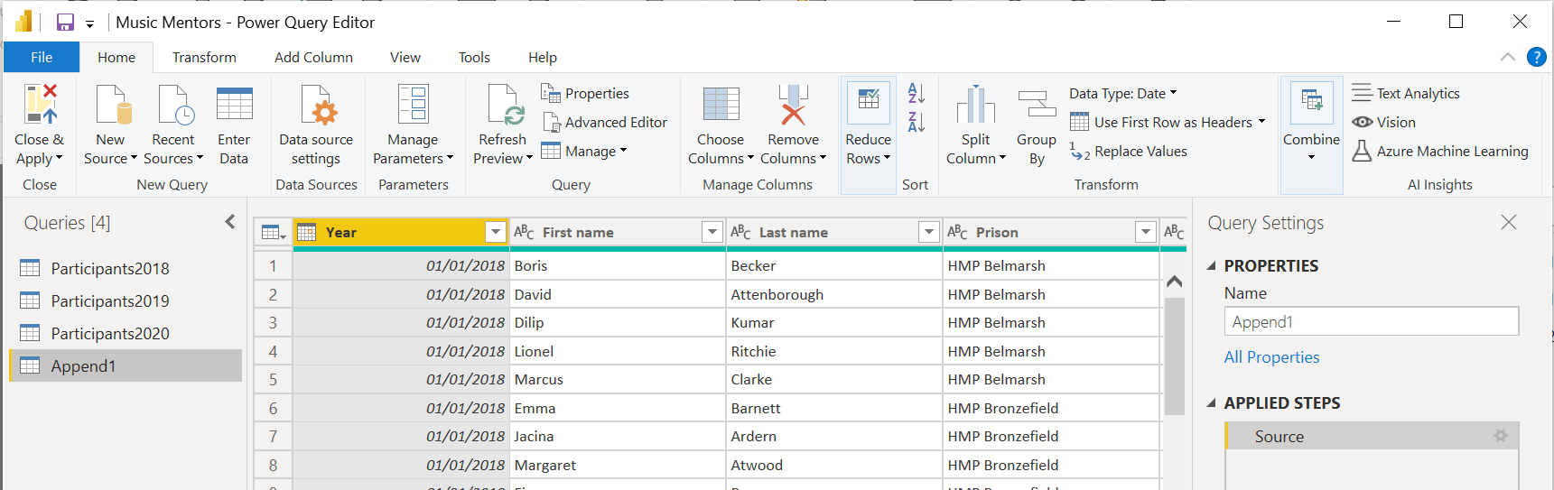
4. Use the Choose Columns feature to choose what data to include
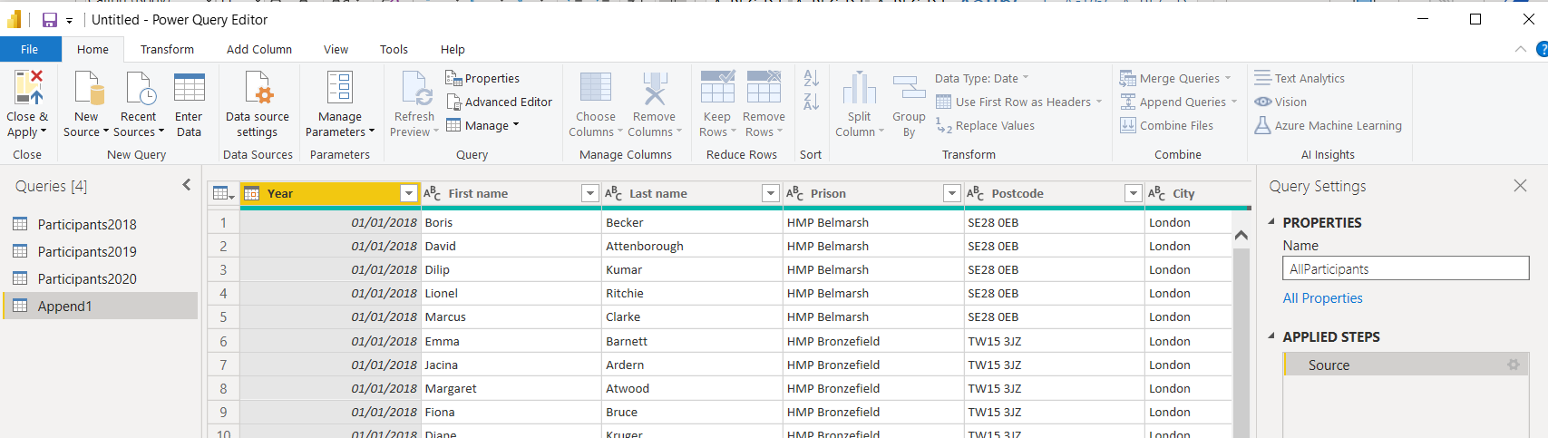
5. A new query called Append1 will be created
6. Rename the query by typing the new name into the Name field
7. Click on Close & Apply to create the query

Create a visual on the report canvas
There are many ways of tackling this and a vast amount of functionality so here are just the basics:
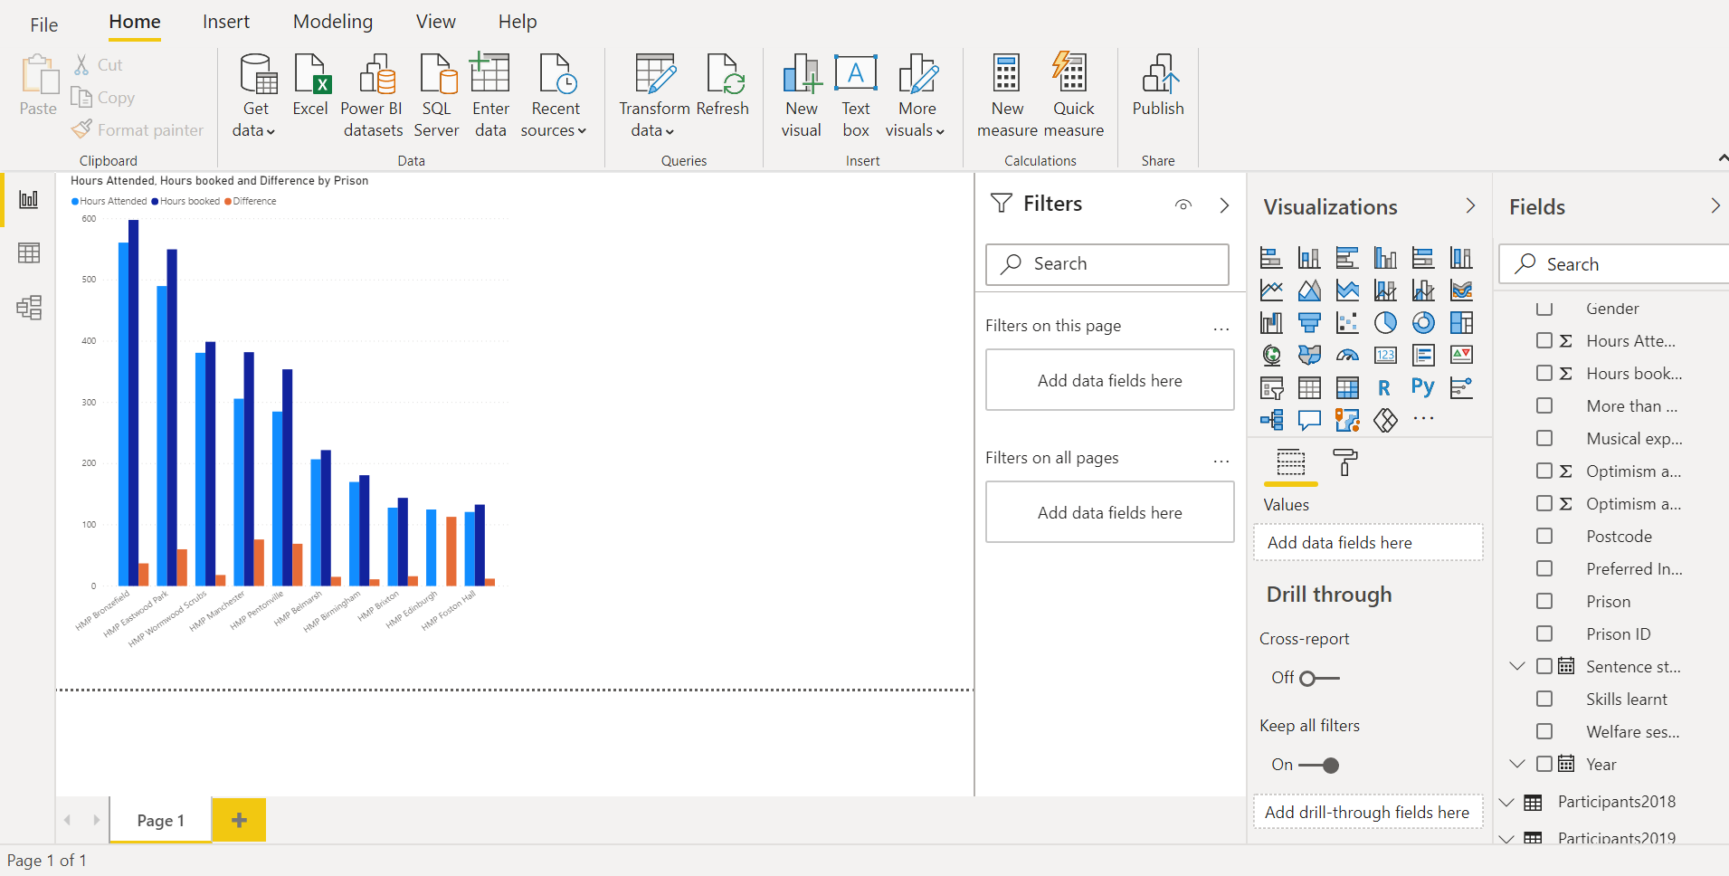
1. Select the Report view
2. Select a visual
3. In the Values view, drag fields to the Values, Fields or Axis wells
4. In the Format view, format your visualisation

Create a Card
1. Click on the report canvas and then click on Card
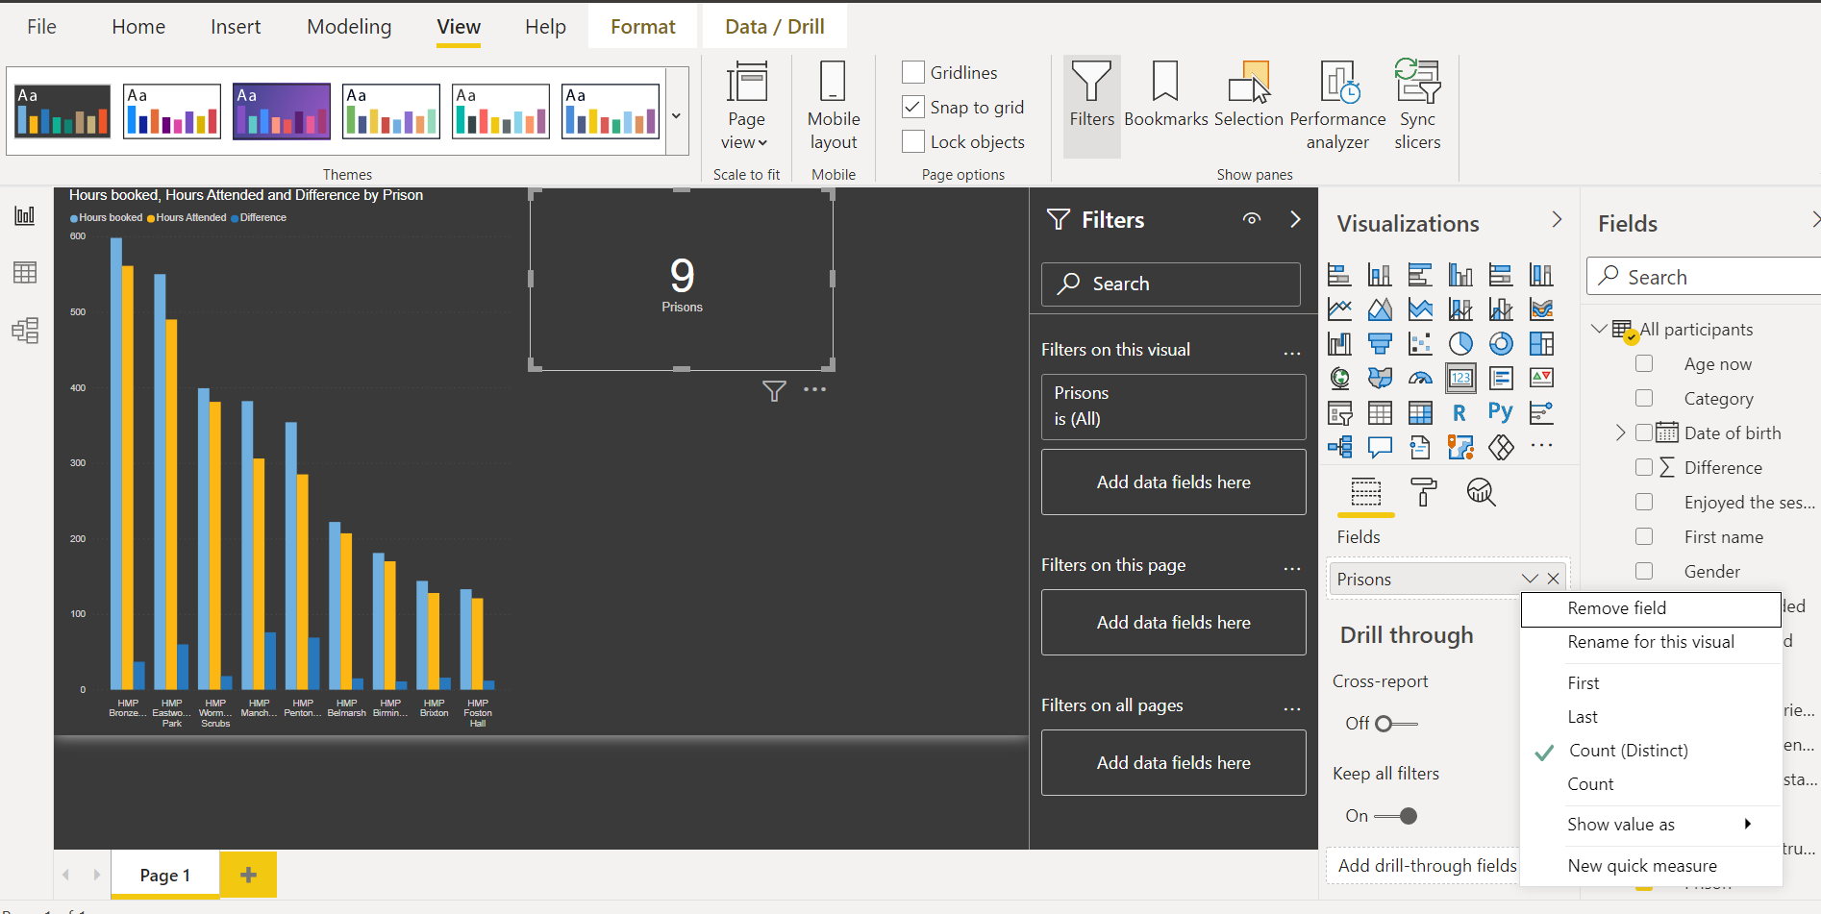
3. Rename the visual
2. Change the field to Count

Create a map visual
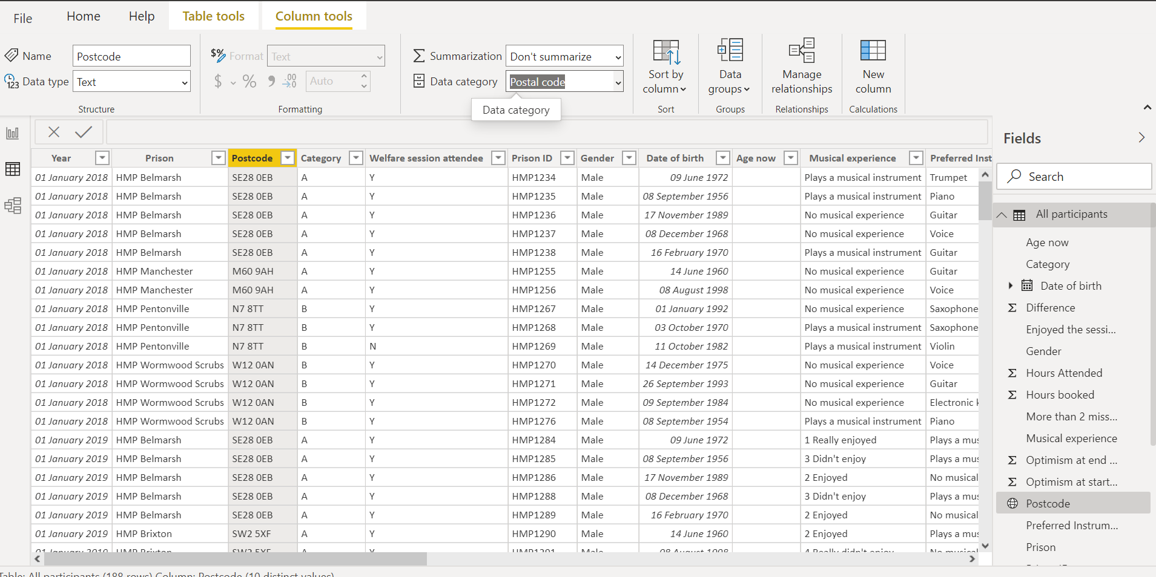
Categorise the fields you want to use as locations before selecting a map visual
1. Select the field you want to use as a location
2. Select a location data category

Then select the map from the visualisation options.

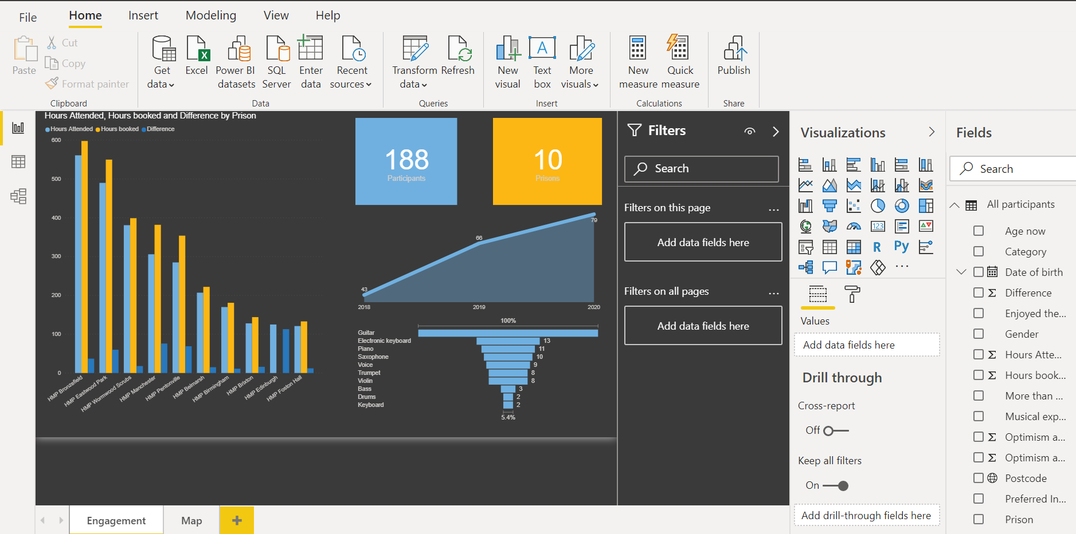
Publish the report internally or with a named person
- Click on publish

This will create a .PBIX file which can be stored on a shared drive & emailed to people. The Power BI service or desktop application is required to open it.

Publishing the report publicly
For this you need to open the report in the Power BI service which you can access through Microsoft 365.
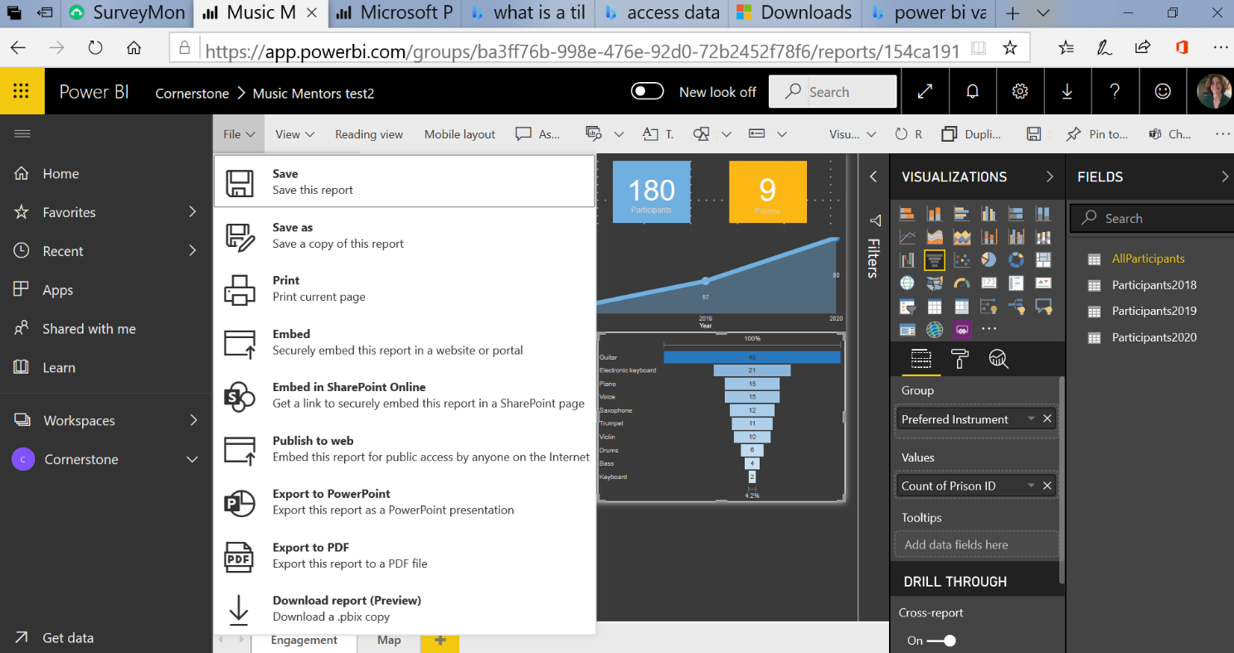
- Select Publish to Web from the File menu

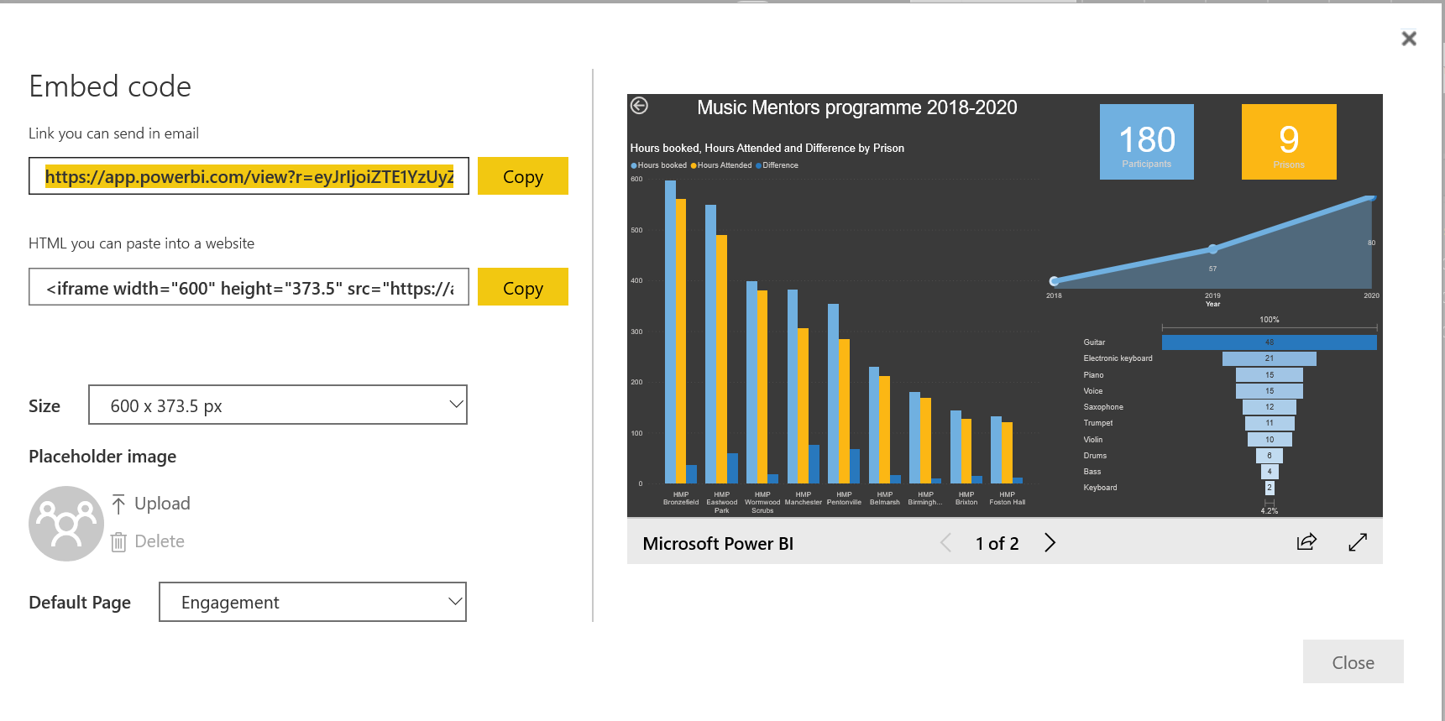
- Copy the code to share with someone or embed it in your website

Training Session Exercises


