User Persona example
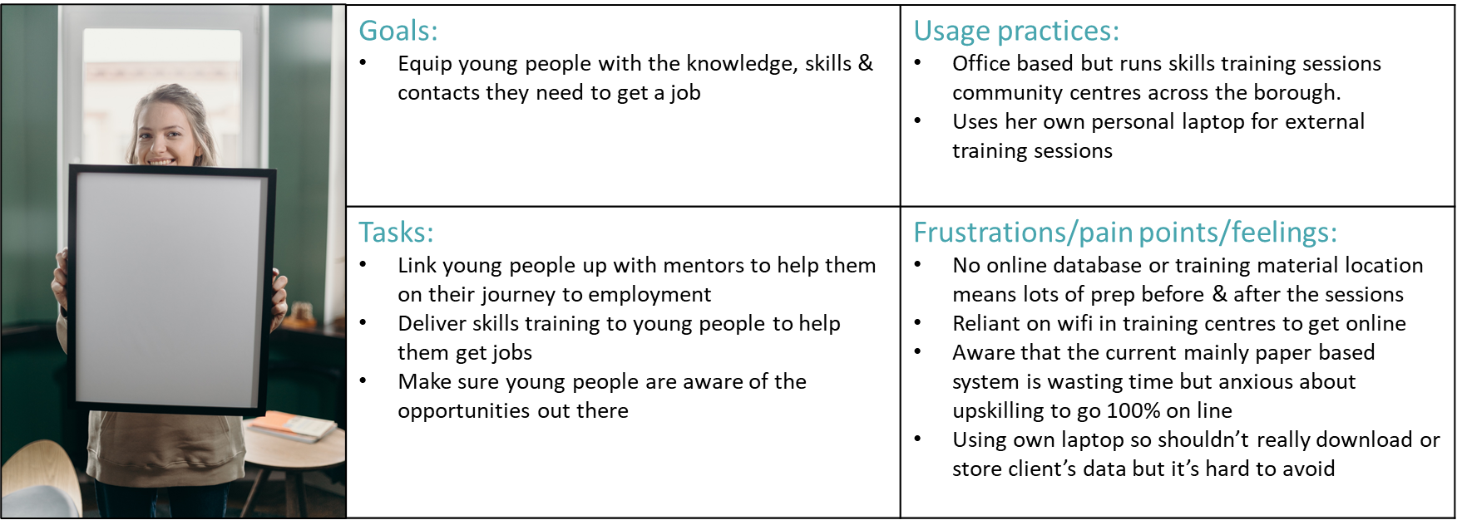
Sarah Jones
Trainer

Job Title: | Goals  - Enter goals here | Usage practices  - Enter usage practice here
 | Tasks/activities  - Enter tasks here | Pain points/frustrations  - Enter pain points here

User Persona template

